Table of Contents

UNITED STATES

SECURITIES AND EXCHANGE COMMISSION

WASHINGTON, DC 20549

SCHEDULE 14A

(Rule 14a-101)
SCHEDULE 14A INFORMATION
Proxy Statement Pursuant to Section 14(a) of the
Securities Exchange Act of 1934 (Amendment No. )

Filed by the Registrant ☒

Filed by a Party other than the Registrant ☐

Check the appropriate box:

☒ Preliminary Proxy Statement

☐ Confidential, For Use of the Commission Only (as permitted by Rule 14a-6(e)(2))

☐ Definitive Proxy Statement

☐ Definitive Additional Materials

☐ Soliciting Material Under § 240.14a-12

FAIR ISAAC CORPORATION

(Name of Registrant as Specified In Its Charter)

(Name of Person(s) Filing Proxy Statement, if Other Than the Registrant)

Payment of Filing Fee (Check all boxes that apply):

☒ No fee required.

☐ Fee paid previously with preliminary materials.

☐ Fee computed on table in exhibit required by Item 25(b) per Exchange Act Rules 14a-6(i)(1) and 0-11.

Table of Contents

PRELIMINARY PROXY STATEMENT – SUBJECT TO COMPLETION
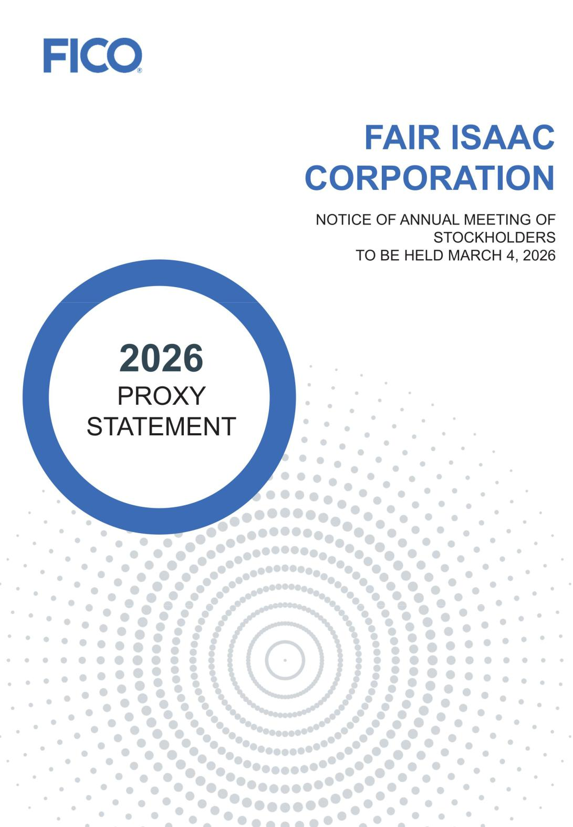

Table of Contents

PRELIMINARY PROXY STATEMENT — SUBJECT TO COMPLETION

NOTICE OF ANNUAL MEETING OF STOCKHOLDERS

Please take notice that the 2026 Annual Meeting of the Stockholders of Fair Isaac Corporation (“Annual Meeting”) will be held at the time and place and for the purposes indicated below.


- Voting Matters and Board

- Recommendations

Proposal 1

Election of Directors

Proposal 2

Advisory Vote to Approve Executive Compensation

Proposal 3

Page Board

Number Recommendation

-  FOR

- FOR



When

Wednesday, March 4, 2026 | 9:30 A.M., local time

 Where

Fair Isaac Corporation

181 Metro Drive, San Jose, California 95110

Ratification of Independent Registered Public Accounting Firm

Proposal 4

85 | FOR

 Who can vote

Approval of an Amendment to the Company’s Restated Certificate of Incorporation to Allow for Exculpation of Officers as Permitted by Delaware Law

Proposal 5

Approval of an Amendment to the Company’s Restated Certificate of Incorporation to Eliminate the Supermajority Voting Requirement

89 | FOR

90 FOR

If you were a stockholder as of January 5, 2026, you are eligible to vote. A list of stockholders entitled to vote will be available for inspection at our principal executive offices (5 West Mendenhall, Suite 105, Bozeman, Montana 59715) during business hours for at least ten days before the Annual Meeting. To view the list, please contact our Corporate Secretary to schedule an appointment.

How to vote

By internet www.proxyvote.com

Use the internet to transmit your voting instructions up until 11:59 P.M. Eastern Time the day before the meeting date.

At the Annual Meeting, we may also transact such other business as may properly come before the meeting or any adjournment thereof.

Annual report

Our 2025 Annual Report accompanies the proxy statement.

Voting

Your vote is important. While stockholders are invited to attend the meeting in person, they should promptly submit their proxy by mail, internet, or phone to ensure their representation. Stockholders who attend the meeting can still vote in person, even if they previously submitted a proxy.

Admittance to meeting

The Annual Meeting will be limited to stockholders, and those without an admission ticket must present identification at the registration table. Stockholders holding shares by a bank, broker, or nominee must certify ownership at the registration table before being admitted.
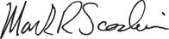

Mark R. Scadina

Executive Vice President, General Counsel and Secretary

January 27, 2026

By telephone 1-800-690-6903

Use any touch-tone telephone to transmit your voting instructions up until 11:59 P.M. Eastern Time the day before the meeting date.

By mail

Complete, sign, and date the proxy card, then return it in the prepaid envelope. If no voting preferences are marked, your proxy will be voted FOR all director nominees, FOR the advisory resolution on executive compensation, FOR the ratification of Deloitte & Touche LLP as the independent auditor for fiscal 2026, FOR an amendment to the Company’s Restated Certificate of Incorporation to allow for exculpation of officers as permitted by Delaware law and FOR an amendment to the Company’s Restated Certificate of Incorporation to eliminate the supermajority voting requirement.

In person at the Annual Meeting

All stockholders can vote in person at the Annual Meeting. Beneficial owners must obtain a legal proxy from their broker, bank, or nominee and present it with their ballot at the meeting.

Table of Contents

A LETTER FROM OUR CHAIRMAN AND OUR CEO

It is our pleasure to invite you to attend the 2026 Annual Meeting of Stockholders of Fair Isaac Corporation at our San Jose, CA office on

Wednesday, March 4, 2026, at 9:30 a.m. Pacific Time. At this year’s meeting, we will conduct a:

- vote on the election of directors;

- non-binding advisory vote to approve the compensation of FICO’s named executive officers;

- vote on the ratification of the selection of Deloitte & Touche LLP as FICO’s independent registered public accounting firm;

- vote to approve an amendment to FICO’s Restated Certificate of Incorporation to allow for exculpation of officers as permitted by Delaware law; and

- vote to approve an amendment to FICO’s Restated Certificate of Incorporation to eliminate the supermajority voting requirement.

Finally, stockholders will have an opportunity to ask questions.

Your vote is important. Whether or not you plan to participate in the annual meeting, please vote as soon as possible. You may vote by proxy prior to the meeting over the internet, by telephone or by mailing a completed proxy card or voting instruction form. Your vote by proxy will ensure your representation at the annual meeting regardless of whether you attend the meeting. Details regarding the annual meeting and the business to be conducted are described in the accompanying Notice of Annual Meeting of Stockholders and Proxy Statement.

Thank you for your trust and ongoing support of FICO.
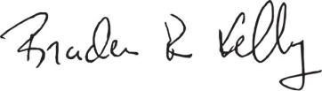

Braden R. Kelly, Chairman
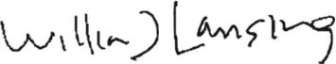

William J. Lansing, CEO

Table of Contents

TABLE OF CONTENTS


 | Proxy Summary |  |  |  |  |  |  |  |  |  |  |  |  |  |  |  |  |  |  |  |  |  |  | 1
 | PROPOSAL 1: ELECTION OF DIRECTORS |  |  |  |  |  |  |  |  |  |  |  |  |  |  |  |  |  |  |  |  |  |  | 11
 | Annual Elections |  |  |  |  |  |  |  |  |  |  |  |  |  |  |  |  |  |  |  |  |  |  | 11
 | Majority Voting Standard |  |  |  |  |  |  |  |  |  |  |  |  |  |  |  |  |  |  |  |  |  |  | 11
 | Director Nominee Selection Process |  |  |  |  |  |  |  |  |  |  |  |  |  |  |  |  |  |  |  |  |  |  | 11
 | Director Nominee Skills and Experience Matrix |  |  |  |  |  |  |  |  |  |  |  |  |  |  |  |  |  |  |  |  |  |  | 12
 | Director Nominees |  |  |  |  |  |  |  |  |  |  |  |  |  |  |  |  |  |  |  |  |  |  | 13
 | Corporate Governance |  |  |  |  |  |  |  |  |  |  |  |  |  |  |  |  |  |  |  |  |  |  | 17
 | Board Leadership Structure |  |  |  |  |  |  |  |  |  |  |  |  |  |  |  |  |  |  |  |  |  |  | 17
 | Board Risk Oversight Role |  |  |  |  |  |  |  |  |  |  |  |  |  |  |  |  |  |  |  |  |  |  | 17
 | Attendance at Board Meetings |  |  |  |  |  |  |  |  |  |  |  |  |  |  |  |  |  |  |  |  |  |  | 19
 | Board Self-Evaluation Process |  |  |  |  |  |  |  |  |  |  |  |  |  |  |  |  |  |  |  |  |  |  | 19
 | Board Committees |  |  |  |  |  |  |  |  |  |  |  |  |  |  |  |  |  |  |  |  |  |  | 20
 | Stockholder-Recommended Director Candidates |  |  |  |  |  |  |  |  |  |  |  |  |  |  |  |  |  |  |  |  |  |  | 23
 |  |  |  |  |  |  |  |  |  |  |  |  |  |  |  |  |  |  |  |  |  |  |  | 24
 | Environmental, Social and Governance (“ESG”) Matters |  |  |  |  |  |  |  |  |  |  |  |  |  |  |  |  |  |  |  |  |  |  | 24
 | Human Capital Resources |  |  |  |  |  |  |  |  |  |  |  |  |  |  |  |  |  |  |  |  |  |  | 25
 | Insider Trading Policy |  |  |  |  |  |  |  |  |  |  |  |  |  |  |  |  |  |  |  |  |  |  | 29
 | Succession Planning |  |  |  |  |  |  |  |  |  |  |  |  |  |  |  |  |  |  |  |  |  |  | 30
 | Stockholder Engagement |  |  |  |  |  |  |  |  |  |  |  |  |  |  |  |  |  |  |  |  |  |  | 31
 | Director Compensation Programs |  |  |  |  |  |  |  |  |  |  |  |  |  |  |  |  |  |  |  |  |  |  | 32
 | Non-Employee Director Compensation |  |  |  |  |  |  |  |  |  |  |  |  |  |  |  |  |  |  |  |  |  |  | 32
 | Director Stock Ownership Guidelines |  |  |  |  |  |  |  |  |  |  |  |  |  |  |  |  |  |  |  |  |  |  | 33
 | Director and Officer Liability Insurance Policies |  |  |  |  |  |  |  |  |  |  |  |  |  |  |  |  |  |  |  |  |  |  | 33
 | Director Compensation for Fiscal 2025 |  |  |  |  |  |  |  |  |  |  |  |  |  |  |  |  |  |  |  |  |  |  | 33

PROPOSAL 2: ADVISORY VOTE ON EXECUTIVE
OFFICER COMPENSATION |  |  |  |  |  |  |  |  |  |  |  |  |  |  |  |  |  |  |  |  |  |  |  |  |  |  |  |  |  |  | 35
Executive Compensation |  |  |  |  |  |  |  |  |  |  |  |  |  |  |  |  |  |  |  |  |  |  |  |  |  |  |  |  |  |  | 36
Compensation Discussion and Analysis |  |  |  |  |  |  |  |  |  |  |  |  |  |  |  |  |  |  |  |  |  |  |  |  |  |  |  |  |  |  | 37
Leadership Development and Compensation Committee |  |  |  |  |  |  |  |  |  |  |  |  |  |  |  |  |  |  |  |  |  |  |  |  |  |  |  |  |  |  | 59
Report |  |  |  |  |  |  |  |  |  |  |  |  |  |  |  |  |  |  |  |  |  |  |  |  |  |  |  |  |  |  | 59
Compensation Tables |  |  |  |  |  |  |  |  |  |  |  |  |  |  |  |  |  |  |  |  |  |  |  |  |  |  |  |  |  |  | 60
Potential Payments Upon Termination or Change in |  |  |  |  |  |  |  |  |  |  |  |  |  |  |  |  |  |  |  |  |  |  |  |  |  |  |  |  |  |  | 69
Control |  |  |  |  |  |  |  |  |  |  |  |  |  |  |  |  |  |  |  |  |  |  |  |  |  |  |  |  |  |  | 69
Equity Compensation Plan Information |  |  |  |  |  |  |  |  |  |  |  |  |  |  |  |  |  |  |  |  |  |  |  |  |  |  |  |  |  |  | 76
CEO Pay Ratio |  |  |  |  |  |  |  |  |  |  |  |  |  |  |  |  |  |  |  |  |  |  |  |  |  |  |  |  |  |  | 77
Pay Versus Performance |  |  |  |  |  |  |  |  |  |  |  |  |  |  |  |  |  |  |  |  |  |  |  |  |  |  |  |  |  |  | 78
PROPOSAL 3: RATIFICATION OF INDEPENDENT |  |  |  |  |  |  |  |  |  |  |  |  |  |  |  |  |  |  |  |  |  |  |  |  |  |  |  |  |  |  | 85
REGISTERED PUBLIC ACCOUNTING FIRM |  |  |  |  |  |  |  |  |  |  |  |  |  |  |  |  |  |  |  |  |  |  |  |  |  |  |  |  |  |  | 85
Audit and Non-Audit Fees |  |  |  |  |  |  |  |  |  |  |  |  |  |  |  |  |  |  |  |  |  |  |  |  |  |  |  |  |  |  | 85
Policy on Audit Committee Preapproval of Audit and |  |  |  |  |  |  |  |  |  |  |  |  |  |  |  |  |  |  |  |  |  |  |  |  |  |  |  |  |  |  | 86
Non-Audit Services of Independent Auditors |  |  |  |  |  |  |  |  |  |  |  |  |  |  |  |  |  |  |  |  |  |  |  |  |  |  |  |  |  |  | 86
Report of the Audit Committee of the Board of Directors |  |  |  |  |  |  |  |  |  |  |  |  |  |  |  |  |  |  |  |  |  |  |  |  |  |  |  |  |  |  | 87
Certain Relationships and Related Persons Transactions |  |  |  |  |  |  |  |  |  |  |  |  |  |  |  |  |  |  |  |  |  |  |  |  |  |  |  |  |  |  | 88
PROPOSAL 4: APPROVAL OF AN
AMENDMENT TO RESTATED CERTIFICATE
OF INCORPORATION TO ALLOW FOR |  |  |  |  |  |  |  |  |  |  |  |  |  |  |  |  |  |  |  |  |  |  |  |  |  |  |  |  |  |  | 89
EXCULPATION OF OFFICERS AS PERMITTED BY |  |  |  |  |  |  |  |  |  |  |  |  |  |  |  |  |  |  |  |  |  |  |  |  |  |  |  |  |  |  | 89
DELAWARE LAW
PROPOSAL 5: APPROVAL OF AN
AMENDMENT TO RESTATED CERTIFICATE |  |  |  |  |  |  |  |  |  |  |  |  |  |  |  |  |  |  |  |  |  |  |  |  |  |  |  |  |  |  | 90
OF INCORPORATION TO ELIMINATE THE |  |  |  |  |  |  |  |  |  |  |  |  |  |  |  |  |  |  |  |  |  |  |  |  |  |  |  |  |  |  | 90
SUPERMAJORITY VOTING REQUIREMENT
Security Ownership of Certain Beneficial Owners and |  |  |  |  |  |  |  |  |  |  |  |  |  |  |  |  |  |  |  |  |  |  |  |  |  |  |  |  |  |  | 91
Management |  |  |  |  |  |  |  |  |  |  |  |  |  |  |  |  |  |  |  |  |  |  |  |  |  |  |  |  |  |  | 91
 |  |  |  |  |  |  |  |  |  |  |  |  |  |  |  |  |  |  |  |  |  |  |  |  |  |  |  |  |  |  | 93
Questions and Answers About the Annual Meeting |  |  |  |  |  |  |  |  |  |  |  |  |  |  |  |  |  |  |  |  |  |  |  |  |  |  |  |  |  |  | 93
Other Information |  |  |  |  |  |  |  |  |  |  |  |  |  |  |  |  |  |  |  |  |  |  |  |  |  |  |  |  |  |  | 97
Appendix A: Reconciliation of Non-GAAP Financial
Measures

Table of Contents

Forward-Looking Statements

Statements contained in this proxy statement that are not statements of historical fact are forward-looking statements within the meaning of the Private Securities Litigation Reform Act of 1995 (the “PSLRA”). Words such as “believes,” “anticipates,” “expects,” “intends,” “targeted,” “should,” “potential,” “goals,” “strategy,” “outlook,” “plan,” “estimated,” “will,” variations of these terms and similar expressions are intended to identify forward-looking statements but are not the exclusive means of identifying such statements. Forward-looking statements involve risks and uncertainties that may cause actual results to differ materially from those in such statements. Factors that could cause actual results to differ from those discussed in the forward-looking statements include, but are not limited to, those described in Part I, Item 1A, “Risk Factors,” of our most recent Annual Report on Form 10-K, as may be updated in subsequent Quarterly Reports on Form 10-Q. The performance of our business and our securities may be adversely affected by these factors and by other factors common to other businesses and investments, or to the general economy. Readers are cautioned not to place undue reliance on forward-looking statements, which speak only as of the date they are made. Except to the extent required by law, we disclaim any intent or obligation to update or revise any forward-looking statements, whether as a result of new information, future events or otherwise.

Table of Contents

 | Proxy | Board of | Corporate | Executive | Audit Committee | Charter | Stock | Other
 | Summary | Directors | Governance | Compensation | Matters | Amendments | Ownership | Matters

PROXY SUMMARY

Proxy voting roadmap

PROPOSAL BOARD RECOMMENDATION PAGE

Election of Directors


- Proposal to elect eight directors to serve until the 2027 Annual Meeting of Stockholders and thereafter until their successors are elected and qualified

For Each Nominee
• The nominees represent a variety of experiences, qualifications, attributes and skills

• All nominees other than our CEO are independent

Advisory Vote on Executive Officer Compensation

- Proposal to approve the advisory (non-binding) resolution relating to the
named executive officer compensation as disclosed in this proxy statement | For

- NEO compensation aligns with stockholder interests, including performance-based incentives

Ratification of Deloitte & Touche LLP as Independent Auditors for Fiscal 2026

- Proposal to ratify the appointment of Deloitte & Touche LLP as the Company’s independent registered public accounting firm for the fiscal year

ending September 30, 2026 | For

- While stockholder ratification of the appointment is not required, we are submitting the selection of Deloitte & Touche LLP for ratification so that our stockholders may participate in this important corporate decision

Approval of an Amendment to the Company’s Restated Certificate of

Incorporation to Allow for Exculpation of Officers as Permitted by Delaware Law.

- Proposal to approve an amendment to the Company’s Restated Certificate of Incorporation to allow for exculpation of officers as permitted by Delaware

law For

- This amendment is aligned with the narrow class and type of claims for which certain officers’ liability can be exculpated under Delaware law and better aligns protections available to those officers with those available to directors

11

35

85

89

Fair Isaac Corporation l 2026 Proxy Statement 1

Table of Contents

 | Proxy | Board of | Corporate | Executive | Audit Committee | Charter | Stock | Other
 | Summary | Directors | Governance | Compensation | Matters | Amendments | Ownership | Matters
PROPOSAL |  |  |  |  |  | BOARD RECOMMENDATION |  |  | PAGE

- Approval of an Amendment to the Company’s Restated Certificate of Incorporation to Eliminate the Supermajority Voting Requirement


- Proposal to approve an amendment to the Company’s Restated Certificate of Incorporation to eliminate the supermajority voting requirement that requires at least 66-2/3% of the voting power of the Company’s outstanding

shares to amend or repeal Article 6 of the Company’s Restated Certificate of For | 90
Incorporation

- Removal of this requirement would result in any amendment or repeal of Article 6 being subject to the affirmative vote of the holders of a majority of the outstanding shares entitled to vote thereon

Fair Isaac Corporation l 2026 Proxy Statement 2

Table of Contents

 | Proxy | Board of | Corporate | Executive | Audit Committee | Charter | Stock | Other
 | Summary | Directors | Governance | Compensation | Matters | Amendments | Ownership | Matters

About FICO

Fair Isaac Corporation (NYSE:FICO) (together with its consolidated subsidiaries, the “Company,” which may also be referred to in this proxy statement as “we,” “us,” “our,” and “FICO”) is a global analytics software leader. We were founded in 1956 on the premise that data, used intelligently, can improve business decisions. Today, FICO’s software and the widely used FICO® Score operationalize analytics, enabling thousands of businesses in more than 80 countries to uncover new opportunities, make timely decisions that matter, and execute them at scale. Most leading banks and credit card issuers rely on our solutions, as do insurers, retailers, telecommunications providers, automotive lenders, consumer reporting agencies, public agencies, and organizations in other industries. We also serve consumers through online services that enable people to access and understand their FICO Scores – the standard measure of consumer credit risk in the United States (“U.S.”) – empowering them to increase financial literacy and manage their financial health. Our business consists of two operating segments: Scores and Software.

Scores – Our Scores segment includes our business-to-business (“B2B”) scoring solutions and services which give our clients access to predictive credit and other scores that can be easily integrated into their transaction streams and decision-making processes. Our B2B scoring solutions include the FICO® Score, which is the standard measure of consumer credit risk in the U.S. It is used in most U.S. credit decisions, by nearly all major banks, credit card issuers, mortgage lenders, and auto loan originators. This segment also includes our business-to-consumer scoring solutions, which includes scores distributed directly by FICO through myFICO.com subscription offering and indirectly through our licensed distribution partners, including Experian and certain lenders through the FICO® Score Open Access Program. The FICO Score is used by 90% of top U.S. lenders. For over three decades it has been the common framework for evaluating and communicating consumer credit risk across consumer credit markets, efficiently enabling billions of decisions across these markets every year in an objective and fair manner.

Software – Our software harnesses the power of analytics and digital decisioning technology to help businesses automate, improve, and connect decisions across their enterprise. Our solutions address customer engagement, acquisition, origination, onboarding, servicing and management, and fraud protection. We also help businesses improve non-customer-facing decisions such as supply chain optimization, scheduling management and policy adherence. This segment includes FICO® Platform, the B2B AI decisioning platform of choice in the market, allowing businesses to optimize hyper-personalized interactions with end customers at scale. FICO Platform is a modular software offering designed to support advanced analytic and decisioning use cases, as well as stand-alone analytic and decisioning software that can be configured by our customers to address a wide variety of business use cases. Users of FICO Platform can bring together data from multiple sources, apply advanced analytics to derive insights, and translate those insights into actions and workflows that can be executed in real-time. By employing hyper-personalization, our customers can deliver on this expectation and others —at scale—across their business, throughout the lifetime of the customer relationship. It can help dissolve data silos, bring innovation and efficiency together, and achieve and maintain trustworthy AI.

Scores Business Highlights During Fiscal 2025:

- We continued to see the market’s ongoing recognition of the FICO® Score as the standard measure of consumer credit risk in the U.S.

- Through our Early Adopter Program, we saw significant adoption of our latest score, FICO® Score 10T for mortgages by non-government sponsored enterprises (“GSEs”). Lenders in the Program have been able to validate the power of FICO Score 10T in real-world mortgage underwriting, loan production, execution and servicing.

- We recently launched our FICO® Mortgage Direct License Program, designed to drive competition, transparency, and cost savings in mortgage, while aligning with calls from policymakers and industry leaders to modernize credit infrastructure and promote affordability, liquidity, and access in the $12 trillion U.S. mortgage industry. We entered into a multi-year direct license and distribution agreement with Xactus, a fintech and market leader in verification solutions for the mortgage industry and the largest credit verification and tri-merge provider of FICO® Scores, for it to participate in the FICO Mortgage Direct License Program.

- In March, we launched the FICO® Score Mortgage Simulator for lender use through Xactus. This tool can allow mortgage professionals to run credit event scenarios by applying simulated changes to a current or

Fair Isaac Corporation l 2026 Proxy Statement 3

Table of Contents

 | Proxy | Board of | Corporate | Executive | Audit Committee | Charter | Stock | Other
 | Summary | Directors | Governance | Compensation | Matters | Amendments | Ownership | Matters

prospective applicant’s credit report data to estimate the potential impact on their FICO® Scores based on those actions. This can benefit both mortgage lenders and consumers by potentially enabling lenders to provide additional loan options and more favorable interest rates.

- We launched FICO® Score 10 BNPL and FICO® Score 10T BNPL, the first credit scores from a leading credit scoring provider to incorporate Buy Now, Pay Later (“BNPL”) data. These scores can provide lenders with deeper insight into how consumers manage repayment on increasingly popular installment loans, enabling a more comprehensive view of their credit readiness.

- In September, we released the inaugural FICO® Score Credit Insights report – a first-of-its-kind analysis offering a detailed look at how consumer credit behaviors are evolving across the U.S. The report highlights how inflation, resumed student loan payments, and evolving payment priorities are reshaping credit scores and delinquency patterns nationwide.

- We recently announced a strategic partnership with Plaid, a leading financial data network, to deliver the next generation of the UltraFICO® Score, which utilizes cash flow data to provide additional information for lending decisions. This innovative solution will combine the proven reliability of the FICO® Score with real time cash-flow data from Plaid to provide lenders with a single, enhanced credit score that improves consumer risk assessment and minimizes operational complexity.

- FICO remains committed to improving financial literacy. We do this in a variety of ways, including free access to FICO® Scores and credit education through our myFICO.com website and through our FICO® Score Open Access program with over 200 leading financial institutions.

Software Business Highlights During Fiscal 2025:

- We continued to see strong demand for FICO® Platform through our “land and expand” strategy, which includes follow-on sales to existing FICO Platform customers and more sales to medium-sized businesses typically served through value-added resellers and systems integrators.

- In May, we hosted a four-day FICO® World event at which we brought together industry professionals from around the world to connect, share best practices, and learn how FICO enables organizations to power customer connections at scale. Participants collaborated on how FICO® Platform can help make real-time decisions at scale and optimize interactions with consumers. On the mainstage, we unveiled innovations, provided demos, and spotlighted advancements that we believe will shape the future of decisioning and enterprise AI.

- On the AI front, we launched the general availability of the FICO® Focused Foundation Model, the FICO® Focused Language Model, and the FICO® Focused Sequence Model, built for financial services and designed to reduce hallucinations and increase accuracy over conventional Generative AI models.

- We signed a new strategic collaboration agreement with Amazon Web Services (“AWS”). Under the new agreement, FICO and AWS will amplify their work to bring more organizations worldwide the power of AI-driven, automated decision workflows with FICO® Platform, and FICO will broaden its participation in AWS partner programs to accelerate client adoption of FICO Platform.

- We were granted more patents this year and as of September 30, 2025 held 230 U.S. and foreign patents and had nearly 80 patents pending. Many of these issued and pending patents relate to advancing responsible AI, machine learning, and applied intelligence technology.

- We continued to see positive industry recognition for our Software Business this year:

  - FICO® Platform named as a Leader in AI Decisioning Platforms for the fourth time by Forrester Research
  - Awarded “Best Anti-Fraud Solution” at the Credit & Collections Technology Awards
  - Awarded “Tech of the Future – Blockchain and Tokenisation” award at the Banking Tech Awards
  - Won a Software category transformative product award at the BIG Innovation Awards
  - Named category leader for enterprise fraud solutions for the fifth time in a row in Chartis’ Enterprise and Payment Fraud Solutions 2025

Fair Isaac Corporation l 2026 Proxy Statement 4

Table of Contents

 | Proxy | Board of | Corporate | Executive | Audit Committee | Charter | Stock | Other
 | Summary | Directors | Governance | Compensation | Matters | Amendments | Ownership | Matters

Financial Highlights
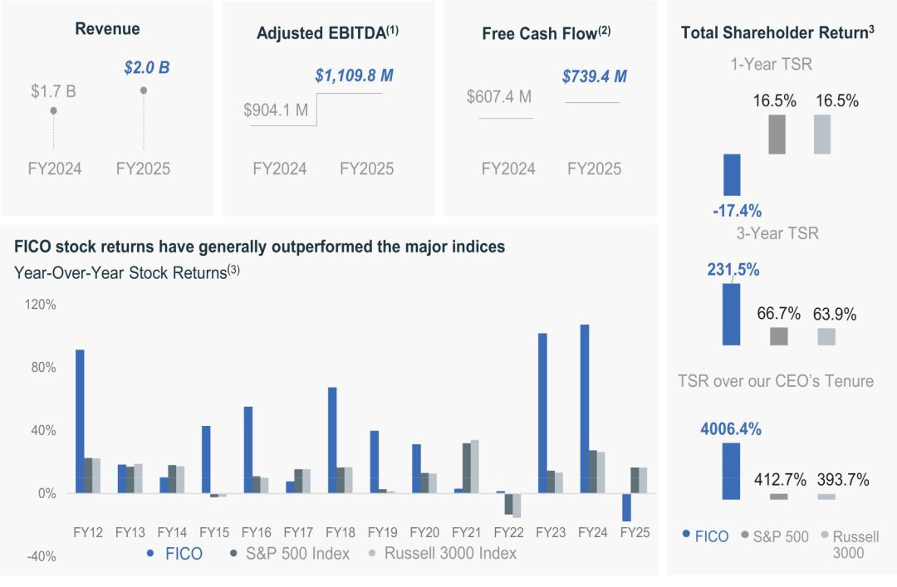

- Adjusted EBITDA is a non-GAAP financial measure and is defined as GAAP net income, adjusted for: interest expense, net; provision for income taxes; other expense (income), net; amortization of intangible assets; depreciation; share-based compensation expense; and restructuring charges, as further adjusted for any impact on revenues related to acquisitions, divestitures or other events deemed by the Leadership Development and Compensation Committee to have been out of management’s control or that may not be indicative of recurring business results and occurring in the measurement year. See Appendix A to this proxy statement for a reconciliation of Adjusted EBITDA to GAAP net income, the most directly comparable GAAP financial measure.

- Free cash flow is a non-GAAP financial measure and is defined as GAAP net cash provided by operating activities, less capital expenditures. See Appendix A to this proxy statement for a reconciliation of free cash flow to GAAP net cash provided by operating activities, the most directly comparable GAAP financial measure.

- Based on 30-day Average Closing Price as of FICO’s September 30 fiscal year end.

Fair Isaac Corporation l 2026 Proxy Statement 5

Table of Contents

 | Proxy | Board of | Corporate | Executive | Audit Committee | Charter | Stock | Other
 | Summary | Directors | Governance | Compensation | Matters | Amendments | Ownership | Matters

Corporate Governance Highlights


Board and Committee Summary

Number of Director Nominees | 8
Number of Independent Director Nominees | 7
Board Committees Consist Entirely of Independent Directors | Yes
All Directors Attended at least 75% of Meetings Held | Yes
Annual Election of All Directors | Yes
Majority Voting for Directors | Yes
Plurality Carveout for Contested Elections | Yes
Director Resignation Policy | Yes
Separate Chairman and CEO | Yes
Chairman is Independent Director | Yes
Independent Directors Meet Regularly in Executive Session | Yes
Annual Board and Committee Self-Evaluations | Yes
Risk Oversight by Full Board and Committees | Yes
Annual Advisory Vote on Executive Compensation | Yes
Prohibit Hedging and Short Sales of FICO Securities | Yes
Stock Ownership Requirements for Directors and Executive Officers | Yes
Executive Compensation Recovery Policy | Yes
Stockholder Rights Summary
Controlled Company | No
Classified Board | No
Vote Standard for Charter or Bylaw Amendment | Majority*
Stockholder Ability to Call Special Meetings | No
Stockholder Ability to Act by Written Consent | Yes
Cumulative Voting | No
Board Ability to Issue Blank-Check Preferred Stock | Yes
Poison Pill | No

- “Majority” with respect to the vote standard for a charter or bylaw amendment refers to the affirmative vote of the holders of a majority of the outstanding shares of the Company entitled to vote thereon. It further assumes that the sole supermajority provision in the Company’s Charter is eliminated, as further described in Proposal 5 in this proxy statement.

Fair Isaac Corporation l 2026 Proxy Statement 6

Table of Contents

 | Proxy | Board of | Corporate | Executive | Audit Committee | Charter | Stock | Other
 | Summary | Directors | Governance | Compensation | Matters | Amendments | Ownership | Matters

Compensation Snapshot

Our compensation strategy is based on a pay-for-performance philosophy, emphasizing variable pay and long-term incentives. This structure aligns the financial goals of our named executive officers with those of our stockholders. Please refer to the Executive Compensation section for further details.

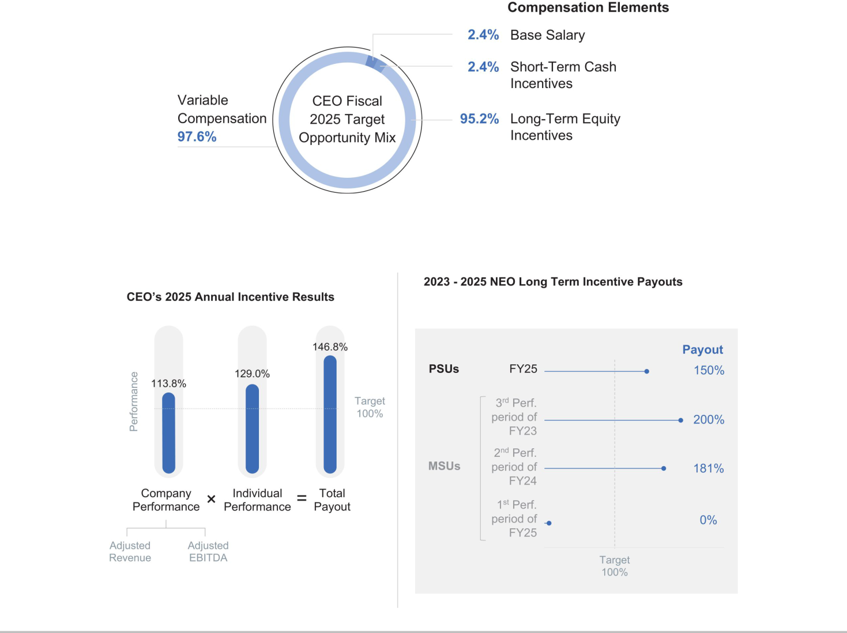

Fair Isaac Corporation l 2026 Proxy Statement 7

Table of Contents

 | Proxy | Board of | Corporate | Executive | Audit Committee | Charter | Stock | Other
 | Summary | Directors | Governance | Compensation | Matters | Amendments | Ownership | Matters

Compensation Highlights

Our compensation program is administered by our Leadership Development and Compensation Committee (the “LDCC”) and seeks to closely link the financial interests of our Company’s executives with those of our stockholders. In making compensation decisions at the outset of fiscal 2025 and throughout the year, the LDCC sought to reinforce strong linkage between Company performance and executive compensation. In keeping with this objective, the LDCC continued to focus on prominently featuring performance-based cash and equity-based incentives.

WHAT WE DO

Linking Pay to Performance

We closely link performance-based rewards with the achievement of performance goals.

Capping Payouts to Discourage Risk

We cap payouts under our plans to discourage excessive or inappropriate risk taking by our executives.

Two-Thirds of Incentives Are Performance-Based

Two-thirds of our annual long-term incentives are performance-based.

Emphasize Long-Term Equity Compensation

We emphasize long-term incentives to align executives’ interests with those of our stockholders.

Reasonable Change-in-Control Arrangements

We have double-trigger change in control provisions.

Stock Ownership Requirements

Independent Compensation Consultant

The LDCC retains an independent compensation consultant.

Annual Compensation Review and Engagement

We hold an annual advisory vote on executive compensation and seek stockholder feedback through engagement.

Compensation Recovery Policies

We have compensation recovery, or “clawback,” policies pertaining to incentive-based compensation.

Minimum Vesting Period for Equity Awards

We have a mandatory minimum vesting period of one year for equity awards.

Limits on Equity Award Value

We limit the aggregate fair value of equity awards granted in any calendar year.

We have stock ownership guidelines that require non- employee directors and executive officers to own a specified amount of stock within five years of their initial election or appointment.

Peer Group Comparisons

We have a peer group comprised of companies of similar size and from relevant industries.

WHAT WE DO NOT DO

No Guaranteed Bonuses

Our compensation plans do not have minimum guaranteed payout levels.

No Hedging or Short-Sales

We do not permit hedging or short sales of our stock.

Stockholder Approval for Option Repricing

We do not permit repricing of underwater stock options without stockholder approval.

Limited Tax “Gross-Ups” or Payments

We do not provide tax gross-ups for our executives (other than with respect to relocation benefits, required spousal travel and certain required regulatory filings).

Limited Executive Perquisites

We do not provide material perquisites.

Fair Isaac Corporation l 2026 Proxy Statement 8

Table of Contents

 | Proxy | Board of | Corporate |  | Executive | Audit Committee | Charter | Stock |  | Other
 | Summary | Directors | Governance |  | Compensation | Matters | Amendments | Ownership |  | Matters
Director Nominees
 |  |  | Years as |  |  |  |  |  | Committee Memberships
Name |  | Age | Director | Principal Occupation |  |  | Independent |  | AC¹ | GNEC² | LDCC³


Braden R. Kelly | 55 | 13
Fabiola R. | 59 | 6
Arredondo | 59 | 6
William J. | 67 | 20
Lansing | 67 | 20
Eva Manolis | 62 | 7
Marc F. McMorris | 57 | 10
Joanna Rees | 64 | 11
David A. Rey | 75 | 15
H. Tayloe | 64 | 2
Stansbury | 64 | 2

Former Partner of Health Evolution Partners

Managing Partner of Siempre Holdings LLC

Chief Executive Officer of Fair Isaac Corporation

Former Vice President of Amazon.com, Inc.

Co-Chief Executive Officer and Co-Founder of Carrick Capital Partners, LLC

Chairman of West Global

Former Executive Vice President and Chief Client Relationship Officer of UnitedHealth Group

Chief Executive Officer of Kaleidescape, Inc.

✓
✓

✓

✓

✓

- 

AC¹ | Audit Committee | Chair
GNEC² | Governance, Nominating and Executive Committee | Member
LDCC³ | Leadership Development and Compensation Committee | Audit Committee Financial Expert
 |  | Fair Isaac Corporation l 2026 Proxy Statement 9



Table of Contents

 | Proxy | Board of | Corporate | Executive | Audit Committee | Charter | Stock | Other
 | Summary | Directors | Governance | Compensation | Matters | Amendments | Ownership | Matters

Composition of Director Nominees
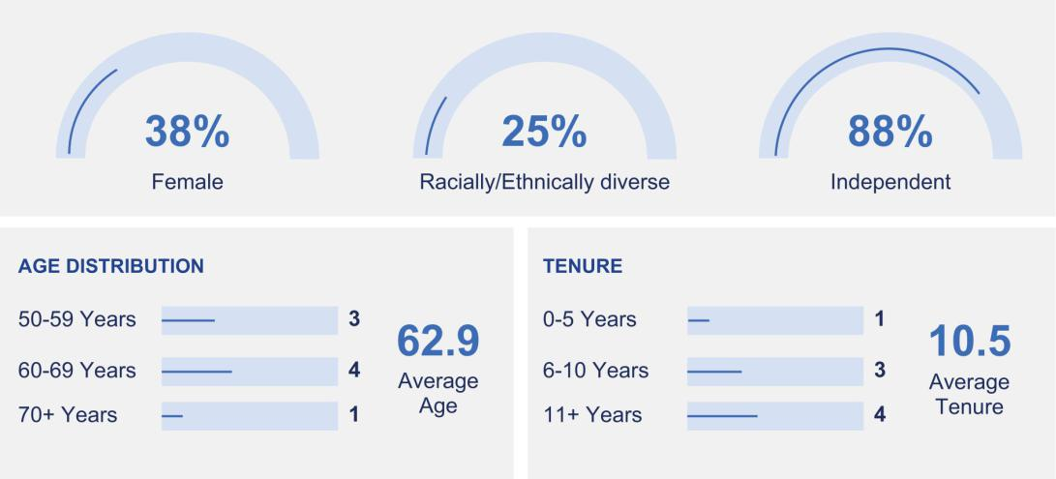

CORE COMPETENCIES |  | STRATEGIC ABILITIES
Skills for day-to-day operations and long-term business sustainability |  | These are specialized abilities that drive innovation,
 |  | competitive advantage, and long-term growth
# Directors |  |  | # Directors
6 | Technology Leadership |  | 4 | Strategy Development
6 | Financial Expertise |  | 4 | Mergers & Acquisitions
5 | Investment Experience |  | 3 | International Business
4 | Executive Leadership |  | 3 | SaaS Experience
2 | Sales & Marketing Intelligence |  | 2 | Cybersecurity Oversight
1 | Risk Management |  | 2 | Cloud-based Software Experience
 |  |  | 1 | Artificial Intelligence Experience

Fair Isaac Corporation l 2026 Proxy Statement 10

Table of Contents

Proxy | Board of |  | Corporate | Executive | Audit Committee | Charter | Stock | Other
Summary | Directors |  | Governance | Compensation | Matters | Amendments | Ownership | Matters
PROPOSAL 1: Election of Directors |  |  |  |  |  | The Board recommends a vote FOR
 |  |  |  |  |  | each nominee


Annual Elections

Directors are elected each year at our annual meeting of stockholders to hold office until our next annual meeting and thereafter until their successors are elected and qualified.

Majority Voting Standard

To be elected, the number of votes cast “FOR” a director nominee must exceed the number of votes cast “AGAINST” that nominee. The Company requires that all nominees submit an irrevocable letter of resignation as a condition to being named as a nominee, which resignation will be effective if (i) the nominee fails to receive a sufficient number of votes to be elected and (ii) the Board of Directors (the “Board” or “Board of Directors”) accepts such resignation. Cumulative voting for the election of directors is not permitted.

Director Nominee Selection Process

Assess the Board’s strategic requirements and target competencies

The Governance, Nominating and Executive Committee assesses the Board’s current makeup and considers the need to bring in expertise to align with Company goals.

Source and Evaluate Potential Candidates

The Governance, Nominating and Executive Committee actively seeks candidates who possess recognized achievements and relevant skills that complement the Board’s strategic goals. They evaluate individuals not only for their skills and experience but also for their ability to contribute varied perspectives.

Recommend Nominees to the Committee

Present the shortlisted candidates to the Governance, Nominating and Executive Committee for review and recommendation.

Secure Full Board Approval

Obtain unanimous approval from the full Board on the proposed nominees.

Stockholder Election

Finalize the slate of approved nominees and present them for election or re-election at the Annual Meeting by stockholder vote.

Based on the recommendation of the Governance, Nominating and Executive Committee, the Board has nominated for election at the Annual Meeting the eight directors named below, each of whom currently serves on the Board. Each of the nominees has consented to being named in this proxy statement and to serve on the Board if elected.

Fair Isaac Corporation l 2026 Proxy Statement 11

Table of Contents

Proxy | Board of |  | Corporate | Executive | Audit Committee | Charter | Stock | Other
Summary | Directors |  | Governance | Compensation | Matters | Amendments | Ownership | Matters

Director Nominee Skills and Experience Matrix

The director nominee skills and experience matrix below identifies some of the key skills and experiences the Board has identified as being important to its responsibilities and reflects how the director nominees, individually and in the aggregate, reflect these skills.

Technology leadership |  | ● |  | ● | ● | ● | ● |  | ●
Executive leadership |  |  |  | ● | ● |  | ● |  | ●
Financial expertise |  | ● |  | ● |  | ● | ● | ● | ●
Investment experience |  | ● | ● |  |  | ● | ● |  | ●
Strategy development |  | ● | ● | ● |  |  |  | ●
International business |  | ● | ● |  |  |  |  | ●
Cybersecurity oversight |  |  |  |  |  |  |  | ● | ●
Mergers and acquisitions |  | ● | ● |  |  | ● |  |  | ●
Software as a service (“SaaS”) experience |  |  |  | ● |  | ● |  |  | ●
Cloud-based software experience |  |  |  |  | ● |  |  |  | ●
Artificial intelligence experience |  |  |  |  |  |  |  |  | ●
Sales and marketing intelligence |  |  | ● |  |  |  | ●
Risk management |  |  |  | ●













A mark indicates a specific area of focus or expertise that the director brings to our Board. The matrix above does not encompass all of the knowledge, skills and experience of our directors, and the fact that a particular knowledge, skill or experience is not listed does not mean that a director does not possess it. In addition, the absence of a particular knowledge, skill or experience with respect to any of our directors does not mean the director in question is unable to contribute to the decision-making process in that area.

Fair Isaac Corporation l 2026 Proxy Statement 12

Table of Contents

Proxy | Board of |  | Corporate | Executive | Audit Committee | Charter | Stock | Other
Summary | Directors |  | Governance | Compensation | Matters | Amendments | Ownership | Matters

Director Nominees


Braden R. Kelly

Chairman of the Board (since 2016) Director (since 2013) Age 55

Independent

Professional Experience

Health Evolution Partners

- Partner (2015 to December 2025)

- Investment Partner (2013 to 2014)

- Senior Advisor (2008 to 2013)

General Atlantic Partners LLC (1995 to 2006)

• Employee u Partner and Managing Director Morgan Stanley & Co. (1993 to 1995)

- Member of mergers, acquisitions and restructuring department (Investment banking division)

Committee Assignments

Chair

Governance, Nominating and Executive Committee

Member

Leadership Development and Compensation Committee

Education

Bachelor of Business Administration degree in finance and business economics from the University of Notre Dame

Expertise, Strategic Capabilities, and Key Competencies
• | Financial expertise | • | Strategy development
• | Investment experience | • | Mergers & Acquisitions
• | Technology leadership | • | International business



Fabiola R. Arredondo

Director (since 2020)

Age 59

Independent

Professional Experience

Managing Partner at Siempre Holdings (since 2001)

Previously held senior operating roles at:

- Yahoo! Inc.

- British Broadcasting Corporation (BBC)

- Bertelsmann SE & Co. KGaA

Board of Governors of FINRA (since December 2022)

Committee Assignments

Member

Leadership Development and Compensation Committee

Education

Bachelor of Arts degree in political science from Stanford

University, and an M.B.A. from Harvard Business School

Other Public Company Board Experience

- The Campbell’s Company (since 2017)

- Burberry PLC (2015 to July 2025)

- Experian PLC (2007 to 2016)

Expertise, Strategic Capabilities, and Key Competencies

• | Investment experience | • | International business
• | Mergers & Acquisitions | • | Sales and marketing intelligence
• | Strategy development

Fair Isaac Corporation l 2026 Proxy Statement 13

Table of Contents

Proxy | Board of |  | Corporate | Executive |  | Audit Committee | Charter | Stock | Other
Summary | Directors |  | Governance | Compensation |  | Matters | Amendments | Ownership | Matters


William J. Lansing

Director (since 2006)

Age 67

Non-Independent

Professional Experience

Chief Executive Officer

- Fair Isaac Corporation (since 2012)

- Infospace, Inc. (2009 to 2010)

- ValueVision Media, Inc. (2004 to 2007)

- NBC Internet, Inc. (2000 to 2001)

- Fingerhut Companies, Inc. (1998 to 2000)

General Partner at General Atlantic LLC (2001 to 2003)

Vice President, Corporate Business Development at General Electric Company (1996 to 1998)

Chief Operating Officer/Executive Vice President at Prodigy, Inc. (in 1996)

Partner, McKinsey & Company (1987 to 1996)

Committee Assignments

None

Education

Bachelor of Arts degree in English from Wesleyan University and a J.D. from Georgetown University

Other Public Company Board Experience

• Shutterfly, Inc. (2017 to 2019)

Expertise, Strategic Capabilities, and Key Competencies

• | Executive leadership | • | Risk management
• | Technology leadership | • | Financial expertise
• | Strategy development | • | SaaS experience


Eva Manolis

Director (since 2018)

Age 62

Independent

Professional Experience

Amazon.com, Inc.

• Vice President (2005 to 2016)

Senior Vice President

- KeepMedia Inc. (2002 to 2005)

- Shutterfly, Inc. (1999 to 2002)

Committee Assignments

Member

Leadership Development and Compensation Committee

Education

Bachelor of Science and Master of Science

degrees in electrical engineering from Brown
University

Other Public Company Board Experience

- iRobot Corporation (since 2019)

- Shutterfly, Inc. (2016 to 2019)

Expertise, Strategic Capabilities, and Key Competencies

• Executive leadership • Cloud-based software experience

• Technology leadership

Fair Isaac Corporation l 2026 Proxy Statement 14

Table of Contents

Proxy | Board of |  | Corporate | Executive |  | Audit Committee | Charter | Stock | Other
Summary | Directors |  | Governance | Compensation |  | Matters | Amendments | Ownership | Matters


Marc F. McMorris

Director (since 2015)

Age 57

Independent

Professional Experience

Carrick Capital Partners

- Co-Chief Executive Officer (since March 2021)

- Co-Founder and Managing Director (2012 to March 2021)

Managing Director at General Atlantic, LLC (2003 to 2011)

Committee Assignments

Member

Audit Committee

Education

Bachelor of Arts degree in economics from the

University of Pennsylvania and an M.B.A. from the Wharton School of the University of Pennsylvania

Expertise, Strategic Capabilities, and Key Competencies

• Financial expertise • Mergers & Acquisitions

• Technology leadership • Investment experience

• SaaS experience


Joanna Rees

Director (since 2015)

Age 64

Independent

Professional Experience

Chairman of West Global

(since November 2023)

Managing Partner of West.Ventures (since 2016)

Chair of the California Workforce Development Board (since June 2025)

Managing Director of Soda Rock Partners (2012 to 2016)

Founded VSP Capital (in 1996) and served as Managing Partner (1996 to 2011)

Various senior marketing management positions, including head of new product development at Groupe Danone (1984 to 1989)

Benton & Bowles (now DMB&B), working on multiple consumer brands (1983 to 1984)

Committee Assignments

Chair

Leadership Development and Compensation Committee

Member

Governance, Nominating and Executive Committee

Education

Bachelor of Science degree in psychology from

Duke University and an M.B.A. from Columbia Business School, Columbia University

Expertise, Strategic Capabilities, and Key Competencies

• | Investment experience | • | Financial expertise
• | Executive leadership | • | Sales and marketing intelligence
• | Technology leadership

Fair Isaac Corporation l 2026 Proxy Statement 15

Table of Contents

Proxy | Board of |  | Corporate | Executive |  |  | Audit Committee | Charter |  | Stock | Other
Summary | Directors |  | Governance | Compensation |  |  | Matters | Amendments |  | Ownership | Matters
David A. Rey |  |  |  |  | Committee Assignments
Director (since 2011) |  |  |  |  | Chair
Age 75 |  |  |  |  | Audit Committee
Independent |  |  |  |  | Member
 |  |  |  |  | Governance, Nominating and Executive Committee
Professional Experience |  |  |  |  | Education
UnitedHealth Group (2008 to 2011) |  |  |  |  | Bachelor of Science degree in industrial engineering and
• Executive Vice President and Chief Client |  |  |  |  | operations research from the University of California, Berkeley
Relationship Officer |  |  |  |  | Expertise, Strategic Capabilities, and Key Competencies
Accenture Ltd (1972 to 2008)
 |  |  |  |  | • | Strategy development |  | • | Cybersecurity oversight
• Employee u Partner |  |  |  |  | • | Financial expertise |  | • | International business


H. Tayloe Stansbury

Director (since 2023)

Age 64

Independent

Professional Experience

Chairman (since August 2021) and Chief Executive Officer (since November 2020) of Kaleidescape

Interim Chief Executive Officer of Watermark Insights, LLC (July 2020 to November 2020)

Various roles including Executive Vice President and Chief Technology Officer at Intuit Inc. (2009 to 2019)

Chief Information Officer of VMware Inc. (2007 to 2009)

Various roles including Executive Vice President of Products and Operations at Ariba, Inc. (2001 to 2007)

Committee Assignments

Member

Audit Committee

Education

A.B. degree in applied mathematics from Harvard University

Other Public Company Board Experience

- Coupa Software Incorporated (2015 to February 2023)

- TCV Acquisition Corp. (April 2021 to March 2023)

- Shutterfly, Inc. (2016 to 2019)

Expertise, Strategic Capabilities, and Key Competencies

• | Executive leadership | • | Financial expertise
• | Cloud-based software experience | • | Investment experience
• | Artificial intelligence experience | • | Mergers and acquisitions
• | Cybersecurity oversight | • | SaaS experience
• | Technology leadership

Fair Isaac Corporation l 2026 Proxy Statement 16

Table of Contents

Proxy | Board of | Corporate |  | Executive | Audit Committee | Charter | Stock | Other
Summary | Directors | Governance |  | Compensation | Matters | Amendments | Ownership | Matters

CORPORATE GOVERNANCE

Board Leadership Structure

The Board of Directors does not have a policy with respect to the separation of the offices of Chairman of the Board and Chief Executive Officer. The Board of Directors believes that it is in the best interest of the Company for the Board of Directors to make a determination on this matter when it appoints a new Chief Executive Officer or Chairman. The Board of Directors has determined that, currently, the most effective leadership structure is to have a separate Chairman of the Board, a position held by Mr. Kelly since February 2016, and Chief Executive Officer, a position held by Mr. Lansing since January 2012, as it provides us the best access to the judgments and experience of both individuals while providing a mechanism for the Board’s independent oversight of management. As a result, the Chairman presides over the meetings of the Board of Directors and the stockholders, and the Chief Executive Officer is allowed more time to focus energies on the management of the Company’s business.

- The roles and responsibilities of the Independent Chairman include:

  - Scheduling, in connection with management and chairs of the standing committees, regular and special meetings of the Board

  - Presiding at all Board meetings, executive sessions and stockholder meetings

  - Advising the CEO of decisions reached and suggestions made at the executive sessions of the independent directors

  - Facilitating communication between the directors and management

  - Meeting directly with management and other employees of the Company, as needed

  - Being available for consultation and direct communication with stockholders

Board Risk Oversight Role

Our management is responsible for identifying the various risks facing the Company, formulating risk management policies and procedures, and managing the Company’s risk exposures. Our Board of Directors’ responsibility is to monitor the Company’s risk management processes by informing itself concerning our material risks and evaluating whether management has reasonable controls in place to address the material risks. While the Board as a whole maintains the ultimate oversight responsibility for risk management, the committees of the Board are assigned responsibility for risk management oversight of specific areas, as detailed in the chart below.

Fair Isaac Corporation l 2026 Proxy Statement 17

Table of Contents

Proxy | Board of | Corporate |  | Executive | Audit Committee | Charter | Stock | Other
Summary | Directors | Governance |  | Compensation | Matters | Amendments | Ownership | Matters
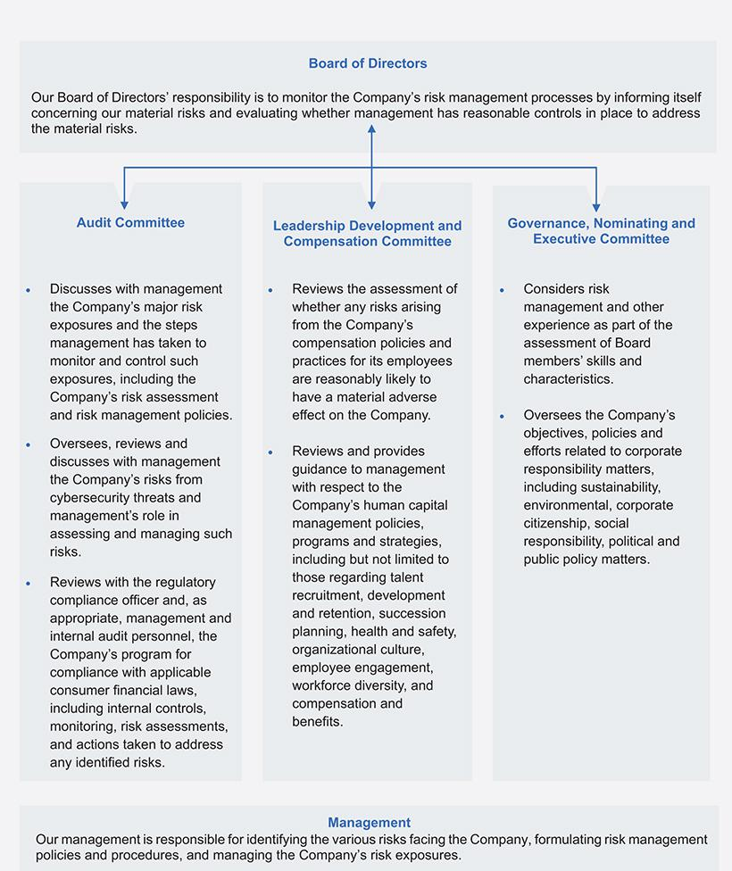

Fair Isaac Corporation l 2026 Proxy Statement 18

Table of Contents

Proxy | Board of | Corporate |  | Executive | Audit Committee | Charter | Stock | Other
Summary | Directors | Governance |  | Compensation | Matters | Amendments | Ownership | Matters

Executive Compensation Risk Oversight

We continually assess the structure of the Company’s compensation programs in the context of recognized best practices. Each year, management reviews our compensation programs to assess risks arising from our policies and practices and presents its findings to the LDCC. The most recent assessment found appropriate risk mitigation features in our compensation programs, including:

- total compensation consists of a mix of fixed and variable elements, and a significant portion of our executive officers’ target total direct compensation comes in the form of long-term equity incentive awards that are earned over several years;

- the stock ownership guidelines in place for our executive officers work to align their long-term interests with those of our stockholders;

- our short-term cash incentive plan applicable to executive officers and other employees is structured to reward achievement of diverse goals, some of which are tied to Company-wide performance and some of which are tied to business unit performance, but all of which are designed to benefit the Company and our stockholders on a long-term basis;

- under the short-term cash incentive plan, award maximums, or “caps,” are in place to prevent windfalls;

- the LDCC retains discretion to adjust awards under the short-term cash incentive plan if a payout determined under the formula is not appropriate in the circumstances; and

- our system of internal controls places a strong focus on avoiding undue financial risk through rigorous review processes.

In light of the risk-limiting features of our compensation policies and practices, the Company has concluded that any risks arising from its compensation policies and practices for its employees are not reasonably likely to have a material adverse effect on the Company.

Attendance at Board Meetings

During fiscal 2025, the Board of Directors met four times. Each director attended at least 75% of the aggregate of the total number of meetings of the Board of Directors and the total number of meetings held by all committees of the Board on which such director served.

All Board members are expected to attend our annual meetings of stockholders. All directors then standing for election attended the 2025 annual meeting.

Our Corporate Governance Guidelines provide that independent directors will meet in executive session without the Chief Executive Officer or other management present at each regular Board meeting. Braden R. Kelly, the Chairman of the Board, is independent and presides at executive sessions held in accordance with our Corporate Governance Guidelines.

Board Self-Evaluation Process

The Board of Directors and committees conduct annual self-evaluations to assess the qualifications, attributes, skills and experience represented on the Board and to determine whether the Board and its committees are functioning effectively. On an annual basis, each director completes written individual director, Board and committee evaluation questionnaires. The questionnaire responses are then aggregated without individual attribution. Our Independent Chairman, on behalf of the Governance, Nominating and Executive Committee, references the response summaries and conducts a discussion with the Board regarding Board and committee effectiveness and engagement in independent executive sessions.

Fair Isaac Corporation l 2026 Proxy Statement 19

Table of Contents

Proxy | Board of | Corporate |  | Executive | Audit Committee | Charter | Stock | Other
Summary | Directors | Governance |  | Compensation | Matters | Amendments | Ownership | Matters

Board Committees

Our Board has three standing committees: Audit; Leadership Development and Compensation; and Governance, Nominating and Executive. All of the members of the committees are independent directors under the applicable SEC rules and NYSE listing standards. Each committee’s charter expressly provides that the committee has the sole discretion to retain, compensate, and terminate its advisors. Current copies of the charters of the three committees are available on the “Investors” page of our website at www.fico.com.

Audit Committee


Committee Highlights |  |  |  |  | Primary Responsibilities
 |  |  |  |  | ● Assists the Board in overseeing the integrity of our financial
8 | Members
8 | Members |  |  |  | statements
Meetings | David A. Rey (Chair) |  |  |  | statements
Fiscal 2025 | Marc F. McMorris |  |  |  | ● Oversees the qualifications and independence of our independent
 | H. Tayloe Stansbury |  |  |  | auditor
 |  |  |  |  | ● Oversees performance of our internal audit function and independent
Independence |  |  |  |  | auditor
Each member of the Audit Committee is |  |  |  |  | ● Oversees our Company’s compliance program, including codes of
independent as defined in Rule 10A-3 adopted |  |  |  |  | conduct, as well as compliance with legal and regulatory
pursuant to the Sarbanes-Oxley Act of 2002 and in |  |  |  |  | requirements related to financial affairs and reporting
the NYSE listing rules. |  |  |  |  | ● Appoints, retains, compensates, and replaces the independent
The Board determined that all members of the Audit
 |  |  |  |  | auditor
Committee are financially literate under NYSE listing |  |  |  |  | ● Reviews the audited financial statements with management and the
rules, and that each of Messrs. McMorris, Rey and
Stansbury is an “audit committee financial expert” |  |  |  |  | independent auditor, and on an annual basis provides an Audit
under the SEC regulations. |  |  |  |  | Committee Report wherein it states that it recommends to the Board
 |  |  |  |  | that the audited financial statements be included in our Annual
 |  |  |  |  | Report on Form 10-K
 |  |  |  |  | ● Oversees, reviews and discusses with management the Company’s
 |  |  |  |  | risks from cybersecurity threats and management’s role in assessing
 |  |  |  |  | and managing such risks



Fair Isaac Corporation l 2026 Proxy Statement 20

Table of Contents

 |  |  |  | Proxy | Board of |  | Corporate |  | Executive |  |  | Audit Committee | Charter | Stock | Other
 |  |  |  | Summary | Directors |  | Governance |  | Compensation |  |  | Matters | Amendments | Ownership | Matters
 |  |  |  | Leadership Development and Compensation Committee
 |  | Committee Highlights |  |  |  |  |  |  |  |  |  | Primary Responsibilities
 |  | 7 |  |  |  | Members |  |  |  |  |  | ● Overall oversight responsibility for the directors’ and executive
 |  |  |  |  |  |  |  |  |  |  |  | officers’ compensation plans and the compensation policies and
 |  |  |  | Meetings |  | Joanna Rees (Chair)
 |  |  |  |  |  |  |  |  |  |  |  | programs of the Company
 |  |  | Fiscal 2025 |  |  | Fabiola R. Arredondo
 |  |  |  |  |  | Braden R. Kelly |  |  |  |  |  | ● Reviews and approves the level and terms of the executive officers’
 |  |  |  |  |  | Eva Manolis |  |  |  |  |  | annual and long-term compensation
 |  |  |  |  |  |  |  |  |  |  |  | ● Evaluates the performance of the CEO and other executive officers of
 |  | Independence |  |  |  |  |  |  |  |  |  | the Company
 |  | Each member of the Leadership Development and |  |  |  |  |  |  |  |  |  | ● Administers the Company’s long-term incentive plans, as well as
 |  | Compensation Committee is independent as |  |  |  |  |  |  |  |  |  | makes recommendations to the Board of Directors regarding the
 |  | required by the NYSE listing rules. |  |  |  |  |  |  |  |  |  | adoption of other incentive plans
 |  |  |  |  |  |  |  |  |  |  |  | ● Makes recommendations to the Governance, Nominating and
 |  | Interlocks and Insider Participation |  |  |  |  |  |  |  |  |  | Executive Committee with respect to the form and amount of director
 |  | None of the members of the Leadership |  |  |  |  |  |  |  |  |  | compensation, and, jointly with the Governance, Nominating and
 |  | Development and Compensation Committee serves |  |  |  |  |  |  |  |  |  | Executive Committee, recommends changes in director
 |  | or has served as an officer or employee of FICO. |  |  |  |  |  |  |  |  |  | compensation to the Board
 |  | None of our executive officers serves or has served |  |  |  |  |  |  |  |  |  | ● Monitors compliance by directors and officers with the Company’s
 |  | on the board of directors or compensation
 |  |  |  |  |  |  |  |  |  |  |  | stock ownership guidelines
 |  | committee of another entity that has an executive
 |  |  |  |  |  |  |  |  |  |  |  | ● Solicits input from independent directors and periodically reviews and
 |  | officer serving on the Board or the Leadership
 |  | Development and Compensation Committee. |  |  |  |  |  |  |  |  |  | reports to the Board with respect to succession planning for the Chief
 |  |  |  |  |  |  |  |  |  |  |  | Executive Officer and other senior management positions
 |  |  |  |  |  |  |  |  |  |  |  | ● Regularly reviews and provides guidance to management with
 |  |  |  |  |  |  |  |  |  |  |  | respect to the Company’s human capital management policies,
 |  |  |  |  |  |  |  |  |  |  |  | programs and strategies, including but not limited to those regarding
 |  |  |  |  |  |  |  |  |  |  |  | talent recruitment, development and retention, succession planning,
 |  |  |  |  |  |  |  |  |  |  |  | health and safety, organizational culture, employee engagement,
 |  |  |  |  |  |  |  |  |  |  |  | workforce diversity, and compensation and benefits
 |  |  |  |  |  |  |  |  |  |  |  | ● Oversees and administers the Company’s policies, plans and
 |  |  |  |  |  |  |  |  |  |  |  | agreements concerning the recovery of incentive compensation
 |  |  |  |  |  |  |  |  |  |  |  | Fair Isaac Corporation l 2026 Proxy Statement 21


Table of Contents

 |  |  |  | Proxy | Board of |  | Corporate |  | Executive |  |  | Audit Committee | Charter | Stock | Other
 |  |  |  | Summary | Directors |  | Governance |  | Compensation |  |  | Matters | Amendments | Ownership | Matters
 |  |  |  | Governance, Nominating and Executive Committee
 |  | Committee Highlights |  |  |  |  |  |  |  |  |  | Primary Responsibilities
 |  | 4 |  |  |  | Members |  |  |  |  |  | ● Reviews annually with the Board the composition (e.g., skills,
 |  |  |  |  |  |  |  |  |  |  |  | experience, diversity, age) of the Board, the requisite skills and
 |  |  |  | Meetings |  | Braden R. Kelly (Chair)
 |  |  |  |  |  |  |  |  |  |  |  | characteristics of new Board members, and the performance and
 |  |  | Fiscal 2025 |  |  | Joanna Rees
 |  |  |  |  |  |  |  |  |  |  |  | continued tenure of incumbent Board members
 |  |  |  |  |  | David A. Rey
 |  |  |  |  |  |  |  |  |  |  |  | ● Seeks individuals qualified to become Board members for
 |  |  |  |  |  |  |  |  |  |  |  | recommendation to the Board
 |  | Independence
 |  |  |  |  |  |  |  |  |  |  |  | ● Develops and recommends to the Board the criteria for identifying
 |  | Each member of the Governance, Nominating and |  |  |  |  |  |  |  |  |  | and evaluating director candidates, and recommends candidates for
 |  | Executive Committee is independent as required by |  |  |  |  |  |  |  |  |  | election or reelection to the Board
 |  | the NYSE listing rules. |  |  |  |  |  |  |  |  |  | ● Leads the Board in an annual evaluation of the Board’s performance,
 |  |  |  |  |  |  |  |  |  |  |  | reports annually to the Board on the results of the evaluation, and
 |  |  |  |  |  |  |  |  |  |  |  | oversees the annual evaluation of the Board’s committees, and the
 |  |  |  |  |  |  |  |  |  |  |  | self-evaluation of individual directors
 |  |  |  |  |  |  |  |  |  |  |  | ● Establishes the agenda for each Board meeting in cooperation with
 |  |  |  |  |  |  |  |  |  |  |  | the CEO and appropriate senior management
 |  |  |  |  |  |  |  |  |  |  |  | ● Recommends to the Board the membership of the standing
 |  |  |  |  |  |  |  |  |  |  |  | committees of the Board
 |  |  |  |  |  |  |  |  |  |  |  | ● Annually reviews and reassesses the adequacy of the Corporate
 |  |  |  |  |  |  |  |  |  |  |  | Governance Guidelines and recommends any proposed changes to
 |  |  |  |  |  |  |  |  |  |  |  | the Board for approval
 |  |  |  |  |  |  |  |  |  |  |  | ● Has general oversight of the Company’s objectives, policies and
 |  |  |  |  |  |  |  |  |  |  |  | efforts related to corporate responsibility matters, including
 |  |  |  |  |  |  |  |  |  |  |  | sustainability, environmental, corporate citizenship, social
 |  |  |  |  |  |  |  |  |  |  |  | responsibility, political and public policy matters
 |  |  |  |  |  |  |  |  |  |  |  | ● Receives recommendations of the Leadership Development and
 |  |  |  |  |  |  |  |  |  |  |  | Compensation Committee with respect to the form and amount of
 |  |  |  |  |  |  |  |  |  |  |  | director compensation, and, jointly with the Leadership Development
 |  |  |  |  |  |  |  |  |  |  |  | and Compensation Committee, recommends changes in director
 |  |  |  |  |  |  |  |  |  |  |  | compensation to the Board
 |  |  |  |  |  |  |  |  |  |  |  | ● Takes action in accordance with Board policy with respect to
 |  |  |  |  |  |  |  |  |  |  |  | investment, budget and capital and exploratory expenditure matters
 |  |  |  |  |  |  |  |  |  |  |  | arising in the normal course of the Company’s business as the same
 |  |  |  |  |  |  |  |  |  |  |  | may from time to time be conducted, subject to such threshold limits
 |  |  |  |  |  |  |  |  |  |  |  | as are set from time to time by the Board
 |  |  |  |  |  |  |  |  |  |  |  | ● Takes action pertaining to selling, leasing, pledging, mortgaging or
 |  |  |  |  |  |  |  |  |  |  |  | otherwise disposing of property or assets of the Company, subject to
 |  |  |  |  |  |  |  |  |  |  |  | such threshold limits as are set forth from time to time by the Board
 |  |  |  |  |  |  |  |  |  |  |  | Fair Isaac Corporation l 2026 Proxy Statement 22


Table of Contents

Proxy | Board of | Corporate |  | Executive | Audit Committee | Charter | Stock | Other
Summary | Directors | Governance |  | Compensation | Matters | Amendments | Ownership | Matters

Stockholder-Recommended Director Candidates

Our Governance, Nominating and Executive Committee considers director candidates recommended by stockholders who are entitled to vote for the election of directors at the Annual Meeting and comply with the notice procedures described below. An eligible stockholder who wishes to nominate a candidate must send a written notice to the FICO Corporate Secretary, 5 West Mendenhall, Suite 105, Bozeman, Montana 59715. Each notice must include the following information about the nominee:

- Name, age, and business and residence addresses;

- Principal occupation or employment;

- Class, series and number of shares of FICO beneficially owned, and additional detailed “ownership information” regarding derivatives, voting arrangements, dividend interests, and related matters (as described in detail in our Bylaws);

- A statement of the person’s citizenship;

- Any other information that must be disclosed about nominees in proxy solicitations pursuant to Section 14 of the Securities Exchange Act of 1934, as amended (the “Exchange Act”), and the rules and regulations promulgated thereunder (including the nominee’s written consent to be named as a nominee and to serve as a director if elected); and

- A written statement from the nominee as to whether such nominee, if elected, intends to tender, promptly following his or her election or re-election, an irrevocable resignation effective upon (i) his or her failure to receive the required vote for re-election at any meeting at which he or she would face re-election and (ii) acceptance of such resignation by the Board.

Each notice must also include the following information about the nominating stockholder and any beneficial owner on whose behalf the nomination is made:

- The name and address, as they appear in our records;

- The class, series and number of shares of FICO beneficially owned, and additional detailed “ownership information” regarding derivatives, voting arrangements, dividend interests, and related matters (as described in detail in our Bylaws);

- A description of all agreements pursuant to which the nomination is being made, and any material interest of such stockholder or beneficial owner, or any affiliates or associates of such person, in such nomination;

- A representation that the stockholder giving notice intends to appear in person or by proxy at the Annual Meeting to nominate the persons named in its notice;

- A representation whether the stockholder or the beneficial owner intends, or is part of a group that intends, to deliver a proxy statement or form of proxy to holders of at least the percentage of FICO’s outstanding shares required to elect the nominee or otherwise solicit proxies from stockholders in support of the nomination; and

- Any other information relating to the person that is required to be disclosed in solicitations for proxies for election of directors pursuant to Section 14 of the Exchange Act, and the rules and regulations promulgated thereunder.

We may require any proposed nominee to furnish such other information as may reasonably be required by us to determine the eligibility of the proposed nominee to serve as a director.

Our Corporate Secretary must receive this information not less than 90 days nor more than 120 days prior to the anniversary date of the immediately preceding annual meeting. In the case of an annual meeting which is held more than 25 days before or after such anniversary date, in order for notice by the stockholder to be considered timely, it must be received no later than the close of business on the 10th day following the date of the first public announcement of the date of the annual meeting.

Fair Isaac Corporation l 2026 Proxy Statement 23

Table of Contents

Proxy | Board of | Corporate |  | Executive | Audit Committee | Charter | Stock | Other
Summary | Directors | Governance |  | Compensation | Matters | Amendments | Ownership | Matters

Environmental, Social and Governance (“ESG”) Matters

We recognize the importance of environmental, social, and governance issues. We have a long-standing commitment to the environment, the communities we call home, our employees, and other stakeholders, and we are proud of our strong governance practices. Our Board and certain of its committees oversee our progress on various ESG initiatives. Additional information regarding our commitment and approach to ESG matters appears on the Corporate Responsibility page of our website at www.fico.com/en/corporate-responsibility. The information on our website is not incorporated herein and is not a part of our proxy solicitation materials.

Fair Isaac Corporation l 2026 Proxy Statement 24

Table of Contents

Proxy | Board of | Corporate |  | Executive | Audit Committee | Charter | Stock | Other
Summary | Directors | Governance |  | Compensation | Matters | Amendments | Ownership | Matters

Human Capital Resources

Human Capital Resources Highlights
Board-level review and oversight of all people programs
Accountability for core values in annual performance assessment process
Structured and recurring talent management and succession planning
Quarterly workforce engagement surveys and action planning
Quarterly town halls to foster transparency and dialogue
Remote and hybrid work location and flexible scheduling policies
Learning management system to promote both technical and leadership skills
Strong culture focus ensuring a strong and attractive employer brand
Employee resource groups to promote mutual understanding and dialogue
Selection processes supported by effective tools and education
Formal intern programs in partnership with top schools
Structured performance management system with behavioral rubrics
Semi-annual, centralized promotion and reward cycles
Employee Stock Purchase Plan with discount and look-back features
Clear career paths for both technical and managerial roles
Competitive health, welfare, and retirement benefit programs
Formal wellness program including education and cash stipends
Paid parental leave policies
Family building and childcare reimbursement benefits
Safe, healthy, and ergonomically-driven work environments
Pre-employment background screening for employees and contingent workers


Our People


As of September 30, 2025, we employed 3,811 persons across 28 countries. Of these, our largest representation included 1,335 (35%) based in the U.S., 1,506 (40%) based in India and 271 (7%) based in the U.K. Other than to the extent mandated by applicable law in certain foreign jurisdictions, none of our employees are covered by a collective bargaining agreement, and no work stoppages were experienced during fiscal 2025.

Our Board of Directors and executive leadership team believe that our people are vital to our success. The LDCC oversees all human capital management policies, programs, and strategies, including but not limited to those regarding talent recruitment, development, retention, succession planning, health and safety, organizational culture, employee engagement, diversity, and compensation and benefit programs. In addition, our Chief Human Resources Officer reports to our Board periodically on people-focused programs.

Three Core Values define our culture and serve to guide behavior and decision-making across our business: Act Like an Owner, Delight Our Customers and Earn the Respect of Others. Our selection process for new talent includes

Fair Isaac Corporation l 2026 Proxy Statement 25

Table of Contents

Proxy | Board of | Corporate |  | Executive | Audit Committee | Charter | Stock | Other
Summary | Directors | Governance |  | Compensation | Matters | Amendments | Ownership | Matters

an evaluation against these values. Each new hire receives a personal welcome memo from the Chief Executive Officer reinforcing these values. In addition, we conduct recurring education sessions for both people managers and individual contributors targeting values-based behaviors. Finally, the performance of each employee is formally evaluated annually against values-based expectations captured in a behaviorally anchored “rubric.”


Employee Engagement

Unlocking the full potential of each individual by gaining their emotional commitment to help drive both personal and company success is an important priority. The resulting discretionary effort provides a powerful force for positive organizational change and ownership. We refer to this as “engagement” and, for the past decade, we have conducted quarterly workforce surveys to measure employee engagement and gain feedback and insights from our people about ways to improve the employee experience and the effectiveness of our business operations. Detailed findings from these surveys are promptly communicated to all employees, individual managers, the executive team, and our Board, and the findings are leveraged to drive positive organizational change. We involve designated human resources business partners and learning consultants who work with senior leaders to explore findings, identify high value actions, and amplify messaging to help our people understand how survey participation can connect to positive change.

Examples of organizational changes that have been driven by the insights from these surveys include investments in expanded workforce capacity, broadened and more frequent company-wide communications, increased employee stock ownership by significantly expanding the use of equity-based awards and encouraging all employees to take advantage of our Employee Stock Purchase Plan, expanded benefit programs including paid parental leave, well-being, family building, childcare reimbursement, and company-funded transportation programs, enhanced incentive plan funding, and expanded investments in professional development targeting leadership and technical skills, as well as initiatives to promote a culture where all employees feel welcome at work.

Because of this ongoing dialogue and related actions, our e-Sat score (“How happy are you working at FICO?”), and each of 22 engagement driver scores from our most recent surveys are at or above our external benchmark scores with our top five scores, relative to external benchmark, being Communication (I feel well-informed about what’s going on at FICO) +13, Action Taking (I believe meaningful action will be taken as a result of this survey) +9, Retention (I rarely think about looking for another job at a different company) +8, Leadership (I have confidence in the leadership team) +7, and Resources (I have the resources needed to do my job well) +7. We closely monitor the “Retention” driver to gain insights and take steps to help mitigate unplanned attrition risk.

As a result of this ongoing dialogue with our people and related action-taking by management, our engagement scores have steadily strengthened and we have enjoyed strong workforce retention over the past year.


Awards and Recognition

Engaging our people, acting on their insights, and investing in organizational culture remain ongoing priorities, and it is encouraging to receive external recognition for these efforts. During fiscal 2025, we received several accolades including: (1) being named by Forbes as one of America’s Best Companies; (2) being named by Newsweek as one of America’s Best Workplaces for Gen Z; and (3) achieving certification from the Great Place to Work Institute and achieving FIA Employee Experience – Amazing Places to Work recognition for our operations in Brazil.


Organizational Culture

FICO is committed to building and reinforcing a culture where all employees feel welcome and where individual perspectives are valued. FICO believes that a highly talented workforce that includes people with a wide range of backgrounds, experiences and perspectives drives innovation while helping us relate to our global customer base. Our goal is to achieve this innovation and connection to our customer base through a culture that attracts the broadest talent audience possible, while always striving to select the most qualified individuals. We also believe that promoting a culture where each individual is truly valued allows our people to reach their full potential. Our FICO Cares organization encourages our people to connect with and contribute to their community. We encourage employees to participate in volunteer activities by providing work schedule flexibility and paid Community Volunteer Leave. We also encourage and match employee cash donations and volunteer time to qualified charitable organizations through our Corporate Matching Gift Program.

Fair Isaac Corporation l 2026 Proxy Statement 26

Table of Contents

Proxy | Board of | Corporate |  | Executive | Audit Committee | Charter | Stock | Other
Summary | Directors | Governance |  | Compensation | Matters | Amendments | Ownership | Matters

Across our global workforce, as of September 30, 2025, the percentage of males and females was 67% and 33%, respectively. Looking at our U.S. workforce, as of September 30, 2025, 46% were racially/ethnically diverse employees who are members of a protected class.

To help ensure understanding of our Commitment to Inclusion and Belonging Policy, as well as our Policy Against Harassment and other foundational and compliance policies, all new hires are provided with a copy of these policies during their onboarding process. In addition, we reinforce the importance of these policies during annual policy reminder communications. To equip our people with appropriate knowledge and outline their responsibilities, all employees receive mandatory training and testing on foundational and compliance policies during the on-boarding process and every two years thereafter, with people managers receiving training regarding their unique leadership responsibilities. As examples, we have a mandatory training program to identify, prevent and combat prohibited harassment.

Additional information on our talent programs is available on the Corporate Responsibility page of our website at www.fico.com/en/corporate-responsibility. Information contained on our website is not deemed part of or incorporated by reference into this proxy statement.


Talent Recruitment

We leverage organizational culture as a competitive advantage in our efforts to attract people from the broadest possible talent pool. This includes marketing our Core Values, opportunities for professional development, competitive compensation and benefit programs, and strong focus on work/life balance and flexible work locations including home-based work. In addition, our job descriptions and public job postings have been written to reflect inclusive language.

We deploy selection practices designed to ensure strong alignment between candidate qualifications and knowledge and skills needed for success in each role, and we invest in hiring manager training focused on effective selection strategies. Further, in the U.S., we detail our targeted base pay ranges on all public job postings and prohibit our recruiters from inquiring about a candidate’s current level of compensation. Our focus on the professional development of our people drives the internal posting of virtually all job opportunities. And, consistent with our remarkably low undesired attrition rate, FICO has significantly strengthened its position as an employer of choice, resulting in attractive external candidate pools.


Professional Development

To support professional development, we offer a structured onboarding program with training specific to a variety of identified career paths to help new employees become rapidly engaged and productive. We have invested in building the FICO Integrated Learning Organization (“ILO”), which is led by our Chief Learning Officer. The ILO develops customized learning content for colleagues, clients, and partners around the world. We deliver high quality, targeted new hire onboarding, technology and product skill training, compliance and management and leadership education through this “FICO Learning” platform. This allows our employees to obtain the knowledge and skills to effectively perform in their current roles, while also preparing them for new opportunities. We also offer financial support for degreed or certificated programs through a tuition reimbursement program.

We have defined specific career paths for all major functions in our organization so that our people understand how they can progress in their career by expanding their knowledge and skills. In doing so, our job titling system reflects both individual contributor (or technical) career tracks and people management career tracks to reinforce our philosophy that people can grow professionally in either track.

To further consistent administration, we conduct annual company-wide performance reviews supported by the use of performance rubrics for each major function. These rubrics set forth clear behavioral expectations for each function through a set of objective descriptors organized across our three levels of performance (Improvement Needed, Achieved Expectations, and Outstanding). In addition to rubrics, outcome-based goals are established for each individual based upon his/her specific role and priorities. Evaluation across both behavioral and outcome-based dimensions yields an overall performance assessment.

We define a “promotion” as an increase in pay band linked to the proven ability to be successful in the next level of responsibility. Our structured promotion process takes place twice annually with promotions to all job levels including senior job levels occurring with our year-end cycle (October/November) and promotions to lower and middle job levels

Fair Isaac Corporation l 2026 Proxy Statement 27

Table of Contents

Proxy | Board of | Corporate |  | Executive | Audit Committee | Charter | Stock | Other
Summary | Directors | Governance |  | Compensation | Matters | Amendments | Ownership | Matters

taking place with our mid-year cycle (April/May). This process supports an integrated approach yielding improved consistency in promotion decisions, including that all groups are representatively recognized. Approximately 20% of our people are recognized via promotion each year.

Some of our employee development programs are mandatory. These include training targeting our Commitment to Inclusion and Belonging Policy, our Policy Against Harassment and other foundational compliance policies. Beyond these broad courses, a strength of our approach is that training can be highly customized by role and individual to target specific knowledge or skill priorities. On average, FICO employees engage in 20-40 hours of formal training per year inclusive of structured courses and self-paced exploratory learning. Management insights, coupled with quarterly employee engagement surveys and learning program feedback surveys, helps make the learning content delivered by our ILO remains highly relevant and effective.


Compensation and Benefit Programs

We regularly participate in market-based compensation surveys, seek the advice of outside experts, and leverage new hire, peer equity, and undesired attrition trend data to ensure that our base pay and incentive structures are competitive. We create a strong sense of shared purpose by having our CEO and each member of our executive leadership team participate in the same annual cash incentive bonus design as all non-sales employees across our organization.

We conduct annual structured talent management and semi-annual rewards program reviews that are designed to closely link rewards to individual performance outcomes and for fairness in promotion and pay decisions. We have invested in building behaviorally anchored “performance rubrics” for all major role types across our organization to bring greater objectivity to the performance assessment process.

Beyond our structured promotion cycles, all compensation actions are determined in November following the conclusion of the year-end performance review process in October. This includes promotion and market-based base pay adjustments, annual bonus awards, and long-term incentive awards. This rewards-planning cycle ensures strong linkage between performance and rewards, and it allows for centralized review and refinement of reward recommendations leading to high quality and representative decisions.

Over the course of the past decade, we’ve steadily and significantly expanded participation in our annual performance-based equity program with approximately 34% of our workforce receiving an annual long-term incentive award in fiscal 2025. In addition, we offer an Employee Stock Purchase Plan for eligible employees, which promotes even broader equity participation. Finally, top 5% performers are identified as part of our year-end performance review process and these individuals are awarded substantial “Extraordinary Impact” awards in the form of restricted stock units subject to one-year cliff vesting.

Fair Isaac Corporation l 2026 Proxy Statement 28

Table of Contents

Proxy | Board of | Corporate |  | Executive | Audit Committee | Charter | Stock | Other
Summary | Directors | Governance |  | Compensation | Matters | Amendments | Ownership | Matters

We offer competitive health and welfare benefit plans with significant company subsidies to offset premiums, retirement plans with a competitive company match to encourage participation, and flexible paid-time-off programs including vacation, sick time and disability time. We have paid Maternity and Parental Leave benefits totaling up to 12 weeks, and we have adopted a Well-Being Program designed to provide broad-based physical and mental health education and personal health coaching, as well as quarterly cash Wellness Awards designed to help employees fund wellness-related purchases which they find most valuable. In addition, we have a global Family Building Benefit program, which provides infertility, cryopreservation, surrogacy and adoption support services. In India, we have a Childcare Reimbursement program to assist parents of young children.

Promoting a Healthy and Safe Work Environment


We are committed to providing a safe and healthy workplace, and our professional work environments reflect that commitment with state-of-the-art computing equipment, sit-stand desk options, ergonomic chairs, and well-appointed breakrooms. We foster a healthy work/life balance for our people including both remote and hybrid work location policies that provide significant flexibility surrounding work location and work schedules. We continuously strive to meet or exceed compliance with all laws, regulations and accepted practices pertaining to workplace safety. All employees and contractors are required to comply with established safety policies, standards, and procedures. Our benefits and facilities teams regularly conduct ergonomic evaluations and take all reasonable steps to accommodate the unique needs of individuals. In addition, we conduct periodic training designed to promote a safe and healthy work environment – including both office and home-based work settings. Our Remote and Hybrid Work Policies allow our people to flexibly work from home and office environments, and we have provided our people with workstation and other equipment at both home and work. Beyond workplace safety, all employees are made aware of and subject to our Code of Business Conduct and Ethics policy which sets forth clear expectations on a number of dimensions, including health and safety commitments.

FICO prohibits all workplace violence and threatening behavior by employees. Behaviors can include physical violence, as well as oral or written statements, gestures or expressions that communicate a direct or indirect threat of physical harm. We are committed to providing a work environment free of unlawful harassment. Our policy prohibits all unlawful harassment including sexual harassment and harassment based on pregnancy, childbirth or related medical conditions, race, religious creed, color, national origin or ancestry, physical or mental disability, medical condition, veteran status, marital status, age, gender, sexual orientation or any other basis protected by federal, state, or local law or ordinance or regulation.

Finally, all employees and contingent workers are required to pass a comprehensive pre-employment background check addressing criminal convictions and verification of employment eligibility, identity, and educational and work history credentials.

Insider Trading Policy

We have an insider trading policy that governs the purchase, sale, and other dispositions and transactions in our securities by our directors, officers, and employees, which is reasonably designed to promote compliance with insider trading laws, rules and regulations, as well as NYSE listing standards, a copy of which is an exhibit to our Annual Report on Form 10-K for the fiscal year ended September 30, 2025.

Fair Isaac Corporation l 2026 Proxy Statement 29

Table of Contents

Proxy | Board of | Corporate |  | Executive | Audit Committee | Charter | Stock | Other
Summary | Directors | Governance |  | Compensation | Matters | Amendments | Ownership | Matters

Succession Planning

Our Board spends considerable time each year reviewing CEO and key leadership succession and development plans. These discussions include an annual dedicated review of CEO succession, as well as discussions at multiple meetings, including in executive session as needed, regarding broader key leader succession, organizational health and scenario planning in the event of unexpected leadership changes. The Board also has regular and direct exposure to senior leadership and high potential officers through formal and informal avenues throughout the year. Beyond the C-suite, we actively assess talent across the organization to optimize deployment of resources, encourage professional development, drive accountability, and identify and take actions to mitigate undesired attrition risk. At the mid-point of each fiscal year, talent assessments are performed by people managers for each team member. These assessments include a mid-year performance rating and a leadership strength rating, the combination of which yields a Talent Management Score ranging from one to nine with recommended follow-up actions associated with each score. In addition, managers identify any significant attrition risks and underlying drivers and develop related mitigation plans. Finally, for each senior leader role, managers identify potential successor candidates along with targeted development needs to encourage readiness.

For vice president-level roles, the executive team plays a central role through a process we refer to as “Session C.” This process, as illustrated below, involves a detailed evaluation of each vice president incumbent using several tools including a personal biography written by the incumbent identifying key accomplishments, career growth aspirations, and champions that can articulate their contributions. In addition, managers complete a Leader Profile for each vice president incumbent highlighting key strengths, development progress over the past year, go-forward development plans, attrition risks and drivers, and succession insights. All of these materials are centrally reviewed and discussed by the executive team during a multi-day meeting. After discussing incumbent vice presidents, the executive team evaluates any proposed candidates for promotion to vice president using a combination of promotion recommendation forms prepared by the sponsoring manager, a 360-degree performance evaluation involving self-evaluation, manager evaluation, direct report evaluation, and insights gathered from key stakeholders. Candidates for vice president-level promotion are placed “on-deck” for a one- to three-year period for observation prior to any promotion decision being finalized. This approach drives high quality, consistent decisions while ensuring our highest potential candidates are properly developed and ready when promoted. This approach drives high quality, consistent decisions while ensuring our highest potential candidates are properly developed and ready when promoted.
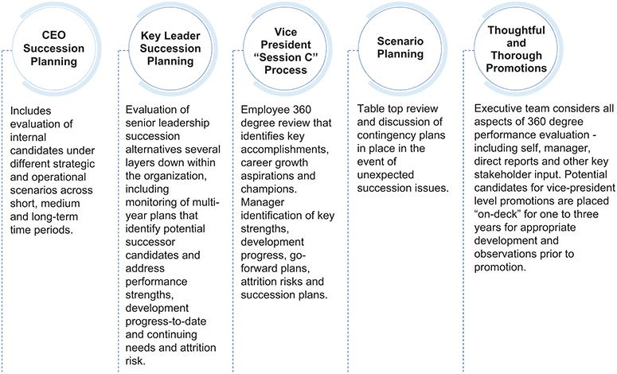

Fair Isaac Corporation l 2026 Proxy Statement 30

Table of Contents

Proxy | Board of | Corporate |  | Executive | Audit Committee | Charter | Stock | Other
Summary | Directors | Governance |  | Compensation | Matters | Amendments | Ownership | Matters

Stockholder Engagement

We recognize the value of engaging in regular, constructive dialogue with our stockholders on matters that are significant to our business, including corporate governance, executive compensation and sustainability, and to share our perspectives with one another. Following our 2025 annual meeting, we conducted outreach with stockholders to receive any feedback our stockholders may have, to better understand their opinions regarding such matters as our corporate governance, executive compensation and sustainability. It is important to FICO that our stockholders are afforded a chance to provide their thoughts on topics of interest, and receptivity to stockholder views is an essential component of the Board’s decision-making process.

Fair Isaac Corporation l 2026 Proxy Statement 31

Table of Contents

Proxy | Board of | Corporate |  | Executive | Audit Committee | Charter | Stock | Other
Summary | Directors | Governance |  | Compensation | Matters | Amendments | Ownership | Matters

DIRECTOR COMPENSATION PROGRAMS

Non-Employee Director Compensation

The following compensation components are paid to our non-employee directors:

- Annual retainer fees;

- An equity grant upon initial election to the Board; and

- Annual equity grants.

Our Compensation Program for Non-Employee Directors, initially adopted on December 8, 2016, and amended on November 30, 2023 (the “Program”), for fiscal 2025 was as described below.

Under the Program, each non-employee director was entitled to receive annual retainer fees in the amounts set forth below and was paid in cash quarterly in arrears during their annual term commencing upon their election or re-election at each annual meeting of stockholders. Such amounts are pro-rated for appointments made to the Board of Directors, chair of a standing Board committee, non-chair member of a standing Board committee or Chairman of the Board between annual meetings.


Base annual retainer fee payable to all non-employee directors | $ 60,000

Additional annual retainer fee payable to Chairs of the Board’s Audit Committee,
Leadership Development and Compensation Committee and Governance, $ 25,000 Nominating and Executive Committee

Additional annual retainer fee payable to Independent Chairman of the Board | $ 100,000

Additional annual retainer fee payable to non-Chair members of the Audit
Committee, Leadership Development and Compensation Committee and $ 15,000 Governance, Nominating and Executive Committee

The stock price used for purposes of all calculations made under the Program equaled the average closing price of a share of the Company’s stock for the trading days within the 30-calendar-day period that ended on the eleventh calendar day before the date of grant.

Each non-employee director had the right, prior to the annual meeting at which he or she is elected or re-elected as a director, to elect to receive some or all of these annual retainer fees in the form of fully vested non-qualified stock options instead of cash. A director who elected to receive some or all of these annual retainer fees in the form of a stock option received an option to purchase a number of shares equal to the amount of the retainer or portion of the retainer being converted divided by the Black-Scholes value of an option.

Upon initial election to the Board, each non-employee director was entitled to receive a number of non-qualified stock options subject to three-year ratable vesting equal to $560,000 divided by the Black-Scholes value of a non-qualified stock option. The director was able to elect to convert either 50% or 100% of these stock options to restricted stock units (“RSUs”) subject to three-year ratable vesting. The number of RSUs was determined by dividing the aggregate Black-Scholes value of the non-qualified stock options being exchanged by the value of an RSU.

Fair Isaac Corporation l 2026 Proxy Statement 32

Table of Contents

Proxy | Board of | Corporate |  | Executive | Audit Committee | Charter | Stock | Other
Summary | Directors | Governance |  | Compensation | Matters | Amendments | Ownership | Matters

Annual equity grants made to non-employee directors who were re-elected at the 2025 annual meeting of stockholders after serving on the Board at least since the previous annual meeting were in the form of stock options subject to one-year cliff vesting equal to $280,000 divided by the Black-Scholes value of a non-qualified stock option, and each committee chair received an additional annual grant in the form of stock options subject to one-year cliff vesting equal to $30,000 divided by the Black-Scholes value of a non-qualified stock option. Each director was able to elect to convert either 50% or 100% of these stock options to RSUs subject to one-year cliff vesting. The number of RSUs was determined by dividing the aggregate Black-Scholes value of the non-qualified stock options being exchanged by the value of an RSU. Equity awards granted upon an annual meeting that are subject to vesting will vest upon the dates of successive annual meetings.

Director Stock Ownership Guidelines

Our policy requires non-employee directors to hold seven times the base annual retainer fee in share value to be owned within five years of initial election or appointment. Our guidelines provide that only shares owned outright and unvested time-based RSUs are counted for purposes of determining compliance with these guidelines (stock options do not count towards ownership). All of the directors currently meet the stock ownership guidelines or are making acceptable progress to their applicable level.

Director and Officer Liability Insurance Policies

Directors are covered under our director and officer liability insurance policies for claims alleged in connection with their service as directors. We have entered into indemnification agreements with all of our directors agreeing to indemnify them to the fullest extent permitted by law for claims alleged in connection with their service as directors.

Director Compensation for Fiscal 2025

The table below summarizes the compensation paid by the Company to each non-employee director for the fiscal year ended September 30, 2025.

 |  |  |  |  | Change in
 |  |  |  |  | Pension
 |  |  |  |  | Value and
 |  |  |  |  | Non-qualified
 | Fees |  |  | Non-Equity | Deferred | All
 | Earned or | Stock | Option | Incentive Plan | Compensation | Other
 | Paid in | Awards | Awards | Compensation | Earnings | Compensation | Total
Name | Cash ($)(1) | ($)(10)(11) | ($)(10)(12) | ($) | ($) | ($) | ($)
Fabiola R. Arredondo | 75,000⁽²⁾ | 288,444 | — | — | — | — | 363,444
Braden R. Kelly | 200,000⁽³⁾ | 320,285 | — | — | — | — | 520,285
James D. Kirsner | 37,500⁽⁴⁾ | — | — | — | — | — | 37,500
Eva Manolis | 75,000⁽⁵⁾ | 288,444 | — | — | — | — | 363,444
Marc F. McMorris | 75,000⁽⁶⁾ | 144,222 | 143,349 | — | — | — | 362,571
Joanna Rees | 100,000⁽⁷⁾ | — | 316,913 | — | — | — | 416,913
David A. Rey | 100,000⁽⁸⁾ | 176,063 | 143,349 | — | — | — | 419,412
H. Tayloe Stansbury | 75,000⁽⁹⁾ | 144,222 | 143,349 | — | — | — | 362,571

- All fees under this column represent fees paid to the directors under the Program described above. The Program anticipates fees commencing with the directors’ election year (February/March to February/March), whereas the compensation reported in this table is that paid during our fiscal year (October through September). Fees that are

Fair Isaac Corporation l 2026 Proxy Statement 33

Table of Contents

Proxy | Board of | Corporate |  | Executive | Audit Committee | Charter | Stock | Other
Summary | Directors | Governance |  | Compensation | Matters | Amendments | Ownership | Matters

paid in cash are paid quarterly in arrears. Fees that, at the election of the director, are paid in stock options are paid in one annual grant upon the director’s election to the Board. As a result, when a director’s election with respect to receiving fees in cash or stock options changes from one year to the next, the director’s compensation disclosed in this column differs from the annual fees described under “Non-Employee Director Compensation” above. Messrs. Kelly and Stansbury, and Ms. Arredondo made election changes during fiscal 2025.
- Represents the $75,000 of annual board and committee retainers paid in cash in fiscal 2025.

- Represents $200,000 in annual board, committee, independent chairman of the board and committee chair retainers which would have been paid in cash in quarterly installments following his re-election that were forgone by Mr. Kelly to instead receive 291 stock options in one grant upon his re-election. The amount recognized for financial statement reporting purposes in fiscal 2025 with respect to such options, which was $204,483, is excluded from the “Option Awards” column.

- Represents $37,500 of annual board and committee retainers paid in cash in the first and second quarters of fiscal 2025 to Mr. Kirsner, who retired from service on the Board effective on March 5, 2025.

- Represents $75,000 of annual board and committee retainers paid in cash in fiscal 2025.

- Represents $75,000 in annual board and committee retainers which would have been paid in cash in quarterly installments following his re-election that were forgone by Mr. McMorris to instead receive 109 stock options in one grant upon his re-election. The amount recognized for financial statement reporting purposes in fiscal 2025 with respect to such options, which was $76,593, is excluded from the “Option Awards” column.

- Represents $100,000 in annual board, committee chair and committee retainers which would have been paid in cash in quarterly installments following her re-election that were foregone by Ms. Rees to instead receive 146 stock options in one grant upon her re-election. The amount recognized for financial statement reporting purposes in fiscal 2025 with respect to such options, which was $102,593, is excluded from the “Option Awards” column.

- Includes (i) $80,000 in annual board and committee retainers paid quarterly to Mr. Rey in cash during fiscal 2025, and (ii) $20,000 in annual board and committee retainers which would have been paid in cash in quarterly installments following his re-election that were forgone by Mr. Rey to instead receive 30 stock options in one grant upon his re-election. The amount recognized for financial statement reporting purposes in fiscal 2025 with respect to such options, which was $21,081, is excluded from the “Option Awards” column.

- Represents $75,000 in annual board and committee retainers which would have been paid in cash in quarterly installments following his re-election that were forgone by Mr. Stansbury to instead receive 109 stock options in one grant upon his re-election. The amount recognized for financial statement reporting purposes in fiscal 2025 with respect to such options, which was $76,593, is excluded from the “Option Awards” column.

- The amounts in this column represent the aggregate grant date fair value of each award computed in accordance with Financial Accounting Standards Board (“FASB”) Accounting Standards Codification (“ASC”) Topic 718. For information on the assumptions used to calculate the value of the awards, refer to Note 13 of the Company’s Consolidated Financial Statements in the Annual Report on Form 10-K for the fiscal year ended September 30, 2025, as filed with the SEC.

- As of September 30, 2025, the RSU awards outstanding for each director are as follows: Ms. Arredondo — 154; Mr. Kelly — 171; Ms. Manolis — 154; Mr. McMorris — 77; Ms. Rees — 0; Mr. Rey — 94; and Mr. Stansbury — 168.

- As of September 30, 2025, the option awards outstanding for each director are as follows: Ms. Arredondo — 4,203; Mr. Kelly — 6,101; Ms. Manolis — 7,203; Mr. McMorris — 2,802; Ms. Rees — 8,751; Mr. Rey — 5,621; and Mr. Stansbury — 809.

Fair Isaac Corporation l 2026 Proxy Statement 34

Table of Contents

Proxy | Board of | Corporate | Executive |  | Audit Committee | Charter | Stock | Other
Summary | Directors | Governance | Compensation |  | Matters | Amendments | Ownership | Matters

PROPOSAL 2: Advisory Vote on Executive Officer |  | The Board recommends a
Compensation |  | vote FOR this proposal

Pursuant to Section 14A of the Exchange Act, the Company seeks a non-binding advisory vote from its stockholders to approve the compensation of our named executive officers as described under “Executive Compensation — Compensation Discussion and Analysis” and the tabular disclosure regarding named executive officer compensation (together with the accompanying narrative disclosure) in this proxy statement.

This proposal gives our stockholders the opportunity to express their views on the Company’s named executive officer compensation. Because your vote is advisory, it will not be binding upon the Board of Directors. However, the LDCC will consider the outcome of the vote when making future executive officer compensation decisions.

As we discuss below in our Compensation Discussion and Analysis, we believe that our compensation policies and decisions are designed to deliver a performance-based pay philosophy, are aligned with the long-term interests of our stockholders and are competitive. The Company’s principal compensation policies, which enable the Company to attract, motivate and retain talented executive officers to lead the Company in the achievement of our business objectives, include:

- We make annual cash compensation decisions based on assessment of the Company’s performance against measurable financial goals, as well as each executive’s individual performance.

- We emphasize long-term incentive compensation awards that collectively reward executive officers based on individual performance, external and internal peer equity compensation practices, and the performance of the Company’s stock.

- Approximately two-thirds of the target value of fiscal 2025 annual long-term equity awards granted to executive officers in December 2024 was in the form of performance-based incentives.

- We require stock ownership by our senior executive officers.

As a result, we are presenting this proposal, which gives you as a stockholder the opportunity to vote on our named executive officer compensation as disclosed in this proxy statement by voting “FOR” or “AGAINST” the following resolution:

RESOLVED, that the stockholders approve the compensation of the Company’s named executive officers, as disclosed in the Compensation Discussion and Analysis, the compensation tables, and the related disclosure contained in the Company’s Proxy Statement for its 2026 Annual Meeting of Stockholders.

Fair Isaac Corporation l 2026 Proxy Statement 35

Table of Contents

Proxy | Board of | Corporate | Executive |  | Audit Committee | Charter | Stock | Other
Summary | Directors | Governance | Compensation |  | Matters | Amendments | Ownership | Matters

EXECUTIVE COMPENSATION Compensation Roadmap
01 | Executive Summary |  |  |  |  |  |  |  |  |  |  |  |  |  |  |  |  |  |  | 38
 |  | Our 2025 Performance Highlights
 |  |  |  |  |  |  |  |  |  |  |  |  |  |  |  |  |  |  |  | 38
 |  | 2025 Compensation Highlights |  |  |  |  |  |  |  |  |  |  |  |  |  |  |  |  |  | 39
 |  | Quality Pay Practices and Policies |  |  |  |  |  |  |  |  |  |  |  |  |  |  |  |  |  | 43
02 | Executive Compensation Program |  |  |  |  |  |  |  |  |  |  |  |  |  |  |  |  |  |  | 43
 |  | Compensation Philosophy and Objectives |  |  |  |  |  |  |  |  |  |  |  |  |  |  |  |  |  | 43
 |  | 2025 Elements of Compensation |  |  |  |  |  |  |  |  |  |  |  |  |  |  |  |  |  | 44
 |  | Base Salary in Fiscal 2025 |  |  |  |  |  |  |  |  |  |  |  |  |  |  |  |  |  | 45
 |  | Short-Term Cash Incentives |  |  |  |  |  |  |  |  |  |  |  |  |  |  |  |  |  | 45
 |  | Company Performance Factor |  |  |  |  |  |  |  |  |  |  |  |  |  |  |  |  |  | 47
 |  | Participant Performance Factor |  |  |  |  |  |  |  |  |  |  |  |  |  |  |  |  |  | 47
 |  | 2025 Payouts |  |  |  |  |  |  |  |  |  |  |  |  |  |  |  |  |  | 49
 |  | Long-Term Equity Incentives in Fiscal 2025 |  |  |  |  |  |  |  |  |  |  |  |  |  |  |  |  |  | 49
03 | Compensation-Setting Process |  |  |  |  |  |  |  |  |  |  |  |  |  |  |  |  |  |  | 53
 |  | LDCC Process |  |  |  |  |  |  |  |  |  |  |  |  |  |  |  |  |  | 53
 |  | Use of Compensation Consultant |  |  |  |  |  |  |  |  |  |  |  |  |  |  |  |  |  | 55
 |  | Compensation Consultant Conflict of Interest |  |  |  |  |  |  |  |  |  |  |  |  |  |  |  |  |  | 55
 |  |  | Analysis
 |  | Retirement Arrangements |  |  |  |  |  |  |  |  |  |  |  |  |  |  |  |  |  | 55
 |  | Other Compensation Arrangements |  |  |  |  |  |  |  |  |  |  |  |  |  |  |  |  |  | 56
04 | Post-Employment Compensation |  |  |  |  |  |  |  |  |  |  |  |  |  |  |  |  |  |  | 56
04 | Arrangements |  |  |  |  |  |  |  |  |  |  |  |  |  |  |  |  |  |  | 56


05 | Policies and Procedures Related to the Grant |  |  |  |  |  |  |  |  |  |  |  |  |  |  |  |  |  |  |  |  |  |  |  |  | 57
05 | of Certain Equity Awards |  |  |  |  |  |  |  |  |  |  |  |  |  |  |  |  |  |  |  |  |  |  |  |  | 57
06 | Executive Stock Ownership Guidelines
06 |  |  |  |  |  |  |  |  |  |  |  |  |  |  |  |  |  |  |  |  |  |  |  |  |  | 58
07 | Executive Officer Incentive Compensation |  |  |  |  |  |  |  |  |  |  |  |  |  |  |  |  |  |  |  |  |  |  |  |  | 58
07 | Recovery Policies
08 | No Hedging |  |  |  |  |  |  |  |  |  |  |  |  |  |  |  |  |  |  |  |  |  |  |  |  | 58
09 | Tax Matters |  |  |  |  |  |  |  |  |  |  |  |  |  |  |  |  |  |  |  |  |  |  |  |  | 58
10 | Leadership Development and Compensation |  |  |  |  |  |  |  |  |  |  |  |  |  |  |  |  |  |  |  |  |  |  |  |  | 59
10 | Committee Report
11 | Compensation Tables |  |  |  |  |  |  |  |  |  |  |  |  |  |  |  |  |  |  |  |  |  |  |  |  | 60
 |  | Summary Compensation Table |  |  |  |  |  |  |  |  |  |  |  |  |  |  |  |  |  |  |  |  |  |  |  | 60
 |  | All Other Compensation Table |  |  |  |  |  |  |  |  |  |  |  |  |  |  |  |  |  |  |  |  |  |  |  | 61
 |  | Grants of Plan-Based Awards for Fiscal 2025 |  |  |  |  |  |  |  |  |  |  |  |  |  |  |  |  |  |  |  |  |  |  |  | 63
 |  | Outstanding Equity Awards at Fiscal 2025 Year |  |  |  |  |  |  |  |  |  |  |  |  |  |  |  |  |  |  |  |  |  |  |  | 66
 |  | End
 |  | Fiscal 2025 Option Exercises and Stock Vested |  |  |  |  |  |  |  |  |  |  |  |  |  |  |  |  |  |  |  |  |  |  |  | 67
 |  | Non-Qualified Deferred Compensation for |  |  |  |  |  |  |  |  |  |  |  |  |  |  |  |  |  |  |  |  |  |  |  | 68
 |  | Fiscal 2025
12 | Potential Payments Upon Termination or
12 | Change in Control |  |  |  |  |  |  |  |  |  |  |  |  |  |  |  |  |  |  |  |  |  |  |  |  | 69
13 | Equity Compensation Plan Information |  |  |  |  |  |  |  |  |  |  |  |  |  |  |  |  |  |  |  |  |  |  |  |  | 76
14 | CEO Pay Ratio |  |  |  |  |  |  |  |  |  |  |  |  |  |  |  |  |  |  |  |  |  |  |  |  | 77
15 | Pay Versus Performance |  |  |  |  |  |  |  |  |  |  |  |  |  |  |  |  |  |  |  |  |  |  |  |  | 78


Fair Isaac Corporation l 2026 Proxy Statement 36

Table of Contents

Proxy | Board of | Corporate | Executive |  | Audit Committee | Charter | Stock | Other
Summary | Directors | Governance | Compensation |  | Matters | Amendments | Ownership | Matters

Compensation Discussion and Analysis

This section describes our executive compensation philosophy, and the process by which our Leadership Development and Compensation Committee (“LDCC”) makes executive compensation and pay decisions for our named executive officers.

Our Fiscal 2025 Named Executive Officers

 |  | William Lansing |  |  | Steven Weber |  | Nikhil Behl |  | Richard Deal |  | Mark Scadina |  | James Wehmann*
 |  | Chief Executive |  |  | Executive Vice |  | President, Software |  | Executive Vice |  | Executive Vice |  | Former President,
 |  | Officer |  |  | President and Chief |  |  |  | President, Chief |  | President, General |  | Scores
 |  |  |  |  | Financial Officer |  |  |  | Human Resources |  | Counsel and
 |  |  |  |  |  |  |  |  | Officer |  | Corporate Secretary
 |  | Years of service |  |  | Years of service |  | Years of service |  | Years of service |  | Years of service |  | Years of service
 |  | 14 years |  |  | 22 years |  | 12 years |  | 25 years |  | 18 Years |  | 13 years

- Mr. Wehmann’s employment with the Company terminated effective September 5, 2025.

Fair Isaac Corporation l 2026 Proxy Statement 37

Table of Contents

Proxy | Board of | Corporate | Executive |  | Audit Committee | Charter | Stock | Other
Summary | Directors | Governance | Compensation |  | Matters | Amendments | Ownership | Matters

Executive Summary

Our 2025 Performance Highlights

During fiscal 2025, we again delivered record revenues and free cash flow as we continued to focus our strategy and pursue our long-term growth initiatives. We utilized our cash to enhance stockholder value through continued investments in FICO Platform, marketing initiatives for our Scores business and our stock repurchase program. Financial highlights and key measures of our performance that were determined at the beginning of the performance period by our LDCC and applied to determine the 2025 performance of our named executive officers are set forth below.
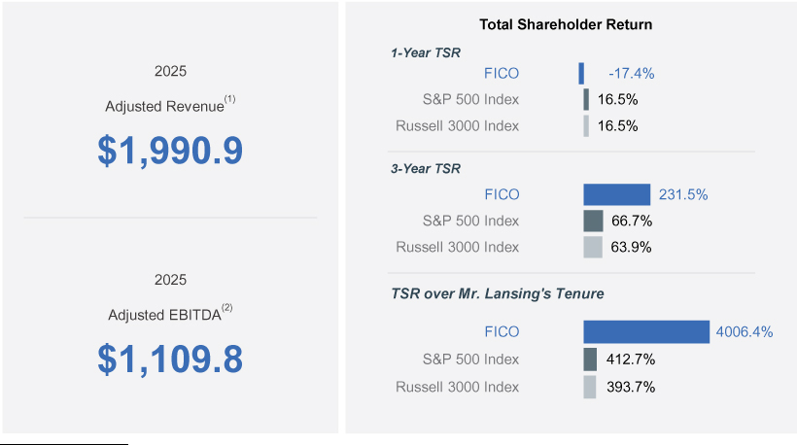

- Adjusted Revenue is the Company’s GAAP revenue as adjusted for any impact on revenues related to acquisitions, divestitures or other events deemed by the LDCC to have been out of management’s control or that may not be indicative of recurring business results and occurring in the measurement year. For fiscal 2025, the LDCC determined that no adjustments to the Company’s GAAP revenue were warranted, and therefore Adjusted Revenue was the same as GAAP revenue.
- Adjusted EBITDA is a non-GAAP financial measure and is defined as GAAP net income, adjusted for certain items. See Appendix A to this proxy statement for a reconciliation of Adjusted EBITDA to GAAP net income, the most directly comparable GAAP financial measure.

Fair Isaac Corporation l 2026 Proxy Statement 38

Table of Contents

Proxy | Board of | Corporate | Executive |  | Audit Committee | Charter | Stock | Other
Summary | Directors | Governance | Compensation |  | Matters | Amendments | Ownership | Matters

2025 Compensation Highlights

Our compensation program is designed to operate effectively across business conditions and to support our pay-for-performance philosophy, emphasizing variable and long-term incentive opportunities that align our named executive officers’ financial interests with those of our stockholders. Consistent with this emphasis, base salaries remained flat for all named executives for fiscal 2025. While the core design of our program remained largely consistent with prior years, after considering stockholder feedback as detailed in the proxy statement for our 2025 annual meeting of stockholders, the LDCC made a number of enhancements to our program for fiscal 2025:

Fiscal 2024 |  |  | Fiscal 2025
 | Short-Term Cash Incentives
200% | Decreased the maximum performance achievable under the |  | 150%
200% | participant performance factor component |  | 150%
 | Long-Term Incentives
Russell 3000 Index | Updated MSU comparator group used to measure relative total |  | S&P 500 Index
Russell 3000 Index | shareholder return (“rTSR”) performance |  | S&P 500 Index
Index average | Enhanced comparative performance level required to |  | 55th percentile of the
Index average | earn target MSU award opportunity |  | Index

The charts below present the mix of total target direct compensation awarded to the NEOs in fiscal 2025 and the performance metrics used across our annual- and long-term incentive programs, which were generally consistent with fiscal 2024, other than the MSU comparator group as described above.
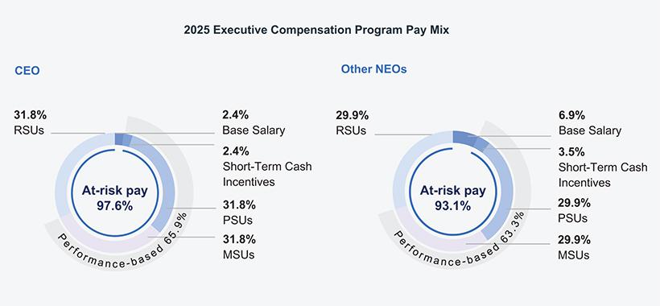

Fair Isaac Corporation l 2026 Proxy Statement 39

Table of Contents

Proxy | Board of | Corporate |  | Executive |  | Audit Committee Charter |  | Stock | Other
Summary | Directors | Governance Compensation |  |  |  | Matters | Amendments | Ownership | Matters
 |  |  | Rationale and |  |  |  |  | Program
Metric
Metric |  |  | Considerations |  |  |  | Annual Incentive | PSUs | MSUs
Adjusted Revenue |  |  | Motivates continued growth |  |  |  | ✔ | ✔
 |  |  | of the business
Adjusted EBITDA |  |  | Rewards operational profitability |  |  |  | ✔ | ✔
Total shareholder return relative to the |  |  | 55th percentile target drives |  |  |  |  |  | ✔
S&P 500 Index |  |  | outperformance relative to the |  |  |  |  |  | ✔
 |  |  | market and provides alignment with
stockholder interests

The LDCC is intentional in its use of Adjusted Revenue and Adjusted EBITDA as the financial metrics in both our short- and long-term incentive programs because the LDCC believes that they best balance the delivery of steady growth against the investments we are making as we continue our strategic shift in the focus of the Software segment towards a cloud-based platform while preserving the value of legacy solutions and that they are strong indicators of our success in generating long-term stockholder value creation.

Short-term incentives represent only 3 to 4% of named executive officers’ total direct compensation and are provided primarily to create shared alignment across our employee population. Importantly, the PSUs awarded to our senior executives utilize meaningfully steeper upwards and downwards payout slopes than the short-term cash incentive plan, consistent with the LDCC’s desire to more heavily weight compensation opportunities toward variable, equity-based compensation opportunities and to strengthen the risk and reward profile of these awards to drive greater accountability for our senior leaders who can most directly influence our results.

Fair Isaac Corporation l 2026 Proxy Statement 40

Table of Contents

Proxy | Board of | Corporate | Executive |  | Audit Committee | Charter | Stock | Other
Summary | Directors | Governance | Compensation |  | Matters | Amendments | Ownership | Matters

Pay outcomes for fiscal 2025 demonstrate the strong pay and performance linkage of our program.
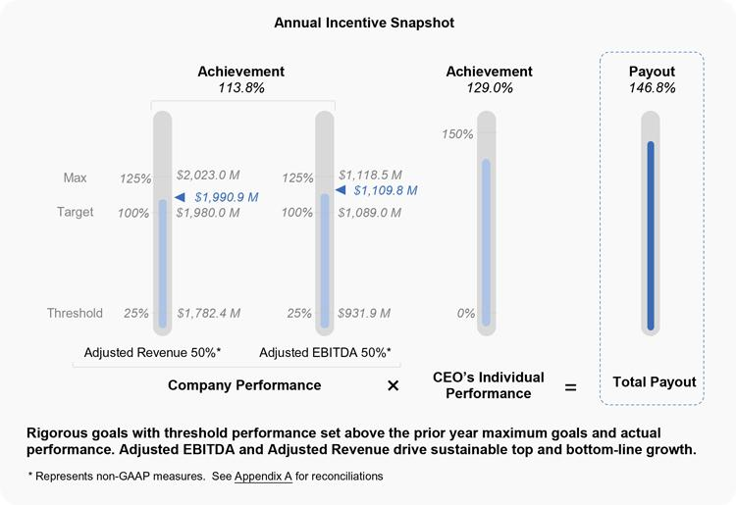

Fair Isaac Corporation l 2026 Proxy Statement 41

Table of Contents

Proxy | Board of | Corporate | Executive |  | Audit Committee | Charter | Stock | Other
Summary | Directors | Governance | Compensation |  | Matters | Amendments | Ownership | Matters
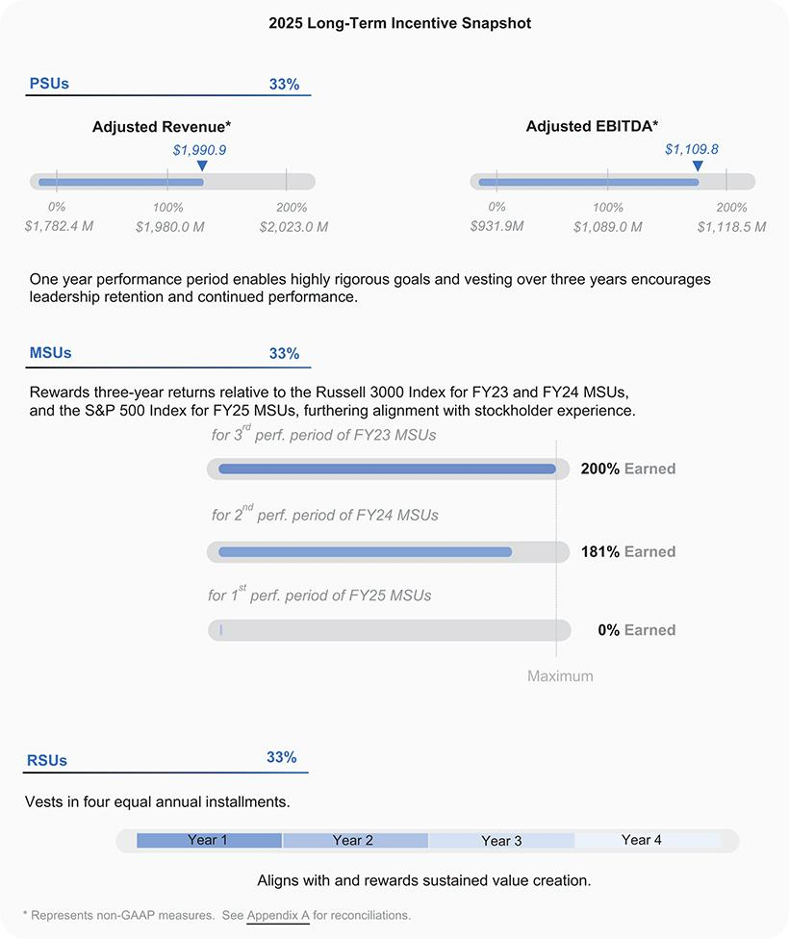

Fair Isaac Corporation l 2026 Proxy Statement 42

Table of Contents

Proxy | Board of | Corporate | Executive |  | Audit Committee | Charter | Stock | Other
Summary | Directors | Governance | Compensation |  | Matters | Amendments | Ownership | Matters

Quality Pay Practices and Policies

Highlighted below are key practices and policies of our compensation program which reinforce our pay-for-performance philosophy, further our retention and motivation objectives, and align executive and stockholder interests.

Quality Pay Practices and Policies Highlights






Only “double-trigger” accelerated vesting or payment for equity awards upon a change in control of the Company

Executive stock ownership guidelines that require ownership and further align our executive officers’ interests with those of our stockholders; only shares owned outright and time-based full value equity awards count towards meeting these guidelines

Prohibition on hedging of Company common stock

A compensation recovery, or “clawback,” policy pertaining to all performance-based compensation in the case of a restatement

Supplemental clawback policy triggered in the event of misconduct situations that covers annual and long-term incentive compensation, including time-based equity awards

Mandatory minimum vesting period of one year for equity awards

Annual compensation peer group review with appropriate updates to ensure valid comparisons

No tax “gross-ups” allowed except with respect to relocation benefits, required spousal travel and certain required regulatory filings

Independent compensation consultant engaged by the LDCC that does not provide any other services to the Company

EXECUTIVE COMPENSATION PROGRAM

Compensation Philosophy and Objectives

Our compensation program is designed to meet the following objectives:


Attract, retain and reward high caliber talent

Pay for Performance

∎

∎

∎

Attract, retain, motivate and reward our outstanding leaders in a competitive market, who are instrumental in maintaining our position as a leading analytics software company

Set rigorous performance targets that drive achievement of our financial goals and strategic plans

Responsive payouts that reward leaders for outperformance and result in a lower, or no, payout for results that fall short of high expectations


Align Executive and Stockholder Interests

Account for Individual Performance

∎

∎

∎

Encourage long-term, sustained value creation for stockholders

Heavily weight equity incentives to maximize alignment between executives’ pay outcomes and stockholder experience

Calibrate pay levels and opportunities relative to individuals’ contributions and track record of performance

Fair Isaac Corporation l 2026 Proxy Statement 43

Table of Contents

Proxy | Board of | Corporate | Executive |  | Audit Committee | Charter | Stock | Other
Summary | Directors | Governance | Compensation |  | Matters | Amendments | Ownership | Matters

2025 Elements of Compensation

The fiscal 2025 executive compensation program consisted of the following key elements.
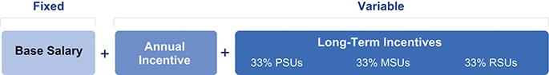

WHAT | • | Cash |  | • | Cash |  | • | Equity |  | • | Equity |  | • | Equity
PAY MIX
CEO |  |  | 2.4% |  |  | 2.4% |  |  | 31.8% |  |  | 31.8% |  |  | 31.8%
Other NEOs |  |  | 6.9% |  |  | 3.5% |  |  | 29.9% |  |  | 29.9% |  |  | 29.9%
WHEN | • | Ongoing |  | • | Annual |  | • | One-year |  | • | Performance over |  | • Vests in four equal
 |  |  |  |  |  |  |  | performance period, |  |  | three years, with |  |  | annual installments
 |  |  |  |  |  |  |  | with any earned |  |  | interim earning and
 |  |  |  |  |  |  |  | shares vesting on |  |  | vesting opportunities
 |  |  |  |  |  |  |  | the first three |  |  | after years one and
 |  |  |  |  |  |  |  | anniversaries of the |  |  | two
 |  |  |  |  |  |  |  | date of grant
HOW | • | N/A |  | • | Company |  | • | Adjusted Revenue |  | • | Company’s TSR |  | • | Stock Price
 |  |  |  |  | Performance |  |  | 50% |  |  | relative to the S&P
 |  |  |  |  | • | Adjusted Revenue | • | Adjusted EBITDA |  |  | 500 Index
Measures, |  |  |  |  |  | 50% |  | 50% |  | • | Payout: 0-200% of
Weightings & Payouts |  |  |  |  | • | Adjusted EBITDA | • | Payout: 0-200% of |  |  | target
 |  |  |  |  |  | 50% |  | target
 |  |  |  | • | Individual
 |  |  |  |  | Performance
 |  |  |  | • | Payout: 0-187.5% of
 |  |  |  |  | target
WHY | • | Base salary |  | • | Our short-term |  | • | Long-term equity incentive awards directly link the vast majority
 |  | provides our |  |  | cash incentive plan |  |  | of each executive officer’s target total direct compensation to the
 |  | executive officers |  |  | creates shared |  |  | market value of our common stock, while promoting retention
 |  | with a stable and |  |  | alignment across |  |  | through multi-year vesting and performance periods
 |  | predictable cash |  |  | our employee |  | • | PSUs build further focus on annual Company financial
 |  | flow |  |  | population and |  | •
 |  |  |  |  |  |  |  | performance targets, using a steeper payout curve than our
 |  |  |  |  | rewards the
 |  |  |  |  |  |  |  | annual incentives in the event of under- or over-performance
 |  |  |  |  | achievement of
 |  |  |  |  | annual Company |  | • | MSUs align executive pay outcomes with stockholder experience
 |  |  |  |  | goals as well as |  |  | and further encourages long-term performance
 |  |  |  |  | individual |  | • | RSUs represent a more stable equity-based compensation
 |  |  |  |  | performance |  | •
vehicle, ensuring program durability across market cycles while
providing linkage to the stock price performance of our common

stock and promoting retention over a four-year vesting period

Fair Isaac Corporation l 2026 Proxy Statement 44

Table of Contents

Proxy | Board of | Corporate | Executive |  | Audit Committee | Charter | Stock | Other
Summary | Directors | Governance | Compensation |  | Matters | Amendments | Ownership | Matters

Base Salary in Fiscal 2025

None of our named executive officers received an increase in base salary as part of the Company’s annual year-end performance review and compensation process in November 2024. This approach reflects the LDCC’s continued emphasis on incentive compensation elements directly linked to the achievement of our target financial goals and the creation of stockholder value.

 | Fiscal 2025 | Fiscal 2024
Named Executive Officer | Base Salary | Base Salary
William Lansing | $750,000 | $750,000
Steven Weber | $400,000 | $400,000
Nikhil Behl | $500,000 | $500,000
Richard Deal | $400,000 | $400,000
Mark Scadina | $400,000 | $400,000
James Wehmann⁽¹⁾ | $500,000 | $500,000

- Mr. Wehmann retired from the Company effective September 5, 2025.

Short-Term Cash Incentives

For fiscal 2025, our annual incentive awards are paid from a single, centralized pool that supports short-term cash incentive payments to our executive officers under our Executive Incentive Plan (“EIP”) and vice president-level leaders under our Management Incentive Plan (“MIP”) and to other eligible employees under our Broad-Based Incentive Plan (“BBIP”).

The LDCC determined named executive officers’ cash incentive payments using the framework set forth below, which was generally the same for all other participants in the EIP, MIP, and BBIP in order to provide shared focus on the performance measures that the LDCC believes are most critical to the success of our business.

Fair Isaac Corporation l 2026 Proxy Statement 45

Table of Contents

Proxy | Board of | Corporate | Executive |  | Audit Committee | Charter | Stock | Other
Summary | Directors | Governance | Compensation |  | Matters | Amendments | Ownership | Matters
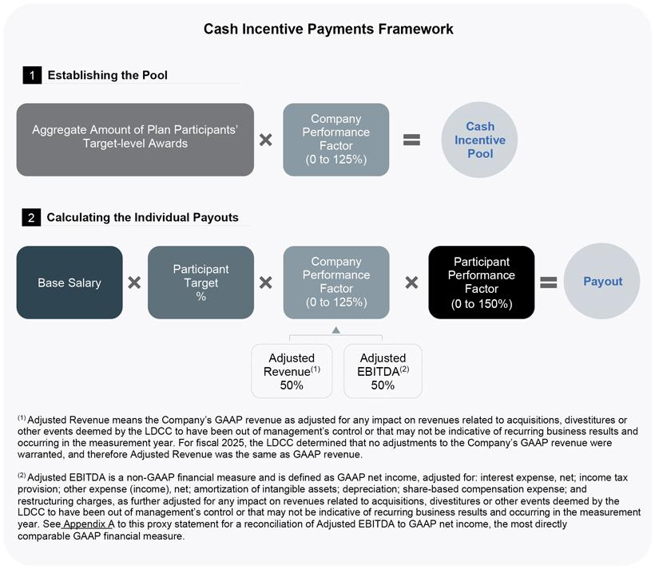

Fair Isaac Corporation l 2026 Proxy Statement 46

Table of Contents

Proxy | Board of | Corporate | Executive |  | Audit Committee | Charter | Stock | Other
Summary | Directors | Governance | Compensation |  | Matters | Amendments | Ownership | Matters

The participant target percentage for each participant in the EIP is based on the Company’s desire to continue to emphasize long-term incentives and the LDCC’s review of market-competitive short-term compensation levels for executives in comparable roles at the peer group companies. As provided in their respective letter agreements, Mr. Lansing’s participant target percentage is 100% of his annual base salary, and the other named executive officers each have a participant target percentage of 50% of their annual base salary in effect at the end of fiscal 2025.

Company Performance Factor

The funding levels for each performance measure, along with the related Company Performance Factor, for fiscal 2025 were as follows:

 |  |  |  |  |  | ($ in Millions)
 | Threshold | Mid-point | Target | Upside | Maximum
Financial Metric | Funding | Funding | Funding | Funding | Funding | Actual
(Weighting) | Level | Level | Level | Level | Level | Performance
Adjusted Revenue (50%) | $1,782.4 | $1,915.0 | $1,980.0 | $2,000.0 | $2,023.0 | $1,990.9
Adjusted EBITDA (50%) | $931.9 | $1,051.0 | $1,089.0 | $1,102.3 | $1,118.5 | $1,109.8
Company Performance Factor | 25% | 50% | 100% | 112.5% | 125% | 113.8%

Participant Performance Factor

The Participant Performance Factor goals can include Company-wide measures as well as business unit metrics and goals that are highly specific to the functions over which the individual has primary responsibility. Our CEO’s performance goals were established by the LDCC at the beginning of the fiscal year after considering input from each non-employee director, and our CEO’s individual annual performance evaluation was completed by the LDCC.

Individual performance goals for our executive officers other than our CEO were established by our CEO, and annual performance evaluations for these executive officers were completed by our CEO and discussed with the LDCC. If an executive officer receives the lowest performance rating on a three-point scale (“Improvement Needed”), his or her Participant Performance Factor and resulting cash incentive payment may be as low as zero. Conversely, if an executive officer receives the highest overall performance rating, his or her Participant Performance Factor may be as high as 150%. Distribution guidelines applicable to these performance ratings ensure that participants in the short-term cash incentive plan are not all rated on the high or low end of the scale, but are instead distributed above and below the target levels. The LDCC may exercise discretion to make adjustments within the performance scale.

Fair Isaac Corporation l 2026 Proxy Statement 47

Table of Contents

Proxy | Board of | Corporate | Executive |  | Audit Committee | Charter | Stock | Other
Summary | Directors | Governance | Compensation |  | Matters | Amendments | Ownership | Matters

The Participant Performance Factor values for our named executive officers for fiscal 2025, other than Mr. Wehmann, along with the key factors considered by the LDCC and our CEO, as applicable, in making these determinations, were as follows. Mr. Wehmann retired from the Company prior to the end of fiscal 2025, and therefore was not eligible for a payout under the EIP for fiscal 2025 performance.

 | Participant
Named Executive | Performance
Officer | Factor |  | Key Factors
William Lansing | 129% |  | • successfully navigated complex regulatory and competitor challenges to our
 |  |  | mortgage score business by overseeing the building and launch of our new
 |  |  | Mortgage Direct program
 |  |  | • expertly managed shareholder communications during a highly dynamic year,
 |  |  | ensuring a clear understanding of our business, innovation priorities, and
 |  |  | growth strategies
 |  |  | • leveraged talent as a strategic differentiator through highly selective hiring,
 |  |  | strategic goal alignment, workforce engagement and retention initiatives, and
 |  |  | continued investment in professional development programs
Steven Weber | 110% |  | • strong oversight of fiscal year revenue forecasting and expense management
 |  |  | efforts enabling strategic investments while ensuring accountability
 |  |  | • effectively engaged in shareholder relations efforts ensuring appropriate
 |  |  | transparency and attracting new investors to our value proposition
 |  |  | • strong focus on regulatory and compliance priorities allowing maximum focus
 |  |  | of organizational resources on valued-added business outcomes
Nikhil Behl | 123% |  | • achieved 17% YoY growth in FICO Platform revenue while up-leveling sales
 |  |  | leadership talent and adopting best practices sales methodologies to drive
 |  |  | future growth
 |  |  | • drove continued innovation surrounding our FICO Platform including rollout of
 |  |  | our new focused foundation model for financial services (FICO FFM) which
 |  |  | enables clients to use small language models built for specific business
 |  |  | problems, significantly helping to mitigate hallucinations while providing
 |  |  | improved transparency, auditability and adaptability
 |  |  | • reengineered software operating investments to fund expanding sales
 |  |  | capacity to meet increasing market demand for our solutions
Richard Deal | 110% |  | • effectively executed our “people first” strategy leading to continued strong
 |  |  | workforce engagement, healthy talent pipelines, and historically low
 |  |  | unplanned attrition
 |  |  | • focused planning and execution of recurring talent management programs
 |  |  | ensuring strong linkage between organizational and individual performance
 |  |  | with reward systems
 |  |  | • oversaw the successful launch of a new AI Coaching system, leveraging a
 |  |  | focused LLM, expanding workforce access to management and leadership
 |  |  | best practices while strengthening the leverage of HR business consultants
Mark Scadina | 121% |  | • provided expert legal and strategic counsel across a range of business growth
 |  |  | and investment decisions, particularly involving our Mortgage Score Direct
 |  |  | strategy

• oversaw effective collaboration with our go-to-market organization, helping to drive business growth while ensuring effective contracting structures

• provided outstanding counsel to the Board and executive officers, enabling strategic decisions while mitigating risks

Fair Isaac Corporation l 2026 Proxy Statement 48

Table of Contents

Proxy | Board of | Corporate | Executive |  | Audit Committee | Charter | Stock | Other
Summary | Directors | Governance | Compensation |  | Matters | Amendments | Ownership | Matters
2025 Payouts

The combined effect of these inputs led to the following payments for the named executive officer participants under the EIP for fiscal 2025 performance, shown along with the target payment levels:

 |  |  | Amount Attributable
 |  |  | to Company
 |  | Target Payout | Performance Factor | Participant | Actual Payout
Named Executive Officer⁽¹⁾ |  | for Fiscal 2025 | (113.8%) | Performance Factor | for Fiscal 2025
William Lansing |  | $750,000 | $ 853,200 | 129% | $1,100,000
Steven Weber |  | $200,000 | $ 227,500 | 110% | $250,000
Nikhil Behl |  | $250,000 | $ 284,400 | 123% | $350,000
Richard Deal |  | $200,000 | $ 227,500 | 110% | $250,000
Mark Scadina |  | $200,000 | $ 227,500 | 121% | $275,000

- Mr. Wehmann retired from the Company prior to the end of fiscal 2025, and therefore was not eligible for a payout under the EIP for fiscal 2025 performance.

Long-Term Equity Incentives in Fiscal 2025

Long-term equity incentive awards drive achievement of the Company’s financial targets while linking compensation to the market value of its common stock. The LDCC emphasizes long-term equity incentives in our executive compensation program to help ensure strong alignment with our stockholders over time.

To strongly align the interests of our executive officers and stockholders, we place two-thirds of the annual long-term incentive value on performance-based vehicles in the form of PSUs and MSUs, considerably higher than the 52% average for our peer group. The target value of each type of equity award granted as part of the fiscal 2025 annual long-term incentive award to our named executive officers is as follows:

 |  | Annual PSUs | Annual MSUs | Annual RSUs
Named Executive Officer |  | 33% | 33% | 33% | Total⁽¹⁾
William Lansing |  | $10,000,000 | $10,000,000 | $10,000,000 | $30,000,000
Steven Weber |  | $1,833,333 | $1,833,333 | $1,833,333 | $5,500,000
Nikhil Behl |  | $2,000,000 | $2,000,000 | $2,000,000 | $6,000,000
Richard Deal |  | $1,833,333 | $1,833,333 | $1,833,333 | $5,500,000
Mark Scadina |  | $1,833,333 | $1,833,333 | $1,833,333 | $5,500,000
James Wehmann⁽²⁾ |  | $2,000,000 | $2,000,000 | $2,000,000 | $6,000,000

- The amounts reported within the compensation tables following this Compensation Discussion and Analysis differ from the target amounts discussed here. The LDCC uses the average closing stock price during the 30-calendar day period ending on the 11th day prior to the date of grant for purposes of converting the intended target value awarded to share units, whereas the amounts reported in the compensation tables reflect the grant date fair value of each award in accordance with applicable accounting requirements. The LDCC considers the use of an averaging period to be best practice, to offset daily stock price volatility, and the 10-day period prior to the grant date provides our executive officers with a reasonable time period to decide what portion, if any, of the designated RSU value (discussed under “Restricted Stock Units” below) to exchange for non-qualified stock options using an economically equivalent value also tied to the 30-day average price.

- Upon Mr. Wehmann’s retirement on September 5, 2025, he forfeited these and all other equity awards then held by him.

In determining the value of annual equity awards for fiscal 2025, the LDCC considered an analysis of competitive market data prepared by its compensation consultant and described below under “Determination of Compensation-Setting Process — Compensation Peer Group,” the individual performance of each executive officer, the need to reinforce positive levels of collaboration and teamwork across members of the executive team, and our retention objectives.

Fair Isaac Corporation l 2026 Proxy Statement 49

Table of Contents

Proxy | Board of | Corporate | Executive |  | Audit Committee | Charter | Stock | Other
Summary | Directors | Governance | Compensation |  | Matters | Amendments | Ownership | Matters

The competitive market data analysis for fiscal 2025 showed that peer group total direct compensation increased approximately 4% and 34% at the median and 75th percentile, respectively, and the long-term incentive value increased 3% and 41% at the median and 75th percentile, respectively. Coupled with continued strong company and individual performance, the LDCC determined to increase the target annual long-term incentive award values for all NEOs other than Mr. Wehmann. With respect to Mr. Lansing, the LDCC particularly considered the strength of his individual performance results and the LDCC’s desire to ensure his compensation is highly competitive and reflective of his personal performance and market value in determining to increase the target value of his fiscal 2025 award to approximately $30 million.

Performance Share Units (“PSUs”). The PSUs granted in fiscal 2025 were earned on the basis of a one-year performance period, with any earned shares vesting in equal installments over the first three anniversaries of the date of grant. The LDCC believes a one-year performance period enables it to set stretch goals based on a time period over which it has a reasonable line of sight. This is because market uncertainties make it difficult to accurately forecast our Adjusted Revenue and Adjusted EBITDA beyond one year. The LDCC believes the complexity of our major products linked to the strategic shift in focus for our Software segment, along with the business complexity of our major customers, yields a very long selling cycle, which in turn contributes significant uncertainty into our revenue stream and resulting EBITDA. Using a one-year performance period allows the LDCC to reward performance for a time period over which the Company has better visibility instead of creating goals over a longer term that are more likely to be problematic. In addition, requiring that two-thirds of any earned shares vest over an additional two years after the first anniversary of the grant date creates long-term alignment with our stockholders’ experience and satisfies our retention objectives.

The maximum number of PSUs that could have been earned over the fiscal 2025 performance period by each named executive officer was specified in the applicable award agreement. In each case, the named executive officer could earn as little as 0% at or below threshold performance and as much as 200% of the target number of PSUs at maximum performance. The LDCC retains discretion to determine the actual number of PSUs that were earned, but, consistent with prior years, did not exercise any such discretion with respect to the fiscal 2025 PSUs. The earnings matrix for the fiscal 2025 PSU awards was:

 |  |  |  |  |  |  | ($ in Millions)
Financial Metric |  | Threshold | Mid-point | Target | Upside | Maximum | Actual
(Weighting) |  | Performance | Performance | Performance | Performance | Performance | Performance
Adjusted Revenue (50%) |  | $1,782.4 | $1,915.0 | $1,980.0 | $2,000.0 | $2,023.0 | $1,990.9⁽¹⁾
Adjusted EBITDA (50%) |  | $931.9 | $1,051.0 | $1,089.0 | $1,102.3 | $1,118.5 | $1,109.8
PSUs Earned (as percentage |  | 0% | 50% | 100% | 150% | 200% | 150.2%
of target)

- For fiscal 2025, the LDCC determined that no adjustments to the Company’s GAAP revenue were warranted, and therefore Adjusted Revenue was the same as GAAP revenue.

The following table sets forth the target number of PSUs and the actual number of PSUs earned for fiscal 2025 performance:

 | Target Number of | Actual Number of
 | PSUs Granted for | PSUs Earned for
Named Executive Officer⁽¹⁾ | Fiscal 2025 | Fiscal 2025
William Lansing | 4,480 | 6,729
Steven Weber | 822 | 1,235
Nikhil Behl | 896 | 1,346
Richard Deal | 822 | 1,235
Mark Scadina | 822 | 1,235

- All of the 2025 PSUs (896 PSUs at target) granted to Mr. Wehmann were forfeited upon his retirement from the Company.

Fair Isaac Corporation l 2026 Proxy Statement 50

Table of Contents

Proxy | Board of | Corporate | Executive |  | Audit Committee | Charter | Stock | Other
Summary | Directors | Governance | Compensation |  | Matters | Amendments | Ownership | Matters

One-third of the earned PSUs vested and were settled in shares of our common stock following the end of fiscal 2025 and two-thirds will vest over the next two fiscal years provided the named executive officer remains with the Company as of each vesting date or vesting of the PSUs continues pursuant to the terms of the applicable award agreement.

Market Share Units (“MSUs”). The MSUs granted as part of the annual awards in fiscal 2025 are earned based on the Company’s total shareholder return relative to the S&P 500 over a three-year performance period, with interim earning opportunities after the first and second years of the performance period. The LDCC decided to measure performance over a total of three years to integrate a longer, multi-year performance period into the Company’s equity compensation program. The number of MSUs earned for each performance period is calculated as follows:
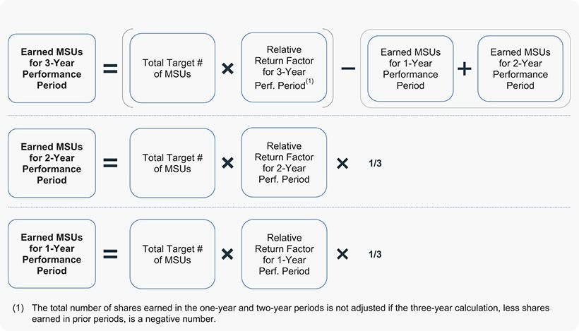

The relative return factor for each performance period of the fiscal 2025 MSUs is determined based on the Company’s total shareholder return relative to the S&P 500 Index for such performance period, with performance at the 55th percentile of the Index required to achieve target payout, as follows (with earned amounts interpolated between relative performance points):
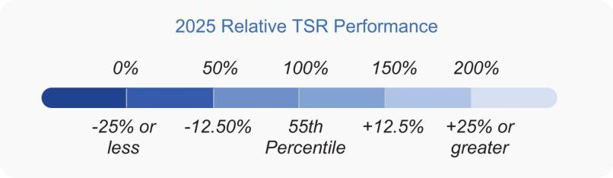

Fair Isaac Corporation l 2026 Proxy Statement 51

Table of Contents

Proxy | Board of | Corporate | Executive |  | Audit Committee | Charter | Stock | Other
Summary | Directors | Governance | Compensation |  | Matters | Amendments | Ownership | Matters

The following table sets forth, for the applicable performance period that includes fiscal 2025 for each of the MSUs granted in fiscal 2025, 2024 and 2023, the Company’s TSR and percentile of performance relative to the TSR of the applicable comparator group – the S&P 500 Index for fiscal 2025 MSUs and the Russell 3000 Index for fiscal 2024 and 2023 MSUs - which on a relative basis for each performance period resulted in the relative return factor reported for each performance period:

 |  |  | Russell 3000 | S&P 500
 |  |  | Index TSR | Index TSR | MSUs Earned
Award | Performance Period | Total TSR of FICO | percentile⁽¹⁾ | percentile | (as a percentage of target)
FY23 MSU | 3-Year | 251.33% | 72.83% | n/a | 200%
FY24 MSU | 2-Year | 80.92% | 53.48% | n/a | 181%
FY25 MSU | 1-Year | -19.87% | n/a | 5.05% | 0%

- Performance for MSUs granted prior to FY25 is determined based on the Company’s TSR performance relative to the Russell 3000 Index, with target payout awarded for performance matching the index, and scaling ranging as follows (with earned amounts interpolated between relative performance points): (i) 0% of target earned for relative performance of -25% or less; (ii) 50% of target earned for relative performance of -12.5%; (iii) 100% of target earned for performance matching the index; (iv) 150% of target earned for relative performance of +16.67%; and (v) 200% of target earned for relative performance of +33.33% or greater.

MSU Payouts for Completed MSU Performance Periods
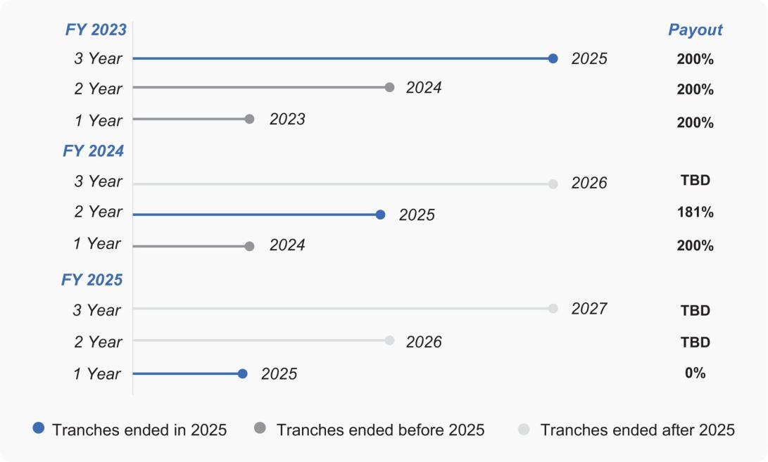

Fair Isaac Corporation l 2026 Proxy Statement 52

Table of Contents

Proxy | Board of | Corporate | Executive |  | Audit Committee | Charter | Stock | Other
Summary | Directors | Governance | Compensation |  | Matters | Amendments | Ownership | Matters

The target number of MSUs and the number of MSUs earned by each named executive officer for each of the three performance periods completed at the end of fiscal 2025 are as follows:

 |  | FY23 MSUs |  |  | FY24 MSUs |  |  | FY25 MSUs
 |  | Target |  |  | Target |  |  | Target
 |  | Number | Actual |  | Number | Actual |  | Number | Actual
 |  | Subject to | Number |  | Subject to | Number |  | Subject to | Number
 |  | Three-Year | of MSUs |  | Two-Year | of MSUs |  | One-Year | of MSUs
Named Executive Officer⁽²⁾ |  | Performance | Earned⁽¹⁾ |  | Performance | Earned |  | Performance | Earned
William Lansing |  | 4,195 | 8,390 |  | 2,818 | 5,100 |  | 1,494 | 0
Steven Weber |  | N/A | N/A |  | 564 | 1,020 |  | 274 | 0
Nikhil Behl |  | N/A | N/A |  | 395 | 714 |  | 299 | 0
Richard Deal |  | 831 | 1,662 |  | 564 | 1,020 |  | 274 | 0
Mark Scadina |  | 831 | 1,662 |  | 564 | 1,020 |  | 274 | 0

- The actual number of MSUs granted in fiscal 2023 and earned in fiscal 2025 was calculated by multiplying the total number of target units in the applicable award agreement by the relative return factor of 200% for fiscal 2025, then subtracting the fiscal 2023 MSUs earned at the conclusion of the first and second performance periods. The total number of Mr. Lansing’s target fiscal 2023 MSUs was 12,585, and multiplying by the 200% relative return factor yielded 25,170. Subtracting the 16,780 MSUs earned for the first and second performance periods yields the remaining 8,390 MSUs earned for the third performance period. The total number of Mr. Deal’s and Mr. Scadina’s target fiscal 2023 MSUs was 2,493 each, and multiplying by the 200% relative return factor yielded 4,986 MSUs each. Subtracting the 3,324 MSUs earned by each for the first and second performance periods yields the remaining 1,662 MSUs earned by each for the third performance period.

- All outstanding and unearned MSUs granted to Mr. Wehmann in fiscal 2023, 2024 and 2025 were forfeited upon his retirement from the Company.

Restricted Stock Units (“RSUs”). The RSUs granted in fiscal 2025 provide a link to our stock price performance and promote our retention objectives over a multi-year vesting period. Generally, the RSUs granted by the LDCC to executive officers vest in four equal annual installments beginning on the first anniversary of the grant date.

As in prior fiscal years, the LDCC permitted our executive officers to exchange up to 100% of their annual time-vested RSUs for non-qualified stock options (“NQSOs”) on an economically equivalent basis, while maintaining the existing four-year annual vesting requirement. We have provided executives with this flexibility of choice since fiscal 2015 as a retention tool, as the LDCC believes that NQSOs provide attractive leverage to the recipient and permit the holder to determine when taxable income events occur via a decision to exercise their NQSOs. In fiscal 2025, however, none of our named executive officers elected to receive a NQSO in exchange for an RSU award.

COMPENSATION-SETTING PROCESS

LDCC Process

Members of executive management participate in the LDCC’s meetings at the LDCC’s request. Management’s role is to contribute input and analysis, which the LDCC considers in making its decisions. The LDCC is not bound by management’s recommendations, but the LDCC relies on the insights of our CEO and Chief Human Resources Officer in determining compensation for our executive officers, other than our CEO. The LDCC also consults with its independent compensation consultant during its review of executive officer compensation. Prior to making decisions on executive compensation, the LDCC refers to comprehensive statements and reports prepared by its compensation consultant and management that reflect the amount and elements of each executive officer’s target total direct compensation opportunity relative to competitive market practices.

The LDCC conducts an annual performance review of our CEO in connection with the determination of his compensation. As part of this process, one or more LDCC members and/or the Chairman of our Board of Directors meet with each senior executive to discuss our CEO’s performance using a structured interview approach. In addition, each Board member completes a written evaluation of our CEO and submits it to the LDCC. Based on these interviews and written evaluations, as well as on its own determinations regarding our CEO’s performance, the LDCC prepares a final performance review for our CEO. The LDCC then submits a recommendation for our CEO’s compensation to our Board of Directors for discussion. Following such discussion, the LDCC finalizes its determination of our CEO’s compensation and informs our CEO of such determination, together with the final performance review.

Fair Isaac Corporation l 2026 Proxy Statement 53

Table of Contents

Proxy | Board of | Corporate | Executive |  | Audit Committee | Charter | Stock | Other
Summary | Directors | Governance | Compensation |  | Matters | Amendments | Ownership | Matters

For each named executive officer, in determining an individual’s compensation levels, the LDCC considers a number of factors, including the executive officer’s role within the Company, experience, performance, and potential for development, the cost to the Company of replacing the individual, and compensation peer group data for comparable roles within the peer group companies. The LDCC does not benchmark total compensation or individual elements of compensation to particular percentiles within the Company’s compensation peer group, but aims to create competitive pay packages that reflect the Company’s and individuals’ performance and that are generally intended to deliver above market median compensation if long-term equity incentive awards pay out at or above target based on challenging required levels of performance. In connection with our fiscal 2025 executive compensation program, the LDCC reviewed summary reports prepared by its compensation consultant and by management reflecting current and proposed base salary, short-term cash incentive and equity award levels for our executive officers. Each element was analyzed relative to the peer group.
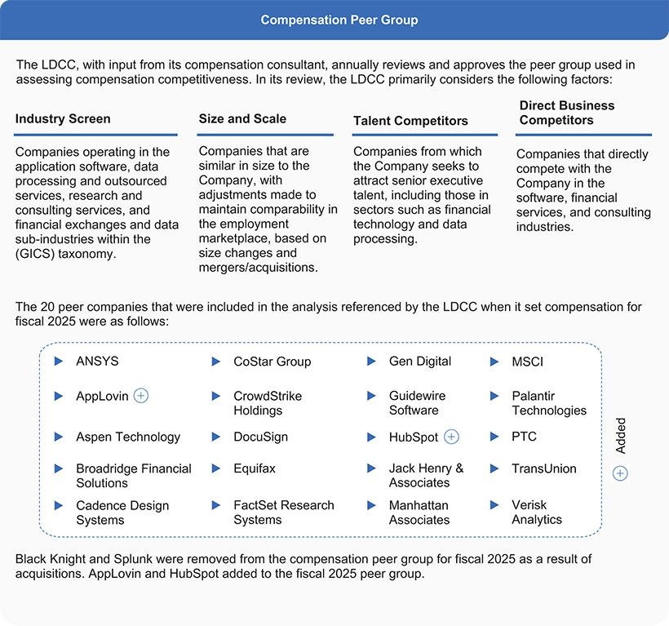

Fair Isaac Corporation l 2026 Proxy Statement 54

Table of Contents

Proxy | Board of | Corporate | Executive |  | Audit Committee | Charter | Stock | Other
Summary | Directors | Governance | Compensation |  | Matters | Amendments | Ownership | Matters

Specific information with respect to the Company’s relative position follows, using values available at the time the compensation levels were being determined in November 2024:

 |  | Market | Operating
 | Revenue | Capitalization | Income | Net Income | One-Year | Three-Year
 | ($ in millions) | ($ in millions) | ($ in millions) | ($ in millions) | TSR (%) | TSR (%)
75th percentile of peer group | $3,864 | $37,084 | $1,104 | $730 | 46% | 13%
50th percentile of peer group | $2,651 | $24,939 | $ 561 | $450 | 21% | 5%
25th percentile of peer group | $2,218 | $15,820 | $ 121 | $196 | -7% | -4%
FICO | $1,653 | $43,318 | $ 702 | $479 | 110% | 64%
Percentile rank | 13% | 83% | 61% | 52% | 92% | 100%

Use of Compensation Consultant

The LDCC retains an external, independent compensation consultant to assist it in analyzing our executive compensation program and assessing market levels of compensation. For fiscal 2025, the LDCC engaged Compensia, Inc. to provide competitive practice and market compensation data, advice regarding the design of compensation programs for our executive officers and non-employee directors, input regarding specific compensation actions for our executive officers and analysis of the composition of our compensation peer group.

Compensation Consultant Conflict of Interest Analysis

The LDCC has considered the relationships that the compensation consultant it engaged in fiscal 2025 has had with the Company, the members of the LDCC and the Company’s executive officers, as well as the policies that the consultant has in place to maintain its independence and objectivity and has determined that no conflicts of interest arose from the work performed by such consultant.

Retirement Arrangements

We offer a Section 401(k) plan for all eligible employees. Under this program, our executive officers (like all of our eligible employees) can receive a Company matching contribution on amounts they contribute to the Section 401(k) plan as follows: 100% match of the first 3% of eligible compensation contributed by the executive officer, followed by a 50% match of the next 2% of eligible compensation contributed by the executive officer. Our executive retirement and savings plan allows our vice presidents and more senior executive officers to defer up to 25% of their base salary and 75% of their short-term cash incentive awards into an investment account. Amounts in this account are payable upon certain employment termination events as specified in the plan.

In November 2018, the LDCC approved the inclusion of retirement provisions in the award agreements for the equity awards granted to our executive officers beginning in December 2018. In May 2023, the LDCC amended the retirement qualification provisions in such award agreements. Such provisions allow for continued vesting of outstanding equity awards upon an executive officer’s retirement provided that (i) such executive officer (a) is 55 or older, (b) has at least 5 years of continuous service as an employee (which must be immediately preceding the date of termination), and (c) has served at least five cumulative years as an Executive Vice President of the Company (while both (b) and (c) must be satisfied, periods of time served as an Executive Vice President under (c) may also be counted toward the five years of continuous service requirement under (b)), and (ii) the sum of such executive officer’s age as of the date of his or her termination plus their years of service as an employee equals at least 75. In order to qualify for continued vesting, the executive officer must provide at least one year’s notice of his or her retirement and must also be available to provide service to the Company, if requested, during the continued vesting period. In addition, during the continued vesting period, the executive officer may not become employed by another entity or organization. The LDCC believes the retirement provisions help enhance retention of our executive officers, improve the executive transition process by ensuring sufficient time to plan for a successor, and ensure continued support from the former executive officer following retirement.

Fair Isaac Corporation l 2026 Proxy Statement 55

Table of Contents

Proxy | Board of | Corporate | Executive |  | Audit Committee | Charter | Stock | Other
Summary | Directors | Governance | Compensation |  | Matters | Amendments | Ownership | Matters

Effective September 5, 2025, Mr. Wehmann retired from FICO. Mr. Wehmann did not meet the applicable qualification provisions for his termination to qualify as a “retirement” under his outstanding award agreements, and therefore he forfeited all outstanding equity awards held by him.

The special performance-based retention and leadership continuity awards of MSUs and NQSOs granted to Mr. Lansing in June 2023 provide that if Mr. Lansing retires, his retirement will not entitle him to acceleration or continued vesting of those MSUs and NQSOs.

Other Compensation Arrangements

We maintain the Fair Isaac Non-Qualified Deferred Compensation Plan, which provides that executives who meet minimum compensation requirements are eligible to defer up to 50% of their salaries (increased during 2025 from 25%) and up to 75% of their bonuses. We credit the participants’ contributions with earnings or losses that reflect the performance of certain independent investment funds. We do not guarantee above-market interest on account balances. We make annual employer matching credits to participants’ accounts on the same basis as provided under the Fair Isaac 401(k) Plan, based on the matching contribution formula available under that plan, reduced by the amount of matching contributions received by the participant under the 401(k) Plan.

Benefits under the Non-Qualified Deferred Compensation Plan are unfunded (paid from the general assets of the Company), and plan participants are unsecured general creditors of the Company. Participants are eligible to receive payment of their vested benefit either in lump sum or installments of up to ten years, at their election, commencing after the earlier of their separation from service or a specific date while still employed.

Our executive officers participate in our general employee benefit plans and programs, including health and dental benefits, on the same terms as all of our other full-time employees. We also pay the premiums for group life, accidental death and dismemberment, and business travel accident insurance for all eligible employees, including our executive officers, in a coverage amount based upon their base salary.

We provide only limited perquisites. When an executive officer’s spouse is expected by the Company to accompany the officer to a Company event, the Company pays for the spouse’s related travel expenses. In addition, in the event that an executive officer is required to make a filing under the Hart-Scott-Rodino Antitrust Improvement Act of 1976 (“HSR”) due to their ownership level of FICO stock and our stock price performance, the Company, with approval from the LDCC, pays the related filing fee and preparation fees. The Company also provides tax reimbursement, or gross-up, payments on any spousal travel payments, HSR-related payments and relocation benefits.

Post-Employment Compensation Arrangements

Each of our named executive officers who is a current executive officer is party to a Letter Agreement that, among other things, provides for payments and benefits in the event of termination of employment by the Company without cause or by the executive officer for good reason, and a Management Agreement that provides for payments and benefits in the event of such a termination of employment in connection with a change in control of the Company. These agreements are described in detail later in this proxy statement.

The LDCC believes that these severance and change-in-control arrangements are meaningful recruitment and retention devices, are important components in a competitive compensation package for our named executive officers, and will mitigate concerns that the executive officers may have regarding their continued employment prior to or following a change in control of the Company, thereby allowing them to focus their undivided attention on advancing the interests of the Company and its stockholders. The change-in-control arrangements are “double-trigger” (that is, they require both a change in control of the Company and a termination of employment without cause or by the executive officer for good reason within 24 months of the change in control) and the named executive officers are not eligible to receive tax payments or gross-ups in connection with any change-in-control arrangement.

Fair Isaac Corporation l 2026 Proxy Statement 56

Table of Contents

Proxy | Board of | Corporate | Executive |  | Audit Committee | Charter | Stock | Other
Summary | Directors | Governance | Compensation |  | Matters | Amendments | Ownership | Matters

Policies and Procedures Related to the Grant of Certain Equity Awards

Equity awards granted to our named executive officers in fiscal 2025 were granted under the 2021 Long-Term Incentive Plan (“2021 LTIP”), which authorizes the issuance of equity awards, including stock options, stock appreciation rights, restricted stock awards, stock unit awards and other stock-based awards. Equity awards for all executive officers are approved by the LDCC. The LDCC has delegated authority to our CEO to approve the granting of equity awards to employees who are not executive officers, subject to certain parameters approved by the LDCC.

The exercise price of stock options is set at fair market value of our common stock on the date of grant, with annual equity awards generally granted by the LDCC on a pre-determined day in December of each fiscal year, consistent with our annual compensation cycle. The dates for these grants are typically set in advance on a fairly consistent cadence year over year.

The timing of any equity grants to executive officers in connection with new hires, promotions, or other non-routine grants is tied to the event giving rise to the award (such as an executive officer’s commencement of employment or promotion effective date), and such awards are typically accumulated and granted together early in the month following the triggering event.

As a result, in all cases, the timing of grants of equity awards, including stock options, occurs independent of the release of any material nonpublic information, and the LDCC does not time the disclosure of material nonpublic information for the purpose of affecting the value of equity-based compensation.

Fair Isaac Corporation l 2026 Proxy Statement 57

Table of Contents

Proxy | Board of | Corporate | Executive |  | Audit Committee | Charter | Stock | Other
Summary | Directors | Governance | Compensation |  | Matters | Amendments | Ownership | Matters

Executive Stock Ownership Guidelines

Our Board of Directors has adopted stock ownership guidelines for our executive officers. Our CEO is required to own at least 100,000 shares of our common stock, and our Executive Vice Presidents are required to own shares valued at least five times their annual base salary. Our guidelines provide that only shares owned outright and unvested time-based RSUs are counted for purposes of determining compliance with these guidelines (stock options and unachieved performance-based equity awards do not count towards ownership). The guidelines provide that executive officers should achieve the stated guidelines within five years of appointment. As of the end of fiscal 2025, all of our executive officers had met or exceeded their required stock ownership level or were making acceptable progress to their required level.

Executive Officer Incentive Compensation Recovery Policies

We have a Compensation Recovery Policy as required by the listing standards of the New York Stock Exchange (the “Required Clawback Policy”). The Required Clawback Policy applies to all incentive-based compensation, which is any compensation that is granted, earned, or vested based wholly or in part upon the attainment of a financial reporting measure, received by our executive officers, including our named executive officers. The Required Clawback Policy applies in the case of an accounting restatement due to the material noncompliance of the Company with any financial reporting requirement under the securities laws, including any required accounting restatement to correct an error in previously issued financial statements that is material to the previously issued financial statements, or that would result in a material misstatement if the error were corrected in the current period or left uncorrected in the current period. The Required Clawback Policy provides that promptly following such an accounting restatement, the LDCC will determine the amount of the erroneously awarded compensation, which is the excess of the amount of incentive-based compensation received by current and former executive officers during the three completed fiscal years immediately preceding the required restatement date over the amount of incentive-based compensation that otherwise would have been received had it been determined based on the restated amounts. The Company will provide each such executive officer with a written notice of such amount and a demand for repayment or return.

We also have a Supplemental Compensation Recovery Policy (the “Supplemental Clawback Policy”). The Supplemental Clawback Policy applies to any annual or long-term incentive compensation, including equity-based compensation, whether based on performance metrics or time-based or service-based metrics, as well as any severance compensation, received by our executive officers, including our named executive officers. Under the Supplemental Clawback Policy, in the event of a felony-level conviction of an executive officer that results in material financial or reputational harm to the Company or a violation by an executive officer of his or her Proprietary Information and Invention Agreement or his or her Post-Employment Restrictions Agreement that results in material financial or reputational harm to the Company, then the Company’s independent directors may determine to seek recovery of all or any portion of any annual or long-term incentive compensation received by, granted to, vested or earned by the officer in the fiscal year in which the misconduct occurred and in any subsequent period.

No Hedging

Under the terms of our insider trading policy, the members of the Board of Directors, officers and employees may not buy or sell puts or calls on Company stock, trade options on any of the stock exchanges or futures exchanges relating to Company stock, enter into equity swaps, prepaid variable forward contracts, collars or exchange funds involving Company stock and other transactions that are designed to hedge or offset decreases in the price of Company stock.

Tax Matters

Section 162(m) of the Code generally disallows a tax deduction to public companies for compensation of more than $ 1 million paid in any taxable year to certain current and former named executive officers. As a general matter, while the LDCC is mindful of the benefit to the Company of the full deductibility of compensation, it believes that it should maintain flexibility in compensating the Company’s executive officers in a manner that can best promote our corporate objectives.

Fair Isaac Corporation l 2026 Proxy Statement 58

Table of Contents

Proxy | Board of | Corporate | Executive |  | Audit Committee | Charter | Stock | Other
Summary | Directors | Governance | Compensation |  | Matters | Amendments | Ownership | Matters

Leadership Development and Compensation Committee Report

The LDCC has discussed and reviewed the “Compensation Discussion and Analysis” with management. Based upon this review and discussion, the LDCC recommended to our Board of Directors that the “Compensation Discussion and Analysis” be included in this proxy statement and incorporated by reference in our Annual Report on Form 10-K.

Submitted by the Leadership Development and

Compensation Committee:

Joanna Rees, Chair
Fabiola R. Arredondo
Braden R. Kelly
Eva Manolis
Fair Isaac Corporation l 2026 Proxy Statement |  |  |  |  |  |  |  |  |  |  |  |  | 59

Table of Contents

Proxy | Board of | Corporate | Executive |  | Audit Committee | Charter | Stock | Other
Summary | Directors | Governance | Compensation |  | Matters | Amendments | Ownership | Matters

Compensation Tables

SUMMARY COMPENSATION TABLE

The following table summarizes all compensation earned in fiscal 2025, 2024 and 2023 by our named executive officers.

 |  |  |  |  |  |  |  |  | Change in
 |  |  |  |  |  |  |  |  | Pension
 |  |  |  |  |  |  |  |  | Value
 |  |  |  |  |  |  |  |  | and Non-
 |  |  |  |  |  |  |  |  | Qualified
 |  |  |  |  |  |  |  | Non-Equity | Deferred
 |  |  |  |  |  | Stock | Option | Incentive | Compensation | All Other
 |  |  | Fiscal | Salary | Bonus | Awards | Awards | Plan | Earnings | Compensation | Total
Name and Principal Position |  |  | Year | ($) | ($) | ($)(1)(2) | ($)(3) | ($)(4) | ($) | ($)(5) | ($)
William Lansing |  | 2025 |  | 750,000 | — | 34,091,860 | — | 1,100,000 | — | 103,407 | 36,045,267
Chief Executive Officer |  | 2024 |  | 750,000 | — | 33,311,064 | — | 1,200,000 | — | 299,471 | 35,560,535
 |  | 2023 |  | 750,000 | — | 48,996,329 | 15,347,003 | 1,200,000 | — | 56,630 | 66,349,962
Steven Weber |  | 2025 |  | 400,000 | — | 6,255,247 | — | 250,000 | — | 53,585 | 6,958,832
Executive Vice President and |  |  | 2024 | 400,000 | — | 6,662,212 | — | 275,000 | — | 60,867 | 7,398,079
Chief Financial Officer |  |  | 2023 | 305,577 | — | 4,079,517 | — | 275,000 | — | 24,098 | 4,684,192
Nikhil Behl⁽⁶⁾ |  | 2025 |  | 500,000 | — | 6,818,373 | — | 350,000 | — | 59,490 | 7,727,863
President, Software
Richard Deal⁽⁷⁾ |  | 2025 |  | 400,000 | — | 6,255,247 | — | 250,000 | — | 58,177 | 6,963,424
Executive Vice President, |  | 2024 |  | 400,000 | — | 6,662,212 | — | 275,000 | — | 44,031 | 7,381,243
Chief Human Resources Officer
Mark Scadina |  | 2025 |  | 400,000 | — | 6,255,247 | — | 275,000 | — | 209,176 | 7,139,423
Executive Vice President, |  | 2024 |  | 400,000 | — | 6,662,212 | — | 300,000 | — | 46,919 | 7,409,131
General Counsel |  | 2023 |  | 400,000 | — | 5,488,415 | — | 300,000 | — | 48,931 | 6,237,346
James Wehmann |  | 2025 |  | 490,385 | — | 6,818,373 | — | — | — | 14,184 | 7,322,942
Former President, Scores |  |  | 2024 | 500,000 | — | 7,997,808 | — | 375,000 | — | 13,446 | 8,886,254
 |  |  | 2023 | 500,000 | — | 8,231,522 | — | 375,000 | — | 12,456 | 9,118,978

- The amounts in the “Stock Awards” column represent the aggregate grant date fair value of each award granted during the fiscal year, computed in accordance with FASB ASC Topic 718, and do not reflect whether the named executive officer has actually realized a financial benefit from the award. For information on the assumptions used to calculate the value of the awards, refer to Note 13 of the Company’s Consolidated Financial Statements in the Annual Report on Form 10-K for the fiscal year ended September 30, 2025, as filed with the SEC.

- Stock Awards for fiscal 2025 include the grant date fair value of time-based RSU awards, PSU awards and MSU awards granted on December 9, 2024, under the 2021 LTIP.

The PSUs were tied to the achievement of certain performance goals during fiscal 2025, and the named executive officer must be an employee on the vesting dates of December 9th of 2025, 2026 and 2027 in order to realize the earned PSU value. The values included in the table for the PSUs are at target value, representing the probable outcome of the performance conditions as calculated at the time of grant. The maximum value of the award on the grant date, assuming the highest level of performance conditions achieved, would be $19,954,906 vs. target of $9,977,453 for Mr. Lansing; $3,661,368 vs. target of $1,830,684 for Mr. Weber; $3,990,982 vs. target of $1,995,491 for Mr. Behl; $3,661,368 vs. target of $1,830,684 for Mr. Deal; $3,661,368 vs. target of $1,830,684 for Mr. Scadina; and $3,990,982 vs. target of $1,995,491 for Mr. Wehmann. The named executive officers earned 150.2% of their respective target award, resulting in 6,729 units for Mr. Lansing; 1,235 units for Mr. Weber; 1,346 units for Mr. Behl; 1,235 units for Mr. Deal; and 1,235 units for Mr. Scadina. Due to his retirement on September 5, 2025, Mr. Wehmann’s fiscal 2025 PSUs were forfeited.

Fair Isaac Corporation l 2026 Proxy Statement 60

Table of Contents

Proxy | Board of | Corporate | Executive |  | Audit Committee | Charter | Stock | Other
Summary | Directors | Governance | Compensation |  | Matters | Amendments | Ownership | Matters

The MSUs granted in fiscal 2025 were tied to the achievement of certain performance goals over three performance periods ending on November 30, 2025, 2026 and 2027. The named executive officers must be employed on the vesting dates of December 9th of 2025, 2026 and 2027 in order to realize the earned MSU value.

The values included in the table for the MSUs are at target value, representing the probable outcome of the performance conditions as calculated at the time of grant. The maximum value of the award on the grant date, assuming the highest level of performance conditions achieved, would be $28,273,908 vs. target of $ 14,136,954 for Mr. Lansing; $5,187,758 vs. target of $2,593,879 for Mr. Weber; $5,654,782 vs. target of $2,827,391 for Mr. Behl; $5,187,758 vs. target of $2,593,879 for Mr. Deal; $5,187,758 vs. target of $2,593,879 for Mr. Scadina; $5,654,782 vs. target of $ 2,827,391 for Mr. Wehmann. Based on FICOs stock performance compared to the 55th percentile company in the S&P 500 Index our total stockholder return of -19.87% for fiscal 2025, 0% of the MSUs granted in fiscal 2025 were earned at the conclusion of the first performance period ending on November 30, 2025. Due to his retirement on September 5, 2025, Mr. Wehmann’s fiscal 2025 MSUs were forfeited.

- The amount in the “Option Awards” column represents the grant date fair value, computed in accordance with FASB ASC Topic 718, of the special performance-based retention and leadership continuity award of non-qualified stock options granted to Mr. Lansing on June 5, 2023. None of the named executive officers elected to receive stock options in exchange for a portion of his RSU awards in any of the years shown. For information on the assumptions used to calculate the value of the stock options, refer to Note 13 of the Company’s Consolidated Financial Statements in the Annual Report on Form 10-K for the fiscal year ended September 30, 2025, as filed with the SEC.

- Represents amounts paid in the first quarter of fiscal 2026 based on performance during fiscal 2025 under our Executive Incentive Plan.

- The amounts shown for fiscal 2025 are detailed in the supplemental table below entitled “All Other Compensation Table.” In addition, the amount shown for Mr. Lansing for fiscal 2024, as well as the amount in the “Total” column, were updated to reflect that, during fiscal 2024, we paid $239,172 in filing fees and related preparation fees on behalf of Mr. Lansing for HSR compliance. Further, the amount shown for Mr. Scadina for fiscal 2024, as well as the amount in the “Total” column, were updated to reflect that, during fiscal 2024, we paid $13,946 in preparation fees on behalf of Mr. Scadina for HSR compliance.

- As permitted by SEC rules, because fiscal 2025 was Mr. Behl’s first year as a named executive officer, the compensation paid to him prior to fiscal 2025 is not included in the table.

- As permitted by SEC rules, because fiscal 2024 was Mr. Deal’s first year as a named executive officer, the compensation paid to him prior to fiscal 2024 is not included in the table.

All Other Compensation Table

 | William | Steven | Nikhil | Richard | Mark | James
Elements of All Other Compensation | Lansing | Weber | Behl | Deal | Scadina | Wehmann
401(k) Match($)⁽¹⁾ | 14,000 | 13,800 | 14,262 | 13,800 | 13,770 | 13,800
Life Insurance Premium($)⁽²⁾ | 349 | 307 | 384 | 307 | 307 | 384
Spousal Travel($)⁽³⁾ | 42,439 | 20,923 | 23,841 | 18,296 | 36,836 | —
Tax Gross Up($)⁽⁴⁾ | 34,959 | 18,555 | 21,003 | 25,774 | 36,093 | —
Other($)⁽⁵⁾⁽⁶⁾ | 11,660 | — | — | — | 122,170 | —
Total($) | 103,407 | 53,585 | 59,490 | 58,177 | 209,176 | 14,184

- Represents the aggregate value of the Company’s cash contribution under the Fair Isaac Corporation 401(k) Plan during fiscal 2025.

- Represents the aggregate incremental cost for the named executive officer’s basic life insurance premium, which is offered to all employees at one times current salary.

Fair Isaac Corporation l 2026 Proxy Statement 61

Table of Contents

Proxy | Board of | Corporate | Executive |  | Audit Committee | Charter | Stock | Other
Summary | Directors | Governance | Compensation |  | Matters | Amendments | Ownership | Matters

- Represents amounts spent on commercial aircraft of the named executive officers’ spouses who were expected by the Company to attend certain Company events.

- Represents gross-up payments to offset imputed income for the cost of spousal travel and, for Mr. Lansing and Mr. Scadina, the amount of gross-up payments to offset imputed income for their HSR-related payments. Company policy allows gross-ups only for required spousal travel, Company-paid relocation costs and certain required regulatory filings, when applicable.
- Represents tax preparation fees incurred by Mr. Lansing, as provided in his Letter Agreement.

- Represents filing fees and related preparation fees paid on behalf of Mr. Scadina for HSR compliance.

Fair Isaac Corporation l 2026 Proxy Statement 62

Table of Contents

Proxy | Board of | Corporate | Executive |  | Audit Committee | Charter | Stock | Other
Summary | Directors | Governance | Compensation |  | Matters | Amendments | Ownership | Matters

GRANTS OF PLAN-BASED AWARDS FOR FISCAL 2025

The following table summarizes grants of plan-based compensation awards made during fiscal 2025 to our named executive officers.

 |  |  |  |  |  |  |  |  | All Other
 |  |  |  |  |  |  |  |  | Stock | Grant
 |  | Estimated Possible Payouts |  |  |  | Estimated Future Payouts |  |  | Awards: | Date Fair
 |  | Under Non-Equity Incentive |  |  |  | Under Equity Incentive |  |  | Number | Value of
 |  |  | Plan Awards⁽¹⁾ |  |  |  | Plan Awards |  | of | Stock
 |  |  |  |  |  |  |  |  | Shares | and
 |  |  |  |  |  |  |  |  | of Stock | Option
 | Grant | Threshold | Target | Maximum |  | Threshold | Target | Maximum | or Units | Awards
Name | Date | ($) | ($) | ($) | (#) |  | (#) | (#) | (#) | ($)⁽⁵⁾
William Lansing |  | 93,750 | 750,000 | 1,406,250
 | 12/09/2024 |  |  |  | ₀(2) |  | 4,480⁽²⁾ | 8,960⁽²⁾ |  | 14,136,954
 | 12/09/2024 |  |  |  | ₀(3) |  | 4,480⁽³⁾ | 8,960⁽³⁾ |  | 9,977,453
 | 12/09/2024 |  |  |  |  |  |  |  | 4,480⁽⁴⁾ | 9,977,453
Steven Weber |  | 25,000 | 200,000 | 375,000
 | 12/09/2024 |  |  |  | ₀(2) |  | 822⁽²⁾ | 1,644⁽²⁾ |  | 2,593,879
 | 12/09/2024 |  |  |  | ₀(3) |  | ₈₂₂(3) | 1,644⁽³⁾ |  | 1,830,684
 | 12/09/2024 |  |  |  |  |  |  |  | 822⁽⁴⁾ | 1,830,684
Nikhil Behl |  | 31,250 | 250,000 | 468,750
 | 12/09/2024 |  |  |  | ₀(2) |  | 896⁽²⁾ | 1,792⁽²⁾ |  | 2,827,391
 | 12/09/2024 |  |  |  | ₀(3) |  | ₈₉₆(3) | 1,792⁽³⁾ |  | 1,995,491
 | 12/09/2024 |  |  |  |  |  |  |  | 896⁽⁴⁾ | 1,995,491
Richard Deal |  | 25,000 | 200,000 | 375,000
 | 12/09/2024 |  |  |  | ₀(2) |  | 822⁽²⁾ | 1,644⁽²⁾ |  | 2,593,879
 | 12/09/2024 |  |  |  | ₀(3) |  | 822⁽³⁾ | 1,644⁽³⁾ |  | 1,830,684
 | 12/09/2024 |  |  |  |  |  |  |  | ₈₂₂(4) | 1,830,684
Mark Scadina |  | 25,000 | 200,000 | 375,000
 | 12/09/2024 |  |  |  | ₀(2) |  | ₈₂₂(2) | 1,644⁽²⁾ |  | 2,593,879
 | 12/09/2024 |  |  |  | ₀(3) |  | 822⁽³⁾ | 1,644⁽³⁾ |  | 1,830,684
 | 12/09/2024 |  |  |  |  |  |  |  | 822⁽⁴⁾ | 1,830,684
James Wehmann |  | 31,250 | 250,000 | 468,750
 | 12/09/2024 |  |  |  | ₀(2) |  | 896⁽²⁾ | 1,792⁽²⁾ |  | 2,827,391
 | 12/09/2024 |  |  |  | ₀(3) |  | ₈₉₆(3) | 1,792⁽³⁾ |  | 1,995,491
 | 12/09/2024 |  |  |  |  |  |  |  | ₈₉₆(4) | 1,995,491

- The amounts shown in these columns represent the estimated threshold (or minimum), target, and maximum possible cash incentive awards for each of the named executive officers. Under our Executive Incentive Plan, Mr. Lansing’s target amount is equal to 100% of his base salary and the target amount for each of the other named executive officers is equal to 50% of their base salary. The maximum amount in each case equals 1.875 times the target amount, which would result if the Company Performance Factor was 125% and the Participant Performance Factor was 150%. The threshold amount in each case is 12.50% of the target amount, which would result if the Company Performance Factor achieved the threshold level of performance and the Participant Performance Factor was 0%. Additional detail regarding the determination of cash incentives to executives for fiscal 2025 is included above under “Compensation Discussion and Analysis.” Actual payments are set forth in the “Summary Compensation Table” above.

- Amounts shown reflect MSUs that were granted under our 2021 LTIP and are subject to the achievement of specific performance goals related to the Company’s total shareholder return relative to the S&P 500 Index, with performance at the 55th percentile of the Index required to achieve target payout, over performance periods of one, two and three years, approved by the LDCC, with no threshold (or minimum) levels of performance. On December 3, 2025, the LDCC certified that for all named executive officers, 0% of the target awards for the first performance period were earned for that tranche of awards eligible to vest on December 9, 2025. The remaining portion of the target awards may be earned subject to achievement of specific performance goals for the two- and three-year performance periods and then subsequently vest subject to the named executive officer’s continued Service as a Service Provider (as defined in the 2021 LTIP) through December 9, 2026, and December 9, 2027, respectively. These awards do not pay dividend equivalents.

Fair Isaac Corporation l 2026 Proxy Statement 63

Table of Contents

Proxy | Board of | Corporate | Executive |  | Audit Committee | Charter | Stock | Other
Summary | Directors | Governance | Compensation |  | Matters | Amendments | Ownership | Matters

- Amounts shown reflect PSUs that were granted under our 2021 LTIP and were subject to the achievement of specific performance goals related to adjusted revenue and adjusted EBITDA metrics approved by the LDCC, with no threshold (or minimum) levels of performance. For all named executive officers, 150.2% of the target awards were earned, one-third of the earned units vested on December 9, 2025, and the remaining two-thirds are scheduled to vest in two annual installments beginning December 9, 2026 (subject to the named executive officer’s continued Service as a Service Provider (as defined in the 2021 LTIP)). These awards do not pay dividend equivalents.

- Reflects RSUs that were granted under our 2021 LTIP which vest in four equal increments on the first four anniversaries of the grant date subject to the named executive officer’s continued Service as a Service Provider (as defined in the 2021 LTIP). These awards do not pay dividend equivalents.

- Represents the grant date fair value of each stock option, MSU, PSU, RSU, or Non-Qualified Option, as applicable, computed in accordance with FASB ASC Topic 718. The values included in the table for the MSUs, and PSUs are at target value, representing the probable outcome of the performance conditions as calculated at the time of grant.

Letter Agreements

The Company is a party to Letter Agreements with each of the named executive officers. The material provisions of such Letter Agreements related to the executive officers’ ongoing compensation arrangements are described below.

William Lansing

For each full fiscal year of the Company during the term of his Letter Agreement, Mr. Lansing will be eligible to receive a cash incentive award with a target value equal to 100% of his annual base salary at the rate in effect at the end of such fiscal year, pursuant to the Company’s Executive Incentive Plan and the terms and conditions established by the LDCC from time to time.

If Mr. Lansing’s employment is terminated by the Company without Cause or if he voluntarily resigns for Good Reason (both as defined below) prior to the expiration of the term of the Letter Agreement, Mr. Lansing will be entitled to the following severance pay and benefits pursuant to the Letter Agreement: (i) a cash payment in an amount equal to two times the sum of (a) his annual base salary in effect on the last day of his employment (but in no event less than $ 675,000), plus (b) the annual cash incentive payment last paid to him before the termination of his employment, such cash payment to be made in a lump sum on the 70th day following Mr. Lansing’s separation from service, and (ii) continuation of certain benefits pursuant to COBRA for 18 months. Mr. Lansing’s receipt of severance pay and benefits would be conditioned on his execution of a release of claims against the Company, his compliance with the terms of any agreements in effect between him and the Company, his cooperation in the transition of his duties, and his agreement not to disparage the Company.

Mr. Lansing’s Letter Agreement also provides that the Company will reimburse him annually up to $25,000 related to financial planning and/or personal income tax preparation and accounting services.

Other Named Executive Officers

For each full fiscal year of the Company during the term of each executive officer’s Letter Agreement, the executive officer will be eligible to receive a cash incentive award with a target equal to 50% of his or her annual base salary at the rate in effect at the end of such fiscal year, pursuant to the Company’s Executive Incentive Plan and the terms and conditions established by the LDCC from time to time.

If an executive officer’s employment is terminated by the Company without Cause or if he or she voluntarily resigns for Good Reason (both as defined below) prior to the expiration of the term of his or her Letter Agreement, such executive officer will be entitled to the following severance pay and benefits pursuant to the Letter Agreement: (1) a cash payment in an amount equal to one times the sum of (a) his or her annual base salary in effect on the last day of employment, plus (b) the annual cash incentive payment last paid to him or her before the termination of employment, such cash payment to be made in a lump sum on the 70th day following his or her separation from service (subject to certain exceptions), and (2) continuation of certain benefits pursuant to COBRA for 12 months. The executive officer’s receipt of severance pay and benefits would be conditioned on his or her release of claims against the Company, compliance with the terms of any agreements in effect between such executive officer and the Company, his or her cooperation in the transition of his or her duties, and his or her agreement not to disparage the Company.

Fair Isaac Corporation l 2026 Proxy Statement 64

Table of Contents

Proxy | Board of | Corporate | Executive |  | Audit Committee | Charter | Stock | Other
Summary | Directors | Governance | Compensation |  | Matters | Amendments | Ownership | Matters

Definitions

In all of the Letter Agreements, “Cause” generally means a good faith determination by the Company of one or more of the following: (i) commission by the executive officer of a felony, (ii) an intentional act of fraud or material dishonesty connected with the executive officer’s employment with the Company or otherwise likely to cause the Company material harm, (iii) the executive officer’s willful failure or refusal to perform in all material respects his or her duties, or (iv) a material breach by the executive officer of the Company’s policies or codes of conduct or of another written agreement between the Company and the executive officer.

In Mr. Lansing’s Letter Agreement, “Good Reason” generally means that one of the following conditions occurs without his consent and the Company does not cure the condition after receiving notice of it: (i) a material diminution in Mr. Lansing’s status or position as Chief Executive Officer, (ii) a requirement that Mr. Lansing relocate to an office located more than 50 miles away from his current office location, (iii) a material breach by the Company of the terms of the Letter Agreement, or (iv) a failure by the Company to obtain agreement from any successor to assume the Letter Agreement.

In the other named executive officers’ Letter Agreements, “Good Reason” generally means that one of the following conditions occurs without the executive officer’s consent and the Company does not cure the condition after receiving notice of it: (i) a material reduction in the executive officer’s base salary, (ii) a material reduction in the executive officer’s annual cash incentive target expressed as a percentage of base salary, (iii) a requirement that the executive officer relocate to an office located more than 50 miles away from his or her current office location, (iv) a material breach by the Company of the terms of the Letter Agreement, or (v) a failure by the Company to obtain agreement from any successor to assume the Letter Agreement.

Fair Isaac Corporation l 2026 Proxy Statement 65

Table of Contents

Proxy | Board of | Corporate | Executive |  | Audit Committee | Charter | Stock | Other
Summary | Directors | Governance | Compensation |  | Matters | Amendments | Ownership | Matters

OUTSTANDING EQUITY AWARDS AT FISCAL 2025 YEAR END

The following table sets forth certain information with respect to outstanding equity awards held by our named executive officers at September 30, 2025.

 |  |  |  | Option Awards |  |  |  |  |  |  | Stock Awards
 |  |  |  |  |  |  |  |  |  |  |  | Equity | Equity
 |  |  |  |  |  |  |  |  |  |  |  | Incentive | Incentive
 |  |  |  |  |  |  |  |  |  |  |  | Plan | Plan
 |  |  |  |  |  |  |  |  |  |  |  | Awards: | Awards:
 |  |  |  |  |  |  |  |  |  | Number |  | Number of | Market or
 |  |  |  |  | Equity |  |  |  |  | of |  | Unearned | Payout
 |  |  |  |  | Incentive |  |  |  |  | Shares |  | Shares, | Value of
 |  |  |  |  | Plan Awards: |  |  |  |  | or | Market | Units or | Unearned
 |  |  | Number of | Number of | Number of |  |  |  |  | Units | Value of | Other | Shares,
 |  |  | Securities | Securities | Securities |  |  |  |  | of Stock | Shares or | Rights | Units or
 |  |  | Underlying | Underlying | Underlying |  |  |  |  | That | Units of | That | Other
 |  |  | Unexercised | Unexercised | Unexercised | Option |  |  |  | Have | Stock That | Have | Rights That
 |  |  | Options | Options | Unearned | Exercise | Option |  |  | Not | Have Not | Not | Have Not
 | Grant |  | (#) | (#) | Options | Price | Expiration |  | Grant | Vested | Vested | Vested | Vested
Name | Date |  | Exercisable | Unexercisable | (#) | ($) | Date |  | Date | (#) | ($)⁽¹⁾ | (#) | ($)⁽¹⁾
William Lansing | 12/10/2018 |  | 6,011 | — | — | 185.05 | 12/09/2025 |  | 12/10/2018 | — | — | — | —
 | 12/10/2019 |  | 9,782 | — | — | 354.18 | 12/09/2026 |  | 12/10/2019 | — | — | — | —
 | — |  | — | — | — | — | — |  | 12/10/2021 | 3,120⁽²⁾ | 4,669,174 | — | —
 | — |  | — | — | — | — | — |  | 12/09/2022 | 6,292⁽²⁾ | 9,416,167 | — | —
 | — |  | — | — | — | — | — |  | 12/09/2022 | 8,390⁽⁴⁾ | 12,555,887 | 8,390⁽⁷⁾ | 12,555,887
 | 06/05/2023 |  | — | 52,082⁽¹⁰⁾ | — | 791.60 | 06/04/2030 |  | 06/05/2023 | — | — | 19,576⁽¹¹⁾ | 29,296,071
 | — |  | — | — | — | — | — |  | 12/09/2023 | 6,341⁽²⁾ | 9,489,497 | — | —
 | — |  | — | — | — | — | — |  | 12/09/2023 | 11,272⁽⁵⁾ | 16,868,886 | 11,272⁽⁸⁾ | 16,868,886
 | — |  | — | — | — | — | — |  | 12/09/2024 | 4,480⁽²⁾ | 6,704,454 | — | —
 | — |  | — | — | — | — | — |  | 12/09/2024 | 6,729⁽⁶⁾ | 10,070,091 | 2,240⁽⁹⁾ | 3,352,227
Steven Weber | — |  | — | — | — | — | — |  | 12/10/2021 | 200⁽²⁾ | 299,306 | — | —
 | — |  | — | — | — | — | — |  | 12/09/2022 | 299⁽²⁾ | 447,462 | — | —
 | — |  | — | — | — | — | — |  | 12/09/2022 | ₉₃₅(3) | 1,399,256 | — | —
 | — |  | — | — | — | — | — |  | 01/09/2023 | ₈₄₂(2) | 1,260,078 | — | —
 | — |  | — | — | — | — | — |  | 12/09/2023 | 1,268⁽²⁾ | 1,897,600 | — | —
 | — |  | — | — | — | — | — |  | 12/09/2023 | 2,254⁽⁵⁾ | 3,373,179 | 2,254⁽⁸⁾ | 3,373,179
 | — |  | — | — | — | — | — |  | 12/09/2024 | 822⁽²⁾ | 1,230,148 | — | —
 | — |  | — | — | — | — | — |  | 12/09/2024 | 1,235⁽⁶⁾ | 1,847,682 | 411⁽⁹⁾ | 615,074
Nikhil Behl | — |  | — | — | — | — | — |  | 12/10/2021 | ₄₆₈(2) | 700,376 | — | —
 | — |  | — | — | — | — | — |  | 05/23/2022 | 2,194⁽²⁾ | 3,283,387 | — | —
 | — |  | — | — | — | — | — |  | 12/09/2022 | 654⁽²⁾ | 978,731 | — | —
 | — |  | — | — | — | — | — |  | 12/09/2023 | 888⁽²⁾ | 1,328,919 | — | —
 | — |  | — | — | — | — | — |  | 12/09/2023 | 1,578⁽⁵⁾ | 2,361,524 | 1,578⁽⁸⁾ | 2,361,524
 | — |  | — | — | — | — | — |  | 07/05/2024 | ₇₂₅(2) | 1,084,984 | — | —
 | — |  | — | — | — | — | — |  | 12/09/2024 | ₈₉₆(2) | 1,340,891 | — | —
 | — |  | — | — | — | — | — |  | 12/09/2024 | 1,346⁽⁶⁾ | 2,014,018 | 448⁽⁹⁾ | 670,445
Richard Deal |  |  | — | — | — | — | — |  | 12/10/2021 | ₈₉₁(2) | 1,333,408 | —
Richard Deal | — |  |  |  |  |  |  |  |  |  |  |  | —
 | — |  | — | — | — | — | — |  | 12/09/2022 | 1,246⁽²⁾ | 1,864,676 | — | —
 | — |  | — | — | — | — | — |  | 12/09/2022 | 1,662⁽⁴⁾ | 2,487,233 | 1,662⁽⁷⁾ | 2,487,233
 | — |  | — | — | — | — | — |  | 12/09/2023 | 1,268⁽²⁾ | 1,897,600 | — | —
 | — |  | — | — | — | — | — |  | 12/09/2023 | 2,254⁽⁵⁾ | 3,373,179 | 2,254⁽⁸⁾ | 3,373,179
 | — |  | — | — | — | — | — |  | 12/09/2024 | 822⁽²⁾ | 1,230,148 | — | —
 | — |  | — | — | — | — | — |  | 12/09/2024 | 1,235⁽⁶⁾ | 1,847,682 | 411⁽⁹⁾ | 615,074
Mark Scadina | 12/10/2018 |  | 3,860 | — | — | 185.05 | 12/09/2025 |  | 12/10/2018 | — | — | — | —
 | — |  | — | — | — | — | — |  | 12/10/2021 | ₈₉₁(2) | 1,333,408 | — | —
 | — |  | — | — | — | — | — |  | 12/10/2022 | 1,246⁽²⁾ | 1,864,676 | — | —
 | — |  | — | — | — | — | — |  | 12/09/2022 | 1,662⁽⁴⁾ | 2,487,233 | 1,662⁽⁷⁾ | 2,487,233
 | — |  | — | — | — | — | — |  | 12/09/2023 | 1,268⁽²⁾ | 1,897,600 | — | —
 | — |  | — | — | — | — | — |  | 12/09/2023 | 2,254⁽⁵⁾ | 3,373,179 | 2,254⁽⁸⁾ | 3,373,179
 | — |  | — | — | — | — | — |  | 12/09/2024 | 822⁽²⁾ | 1,230,148 | — | —
 | — |  | — | — | — | — | — |  | 12/09/2024 | 1,235⁽⁶⁾ | 1,847,682 | ₄₁₁(9) | 615,074
James Wehmann | — |  | — | — | — | — | — |  | — | — | — | —
 |  |  |  |  |  |  |  |  |  |  |  |  | —

- The market value of stock awards that have not vested was determined by multiplying the closing market price of the Company’s common stock on September 30, 2025 ($1,496.53) by the number of stock awards.

Fair Isaac Corporation l 2026 Proxy Statement 66

Table of Contents

Proxy | Board of | Corporate | Executive |  | Audit Committee | Charter | Stock | Other
Summary | Directors | Governance | Compensation |  | Matters | Amendments | Ownership | Matters

- These RSUs vest in shares in four equal increments on the first four anniversaries of the grant date, subject to the named executive officer’s continued employment.

- These RSUs vest in shares on the third anniversary of the grant date, subject to Mr. Weber’s continued employment.

- These earned PSUs vest in shares in three equal increments on the 10th of December in 2023, 2024, and 2025, subject to the named executive officer’s continued employment.

- These earned PSUs vest in shares in three equal increments on the 9th of December in 2024, 2025, and 2026, subject to the named executive officer’s continued employment.

- These earned PSUs vest in shares in three equal increments on the 9th of December in 2025, 2026, and 2027, subject to the named executive officer’s continued employment.

- These MSUs are earned upon achievement of performance goals related to the Company’s total shareholder return relative to the Russell 3000 Index over performance periods of one, two, and three years ending November 30 and then vest on the 10th of December in 2023, 2024 and 2025, subject to the named executive officer’s continued employment.

- These MSUs are earned upon achievement of performance goals related to the Company’s total shareholder return relative to the Russell 3000 Index over performance periods of one, two, and three years ending November 30 and then vest on the 9th of December in 2024, 2025, and 2026, subject to the named executive officer’s continued employment.

- These MSUs are earned upon achievement of performance goals related to the Company’s total shareholder return relative to the S&P 500 Index over performance periods of one, two, and three years ending November 30 and then vest on the 9th of December in 2025, 2026, and 2027, subject to the named executive officer’s continued employment.

- These stock options vest as follows: three-fifths (3/5ths) of the options vest on June 5, 2026; one-fifth (1/5th) of the options vest on June 5, 2027; and the remaining one-fifth (1/5th) of the options vest on June 5, 2028, subject to Mr. Lansing’s continued employment.

- These MSUs are earned upon achievement of performance goals related to the Company’s total shareholder return relative to the Russell 3000 Index over performance periods of three, four, and five years ending May 31 and then vest on the 5th of June in 2026, 2027 and 2028, subject to Mr. Lansing’s continued employment.

FISCAL 2025 OPTION EXERCISES AND STOCK VESTED

 |  | Option Awards |  |  | Stock Awards
 |  | Number of |  |  | Number of
 |  | Shares | Value |  | Shares | Value
 |  | Acquired | Realized |  | Acquired | Realized
 |  | on Exercise | on Exercise |  | on Vesting | On Vesting
Name | (#) |  | ($)⁽¹⁾ |  | (#) | ($)⁽²⁾
William Lansing | 48,084 |  | 74,315,840 |  | 55,434 | 122,253,954
Steven Weber |  | — | — |  | 4,321 | 9,459,938
Nikhil Behl |  | — | — |  | 5,490 | 10,921,232
Richard Deal |  | — | — |  | 12,946 | 28,488,232
Mark Scadina | 7 |  | 15,405 |  | 12,946 | 28,488,232
James Wehmann |  | — | — |  | 18,612 | 40,935,233

- Equal to the number of shares acquired on exercise multiplied by the difference between the market price of a share of the Company’s common stock on the date of exercise and the exercise price of the options.
- Equal to the number of shares vested multiplied by the closing price of a share of the Company’s common stock on the date of vesting.

Fair Isaac Corporation l 2026 Proxy Statement 67

Table of Contents

Proxy | Board of | Corporate | Executive |  |  | Audit Committee |  | Charter | Stock | Other
Summary | Directors | Governance | Compensation |  |  | Matters |  | Amendments | Ownership | Matters
 |  | NON-QUALIFIED DEFERRED COMPENSATION FOR FISCAL 2025
 |  | Executive |  | Registrant |  |  | Aggregate | Aggregate
 |  | Contributions in |  | Contributions in |  |  | Earnings | Withdrawals/ | Aggregate Balance
 |  | Last FY |  | Last FY |  |  | in Last FY | Distributions | at Last FYE
Name |  | ($)⁽¹⁾ |  | ($) |  |  | ($)⁽²⁾ | ($) |  | ($)
William Lansing |  | — |  |  | — |  | 486,207 | — | 3,452,676⁽³⁾
Steven Weber |  | 172,115 |  |  | — |  | 110,211 | — |  | 840,282⁽⁴⁾
Nikhil Behl |  | 324,519 |  |  | — |  | 600,931 | — | 4,617,477⁽⁵⁾
Richard Deal |  | — |  |  | — |  | — | — |  | —
Mark Scadina |  | — |  |  | — |  | — | — |  | —
James Wehmann |  | 413,712 |  |  | — |  | 704,231 | — | 5,331,469⁽⁶⁾

- The amount reported in this column has been reported in the fiscal 2025 Summary Compensation Table as part of the individual’s compensation.

- The amount reported in this column was not reported in the Summary Compensation Table as part of the individual’s compensation for the most recent fiscal year because none of the earnings are considered to be “above market” or “preferential.”

- Of the amount shown in this column, $1,499,999 was previously reported as compensation to Mr. Lansing in the Summary Compensation Table for years prior to fiscal 2025.

- Of the amount shown in this column, $237,500 was previously reported as compensation to Mr. Weber in the Summary Compensation Table for years prior to fiscal 2025.

- Of the amount shown in this column, $0 was previously reported as compensation to Mr. Behl in the Summary Compensation Table for years prior to fiscal 2025, as he was not a Named Executive Officer.

- Of the amount shown in this column, $2,282,611 was previously reported as compensation to Mr. Wehmann in the Summary Compensation Table for years prior to fiscal 2025.

This plan is intended for a select group of employees of the Company who are in the highest salary band. Employees can defer up to 50% (increased during 2025 from 25%) of base salary and up to 75% of incentive award compensation into the plan. These elections are irrevocable and stay in place for the entire calendar year. The Company does not make any employer contributions to this plan, and employees are always 100% vested in their contributions. Employees make their own investment election decisions from a select group of investment choices designated by the Company.

Participating employees also make an irrevocable election for distributions from the plan at retirement. If they terminate employment prior to retirement, then participating employees will receive their distribution on the first day of the seventh calendar month following separation from service due to any reason.

Fair Isaac Corporation l 2026 Proxy Statement 68

Table of Contents

Proxy | Board of | Corporate | Executive |  | Audit Committee | Charter | Stock | Other
Summary | Directors | Governance | Compensation |  | Matters | Amendments | Ownership | Matters

POTENTIAL PAYMENTS UPON TERMINATION OR CHANGE IN CONTROL

The information below describes the compensation that would become payable under existing plans and arrangements if a named executive officer’s employment terminates under certain circumstances or if a change in control of the Company occurs.

Executive Officer Management Agreements

Each of our named executive officers is a party to a Management Agreement, as amended (the “Management Agreement”), with the Company. The Management Agreements are for a fixed term with automatic one-year extensions. Except in the case of Mr. Lansing, if during the term of the Management Agreements a change of control Event occurs, and if the executive officer’s employment is terminated within 60 days before or two years following the Event due to an involuntary termination by the Company without Cause or for Good Reason by the executive (as defined below), the executive will be entitled to the following pay and benefits: (i) a cash payment in an amount equal to one times the sum of (a) his or her annual base salary in effect on the last day of his or her employment, plus (b) the annual cash incentive payment last paid to him or her before the termination of his or her employment, such cash payment to be made in a lump sum on the 70th day following his or her separation from service (subject to certain exceptions), and (ii) continuation of certain benefits pursuant to COBRA for 12 months. In addition, all of such officer’s unvested stock options, restricted stock units and performance share units will vest in full, subject to certain limitations specified in the Management Agreement. The officer’s receipt of these severance amounts is conditioned on the officer’s delivery of a release of claims and agreement not to solicit Company employees for one year following termination of employment.

Mr. Lansing’s Management Agreement provides for the same general non-economic provisions described above. In the case of a qualifying termination of employment in connection with or following a change of control Event, Mr. Lansing’s severance will be in the amount of three times the sum of base salary and the incentive payment for the prior fiscal year, calculated in the same manner described above, and he is entitled to 18 months of continued benefits pursuant to COBRA.

In all of the Management Agreements, an “Event” generally means (i) the acquisition by a person of 30% or more the shares of our Company’s common stock, (ii) continuing directors no longer represent a majority of the members of the Board, (iii) the consummation of a reorganization, merger or consolidation of the Company or a statutory share exchange unless immediately following such transaction, all or substantially all of the persons who were the beneficial owners of the Company’s stock before the transaction own more than 70% of the common stock of the resulting corporation, or (iv) approval by the Company’s stockholders of a complete liquidation or dissolution or the sale of all or substantially all of the Company’s assets unless the sale is made to a corporation more than 70% of whose shares are held by persons who were the beneficial owners of the Company’s stock before the transaction.

In all of the Management Agreements, “Cause” generally means (i) willful and gross neglect by the executive officer of his or her duties, or (ii) a felony committed by the executive officer that is substantially detrimental to the Company.

In all of the Management Agreements, “Good Reason” generally means that one of the following conditions occurs without the executive officer’s consent and the Company does not cure the condition after receiving notice of it: (i) a material reduction in the executive officer’s authority, duty or responsibilities, (ii) a material reduction in the executive officer’s annual base salary or target incentive, (iii) a material reduction in the aggregate benefits the executive officer enjoys under the Company’s wellness and compensatory programs, (iv) a requirement that the executive officer relocate to an office located more than 50 miles away from his or her current office location, or (v) a failure by the Company to obtain agreement from any successor to assume the Letter Agreement.

If an executive officer receives any payment or benefit under his or her management agreement following termination of employment, the executive officer will not be entitled to receive severance benefits under his or her Letter Agreement.

Fair Isaac Corporation l 2026 Proxy Statement 69

Table of Contents

Proxy | Board of | Corporate | Executive |  | Audit Committee | Charter | Stock | Other
Summary | Directors | Governance | Compensation |  | Matters | Amendments | Ownership | Matters

Severance Arrangements

See the description of the named executive officers’ Letter Agreements above for information about severance pay and benefits.

Equity Awards

The 2021 Long-Term Incentive Plan (“2021 LTIP”) and the 2012 Long -Term Incentive Plan (“2012 LTIP”) provide for full vesting of equity awards granted under the plan, including stock options and RSUs, in the event of a recipient’s death or disability. In addition, the award agreements for the stock options and RSUs held by the named executive officers generally provide that the vesting of such awards will continue in accordance with same vesting schedule if the officer has a qualifying retirement, other than the special performance-based retention and leadership continuity option award granted to Mr. Lansing in June 2023.

The award agreements for the PSUs granted to executive officers and outstanding as of September 30, 2025 provide that (i) upon termination of service during the performance period due to death or disability, the target number of units will be deemed to be earned and will vest in full upon such termination, and (ii) upon a change in control during the performance period as a result of which the Company does not survive as an operating company or survives only as a subsidiary of another entity (a “business combination”), the target number of units will be deemed to be earned and will vest in full upon or immediately before, and conditioned upon, the consummation of the business combination. In addition, upon (i) termination of service during the vesting period due to death or disability, all earned units will vest in full upon such termination, or (ii) a business combination during the vesting period, all earned units will vest in full upon or immediately before, and conditioned upon, the consummation of the business combination. Further, units will continue to be earned and vest if the participant has a qualifying retirement.

The award agreements for the MSUs granted to executive officers under the 2021 LTIP provide that upon a change in control in which the Company does not survive as an operating company or only survives as a subsidiary of another entity (i) each performance period is truncated to end on the day of such change in control; (ii) the units earned at the end of each adjusted performance period are calculated with a modified calculation of the relative return factor; (iii) a portion of these adjusted period earned units vest immediately (determined by multiplying the adjusted period earned units by a fraction, the numerator of which is the number of days in the adjusted performance period and the denominator of which is the days in the performance period before adjustment); and (iv) the unvested units after the previous calculation will vest monthly. Furthermore, if the award recipient is terminated for reasons other than Cause all unvested units described in the preceding sentence will vest in full. Except upon an award recipient’s death or disability after the final performance period in the applicable award agreement for an MSU (where only earned units will vest in full), all units will vest in full upon an award recipient’s death or disability. In addition, the units will continue to be earned and vest if the participant has a qualifying retirement, other than the special performance-based retention and leadership continuity MSU award granted to Mr. Lansing in June 2023.

Insurance Benefits

All FICO employees are covered under our Short- and Long-Term Disability Policies. For the first six months of a qualified disability, the employee receives 60% of base salary under the Short-Term Disability Policy. After six months of disability, the employee becomes eligible to receive 50% of base salary (up to a maximum of $10,000 per month) under the Long-Term Disability Policy. These Long-Term Disability payments continue for up to twenty-four months from the commencement of the initial Long-Term Disability period, provided the employee is unable to earn more than 80% of their pre-disability earnings at their own occupation. If, after this twenty-four-month period, the employee is unable to earn more than 80% of their pre-disability earnings at any gainful occupation for which they are reasonably qualified (factoring in training, prior education, and experience), the Long-Term Disability benefit may continue up to age 65. Supplemental disability insurance can also be purchased by employees to increase the percentage of base salary to which they are entitled under the policies.

All employees are also covered by a Company-provided life insurance policy, which provides for the lump sum payment of one times the employee’s base salary in the event of death, or two times base salary in the event of accidental death. Additional amounts may be payable under a Company-provided business travel accident insurance policy.

Fair Isaac Corporation l 2026 Proxy Statement 70

Table of Contents

Proxy | Board of | Corporate | Executive |  | Audit Committee | Charter | Stock | Other
Summary | Directors | Governance | Compensation |  | Matters | Amendments | Ownership | Matters

Estimated Payments That Would Have Been Made to the Named Executive Officers

The tables below quantify the estimated payments and benefits that would have been provided to our named executive officers, other than Mr. Wehmann, in connection with the termination of their employment under the circumstances indicated. The information assumes that the triggering event occurred on September 30, 2025, the last day of fiscal 2025, and the price per share of our common stock is the closing market price on September 30, 2025, the last trading day of fiscal 2025 (which was $1,496.53). Benefits payable under our Short-Term and Long-Term Disability Policies and Company-provided life insurance policy are not reflected in the following tables.

As discussed above, Mr. Wehmann’s employment with us terminated on September 5, 2025. Mr. Wehmann did not receive any payments or benefits in connection with his termination of employment, and his Letter Agreement, Management Agreement and all outstanding equity awards held by him were terminated effective September 5, 2025.

William Lansing

 |  |  |  | Termination
 |  |  |  | by Us
 |  |  |  | Without
 |  |  |  | Cause in
 |  |  |  | Connection
 |  |  |  | with a
 |  |  |  | Change in
 |  |  | Termination | Control or
 |  |  | by Us | by the NEO
 |  |  | Without | with Good
 |  |  | Cause or | Reason in
 |  |  | by | Connection
 | Voluntary | Termination | NEO with | with a
 | Termination | by Us for | Good | Change in | Retirement⁽⁷⁾
 | by NEO | Cause | Reason | Control | Retirement⁽⁷⁾ | Disability | Death
Payment or Benefit | ($) | ($) | ($) | ($) | ($) | ($) | ($)
Value of Cash Severance⁽¹⁾ | — | — | 3,700,000 | 5,550,000 | — | — | —
Value of Benefits⁽²⁾ | — | — | 29,700 | 29,700 | — | — | —
Market Value of Accelerated Stock Option Awards⁽³⁾ | — | — | — | 36,714,164 | — | 36,714,164 | 36,714,164
Market Value of Accelerated RSU Awards⁽⁴⁾ | — | — | — | 30,279,292 | — | 30,279,292 | 30,279,292
Market Value of Accelerated PSU Awards⁽⁵⁾ | — | — | — | 39,494,923 | — | 39,494,923 | 39,494,923
Market Value of Accelerated MSU Awards⁽⁶⁾ | — | — | — | 50,712,911 | — | 50,712,911 | 50,712,911
Total | — | — | 3,729,700 | 162,780,990 | — | 157,201,290 | 157,201,290

- Pursuant to Mr. Lansing’s Letter Agreement, he is entitled to a lump sum payment equal to two times the sum of his current base salary plus the annual incentive award last paid to him if his employment is terminated by the Company without cause or by him for good reason. Mr. Lansing’s Management Agreement provides for the same payments in the event his employment is terminated by the Company without cause or by Mr. Lansing for good reason within 60 days before or two years following a change in control, except that the lump sum payment is calculated as three times the sum of his base salary plus annual incentive award.

- Pursuant to Mr. Lansing’s Letter Agreement, the Company is obligated to provide benefits to Mr. Lansing at existing levels for 18 months post-termination if his employment is terminated by the Company without cause or by Mr. Lansing for good reason. Mr. Lansing’s Management Agreement provides for the same benefits in the event his employment is terminated by the Company without cause or by Mr. Lansing for good reason within 60 days before or two years following a change in control. The amounts shown represent the total cost of COBRA premiums for continuing such benefits over the applicable time period.

- The amounts shown represent the in-the-money value of unexercisable stock options that would immediately become exercisable upon the applicable triggering event, based on the Company’s closing stock price on September 30, 2025, of $1,496.53. Mr. Lansing’s Management Agreement provides for such acceleration upon a termination of employment in connection with a change in control, and the terms of the equity awards provide for such acceleration upon death or disability.

- The amounts shown represent the RSUs that would immediately vest upon the applicable triggering event, based on the Company’s closing stock price on September 30, 2025, of $1,496.53. Mr. Lansing’s Management Agreement provides for such acceleration upon a termination of employment in connection with a change in control, and the terms of the equity awards provide for such acceleration upon death or disability.

Fair Isaac Corporation l 2026 Proxy Statement 71

Table of Contents

Proxy | Board of | Corporate | Executive |  | Audit Committee | Charter | Stock | Other
Summary | Directors | Governance | Compensation |  | Matters | Amendments | Ownership | Matters

- The amounts shown represent the earned PSUs that would immediately vest upon the applicable triggering event, based on the Company’s closing stock price on September 30, 2025, of $1,496.53. Mr. Lansing’s Management Agreement and the terms of the equity award provide for such acceleration upon a termination of employment in connection with a change in control, and the terms of the equity award provides for such acceleration upon death or disability.

- The amounts shown represent the unearned MSUs that would immediately be earned and vest upon the applicable triggering event, based on the Company’s closing stock price on September 30, 2025, of $1,496.53 and a relative total shareholder return performance of 0% in the adjusted performance period. The terms of the equity award provide for such acceleration upon a termination of employment for reasons other than Cause in connection with a change in control, and the terms of the equity award provides for such acceleration upon death or disability.

- Because Mr. Lansing is eligible for retirement pursuant to the terms of his equity award agreements, the earning and vesting of his equity awards generally would continue on the same schedule after his qualifying retirement, other than the special performance-based retention and leadership continuity MSU and stock option awards he received in June 2023.

Steven Weber

 |  |  |  | Termination
 |  |  |  | by Us
 |  |  |  | Without
 |  |  |  | Cause in
 |  |  |  | Connection
 |  |  |  | with a
 |  |  |  | Change in
 |  |  | Termination | Control or
 |  |  | by Us | by the NEO
 |  |  | Without | with Good
 |  |  | Cause or | Reason in
 |  |  | by | Connection
 | Voluntary | Termination | NEO with | with a
 | Termination | by Us For | Good | Change in
 | by NEO | Cause | Reason | Control | Retirement | Disability | Death
Payment or Benefit | ($) | ($) | ($) | ($) | ($) | ($) | ($)
Value of Cash Severance⁽¹⁾ | — | — | 650,000 | 650,000 | — | — | —
Value of Benefits⁽²⁾ | — | — | 25,764 | 25,764 | — | — | —
Market Value of Accelerated Stock Option Awards⁽³⁾ | — | — | — | — | — | — | —
Market Value of Accelerated RSU Awards⁽⁴⁾ | — | — | — | 8,646,950 | — | 8,646,950 | 8,646,950
Market Value of Accelerated PSU Awards⁽⁵⁾ | — | — | — | 5,221,394 | — | 5,221,394 | 5,221,394
Market Value of Accelerated MSU Awards⁽⁶⁾ | — | — | — | 2,916,737 | — | 2,916,737 | 2,916,737
Total | — | — | 675,764 | 17,460,845 | — | 16,785,081 | 16,785,081

- Pursuant to Mr. Weber’s Letter Agreement, he is entitled to a lump sum payment equal to one times the sum of his current base salary plus the annual incentive award last paid to him if his employment is terminated by the Company without cause or by Mr. Weber for good reason. Mr. Weber’s Management Agreement provides for the same payments in the event his employment is terminated by the Company without cause or by Mr. Weber for good reason within 60 days before or two years following a change in control.

- Pursuant to Mr. Weber’s Letter Agreement, the Company is obligated to provide benefits to Mr. Weber at existing levels for 12 months post-termination if his employment is terminated by the Company without cause or by Mr. Weber for good reason. Mr. Weber’s Management Agreement provides for the same benefits in the event his employment is terminated by the Company without cause or by Mr. Weber for good reason within 60 days before or two years following a change in control. The amounts shown represent the total cost of COBRA premiums for continuing such benefits over the applicable time period.
- Mr. Weber currently does not have any stock options that would accelerate.

- The amounts shown represent the RSUs that would immediately vest upon the applicable triggering event, based on the Company’s closing stock price on September 30, 2025, of $1,496.53. Mr. Weber’s Management Agreement

provides for such acceleration upon a termination of employment in connection with a change in control, and the terms of the equity awards provide for such acceleration upon death or disability.

- The amounts shown represent the earned PSUs that would immediately vest upon the applicable triggering event, based on the Company’s closing stock price on September 30, 2025, of $1,496.53. Mr. Weber’s Management

Fair Isaac Corporation l 2026 Proxy Statement 72

Table of Contents

Proxy | Board of | Corporate | Executive |  | Audit Committee | Charter | Stock | Other
Summary | Directors | Governance | Compensation |  | Matters | Amendments | Ownership | Matters

Agreement and the terms of the equity award provide for such acceleration upon a termination of employment in connection with a change in control, and the terms of the equity award provides for such acceleration upon death or disability.
- The amounts shown represent the unearned MSUs that would immediately be earned and vest upon the applicable triggering event, based on the Company’s closing stock price on September 30, 2025, of $1,496.53 and a relative total shareholder return performance of 0% in the adjusted performance period. The terms of the equity award provide for such acceleration upon a termination of employment for reasons other than Cause in connection with a change in control, and the terms of the equity award provides for such acceleration upon death or disability.

Nikhil Behl

 |  |  |  | Termination
 |  |  |  | by Us
 |  |  |  | Without
 |  |  |  | Cause in
 |  |  |  | Connection
 |  |  |  | with a
 |  |  |  | Change in
 |  |  | Termination | Control or
 |  |  | by Us | by the NEO
 |  |  | Without | with Good
 |  |  | Cause or | Reason in
 |  |  | by | Connection
 | Voluntary | Termination | the NEO | with a
 | Termination | by Us For | with Good | Change in
 | by NEO | Cause | Reason | Control | Retirement | Disability | Death
Payment or Benefit | ($) | ($) | ($) | ($) | ($) | ($) | ($)
Value of Cash Severance⁽¹⁾ | — | — | 850,000 | 850,000 | — | — | —
Value of Benefits⁽²⁾ | — | — | 35,208 | 35,208 | — | — | —
Market Value of Accelerated Stock Option Awards⁽³⁾ | — | — | — | — | — | — | —
Market Value of Accelerated RSU Awards⁽⁴⁾ | — | — | — | 8,717,288 | — | 8,717,288 | 8,717,288
Market Value of Accelerated PSU Awards⁽⁵⁾ | — | — | — | 4,375,853 | — | 4,375,853 | 4,375,853
Market Value of Accelerated MSU Awards⁽⁶⁾ | — | — | — | 2,521,653 | — | 2,521,653 | 2,521,653
Total | — | — | 885,208 | 16,500,002 | — | 15,614,794 | 15,614,794

- Pursuant to Mr. Behl’s Letter Agreement, he is entitled to a lump sum payment equal to one times the sum of his current base salary plus the annual incentive award last paid to him if his employment is terminated by the Company without cause or by Mr. Behl for good reason. Mr. Behl’s Management Agreement provides for the same payments in the event his employment is terminated by the Company without cause or by Mr. Behl for good reason within 60 days before or two years following a change in control.

- Pursuant to Mr. Behl’s Letter Agreement, the Company is obligated to provide benefits to Mr. Behl at existing levels for 12 months post-termination if his employment is terminated by the Company without cause or by Mr. Behl for good reason. Mr. Behl’s Management Agreement provides for the same benefits in the event his employment is terminated by the Company without cause or by Mr. Behl for good reason within 60 days before or two years following a change in control. The amounts shown represent the total cost of COBRA premiums for continuing such benefits over the applicable time period.
- Mr. Behl currently does not have any stock options that would accelerate.

- The amounts shown represent the RSUs that would immediately vest upon the applicable triggering event, based on the Company’s closing stock price on September 30, 2025, of $1,496.53. Mr. Behl’s Management Agreement provides for such acceleration upon a termination of employment in connection with a change in control, and the terms of the equity awards provide for such acceleration upon death or disability.

- The amounts shown represent the earned PSUs that would immediately vest upon the applicable triggering event, based on the Company’s closing stock price on September 30, 2025, of $1,496.53. Mr. Behl’s Management Agreement and the terms of the equity award provide for such acceleration upon a termination of employment in connection with a change in control, and the terms of the equity award provides for such acceleration upon death or disability.

- The amounts shown represent the unearned MSUs that would immediately be earned and vest upon the applicable triggering event, based on the Company’s closing stock price on September 30, 2025, of $1,496.53 and a relative

Fair Isaac Corporation l 2026 Proxy Statement 73

Table of Contents

Proxy | Board of | Corporate | Executive |  | Audit Committee | Charter | Stock | Other
Summary | Directors | Governance | Compensation |  | Matters | Amendments | Ownership | Matters

total shareholder return performance of 0% in the adjusted performance period. The terms of the equity award provide for such acceleration upon a termination of employment for reasons other than Cause in connection with a change in control, and the terms of the equity award provides for such acceleration upon death or disability.

Richard Deal

 |  |  |  | Termination
 |  |  |  | by Us
 |  |  |  | Without
 |  |  |  | Cause in
 |  |  |  | Connection
 |  |  |  | with a
 |  |  |  | Change in
 |  |  | Termination | Control or
 |  |  | by Us | by the NEO
 |  |  | Without | with Good
 |  |  | Cause or | Reason in
 |  |  | by | Connection
 | Voluntary | Termination | NEO with | with a
 | Termination | by Us For | Good | Change in
 | by NEO | Cause | Reason | Control | Retirement | Disability | Death
Payment or Benefit | ($) | ($) | ($) | ($) | ($) | ($) | ($)
Value of Cash Severance⁽¹⁾ | — | — | 650,000 | 650,000 | — | — | —
Value of Benefits⁽²⁾ | — | — | 25,764 | 25,764 | — | — | —
Market Value of Accelerated Stock Option Awards⁽³⁾ | — | — | — | — | — | — | —
Market Value of Accelerated RSU Awards⁽⁴⁾ | — | — | — | 6,325,832 | — | 6,325,832 | 6,325,832
Market Value of Accelerated PSU Awards⁽⁵⁾ | — | — | — | 7,708,627 | — | 7,708,627 | 7,708,627
Market Value of Accelerated MSU Awards⁽⁶⁾ | — | — | — | 4,160,353 | — | 4,160,353 | 4,160,353
Total | — | — | 675,764 | 18,870,576 | — | 18,194,812 | 18,194,812

- Pursuant to Mr. Deal’s Letter Agreement, he is entitled to a lump sum payment equal to one times the sum of his current base salary plus the annual incentive award last paid to him if his employment is terminated by the Company without cause or by Mr. Deal for good reason. Mr. Deal’s Management Agreement provides for the same payments in the event his employment is terminated by the Company without cause or by Mr. Deal for good reason within 60 days before or two years following a change in control.

- Pursuant to Mr. Deal’s Letter Agreement, the Company is obligated to provide benefits to Mr. Deal at existing levels for 12 months post-termination if his employment is terminated by the Company without cause or by Mr. Deal for good reason. Mr. Deal’s Management Agreement provides for the same benefits in the event his employment is terminated by the Company without cause or by Mr. Deal for good reason within 60 days before or two years following a change in control. The amounts shown represent the total cost of COBRA premiums for continuing such benefits over the applicable time period.
- Mr. Deal currently does not have any stock options that would accelerate.

- The amounts shown represent the RSUs that would immediately vest upon the applicable triggering event, based on the Company’s closing stock price on September 30, 2025, of $1,496.53. Mr. Deal’s Management Agreement provides for such acceleration upon a termination of employment in connection with a change in control, and the terms of the equity awards provide for such acceleration upon death or disability.

- The amounts shown represent the earned PSUs that would immediately vest upon the applicable triggering event, based on the Company’s closing stock price on September 30, 2025, of $1,496.53. Mr. Deal’s Management Agreement and the terms of the equity award provide for such acceleration upon a termination of employment in connection with a change in control, and the terms of the equity award provides for such acceleration upon death or disability.

- The amounts shown represent the unearned MSUs that would immediately be earned and vest upon the applicable triggering event, based on the Company’s closing stock price on September 30, 2025, of $1,496.53 and a relative total shareholder return performance of 0% in the adjusted performance period. The terms of the equity award provide for such acceleration upon a termination of employment for reasons other than Cause in connection with a change in control, and the terms of the equity award provides for such acceleration upon death or disability.

Fair Isaac Corporation l 2026 Proxy Statement 74

Table of Contents

Proxy | Board of | Corporate | Executive |  | Audit Committee |  | Charter | Stock |  | Other
Summary | Directors | Governance | Compensation |  | Matters |  | Amendments | Ownership |  | Matters
Mark Scadina
 |  |  |  |  |  |  | Termination
 |  |  |  |  |  |  | by Us
 |  |  |  |  |  |  | Without
 |  |  |  |  |  |  | Cause in
 |  |  |  |  |  |  | Connection
 |  |  |  |  |  |  | with a
 |  |  |  |  |  |  | Change in
 |  |  |  |  |  | Termination | Control or
 |  |  |  |  |  | by Us | by the NEO
 |  |  |  |  |  | Without | with Good
 |  |  |  |  |  | Cause or | Reason in
 |  |  |  |  |  | by | Connection
 |  |  | Voluntary |  | Termination | NEO with | with a
 |  |  | Termination |  | by Us For | Good | Change in
 |  |  | by NEO |  | Cause | Reason | Control | Retirement | Disability |  | Death
Payment or Benefit |  |  | ($) |  | ($) | ($) | ($) | ($) |  | ($) | ($)
Value of Cash Severance⁽¹⁾ |  |  |  | — | — | 675,000 | 675,000 | — |  | — | —
Value of Benefits⁽²⁾ |  |  |  | — | — | 25,764 | 25,764 | — |  | — | —
Market Value of Accelerated Stock Option Awards⁽³⁾ |  |  |  | — | — | — | — | — |  | — | —
Market Value of Accelerated RSU Awards⁽⁴⁾ |  |  |  | — | — | — | 6,325,832 | — | 6,325,832 |  | 6,325,832
Market Value of Accelerated PSU Awards⁽⁵⁾ |  |  |  | — | — | — | 7,708,627 | — | 7,708,627 |  | 7,708,627
Market Value of Accelerated MSU Awards⁽⁶⁾ |  |  |  | — | — | — | 4,160,353 | — | 4,160,353 |  | 4,160,353
Total |  |  |  | — | — | 700,764 | 18,895,576 | — | 18,194,812 |  | 18,194,812

- Pursuant to Mr. Scadina’s Letter Agreement, he is entitled to a lump sum payment equal to one times the sum of his current base salary plus the annual incentive award last paid to him if his employment is terminated by the Company without cause or by Mr. Scadina for good reason. Mr. Scadina’s Management Agreement provides for the same payments in the event his employment is terminated by the Company without cause or by Mr. Scadina for good reason within 60 days before or two years following a change in control.

- Pursuant to Mr. Scadina’s Letter Agreement, the Company is obligated to provide benefits to Mr. Scadina at existing levels for 12 months post-termination if his employment is terminated by the Company without cause or by Mr. Scadina for good reason. Mr. Scadina’s Management Agreement provides for the same benefits in the event his employment is terminated by the Company without cause or by Mr. Scadina for good reason within 60 days before or two years following a change in control. The amounts shown represent the total cost of COBRA premiums for continuing such benefits over the applicable time period.
- Mr. Scadina currently does not have any stock options that would accelerate.

- The amounts shown represent the RSUs that would immediately vest upon the applicable triggering event, based on the Company’s closing stock price on September 30, 2025, of $1,496.53. Mr. Scadina’s Management Agreement provides for such acceleration upon a termination of employment in connection with a change in control, and the terms of the equity awards provide for such acceleration upon death or disability.

- The amounts shown represent the earned PSUs that would immediately vest upon the applicable triggering event, based on the Company’s closing stock price on September 30, 2025, of $1,496.53. Mr. Scadina’s Management Agreement and the terms of the equity award provide for such acceleration upon a termination of employment in connection with a change in control, and the terms of the equity award provides for such acceleration upon death or disability.

- The amounts shown represent the unearned MSUs that would immediately be earned and vest upon the applicable triggering event, based on the Company’s closing stock price on September 30, 2025, of $1,496.53 and a relative total shareholder return performance of 0% in the adjusted performance period. The terms of the equity award provide for such acceleration upon a termination of employment for reasons other than Cause in connection with a change in control, and the terms of the equity award provides for such acceleration upon death or disability.

Fair Isaac Corporation l 2026 Proxy Statement 75

Table of Contents

Proxy | Board of | Corporate | Executive |  | Audit Committee | Charter | Stock | Other
Summary | Directors | Governance | Compensation |  | Matters | Amendments | Ownership | Matters

EQUITY COMPENSATION PLAN INFORMATION

 |  |  | Number of
 | Number of |  | Securities
 | Securities |  | Remaining
 | to be |  | Available
 | Issued upon | Weighted | for Future
 | Exercise of | Average | Issuance
 | Outstanding | Exercise Price of | Under Equity
Plan Category | Options | Outstanding | Compensation
Plan Category | and Rights | Options and Rights | Plans
Equity compensation plans approved by security holders | 413,374⁽¹⁾ | 457.5914⁽²⁾ | 5,136,512⁽³⁾
Equity compensation plans not approved by security holders | — | — | —
Total | 413,374⁽¹⁾ | 457.5914⁽²⁾ | 5,136,512⁽³⁾

- This amount represents the shares of Company common stock that may be issued upon the exercise of stock options or the vesting of RSUs, PSUs and MSUs granted under the 2012 LTIP and the 2021 LTIP that were outstanding as of September 30, 2025. The number of shares related to unearned PSUs and MSUs are assumed to be earned at the target award level. In the event that the unearned PSUs and MSUs are earned out at the maximum award level, an additional 136,048 shares would be issuable.

- The weighted-average exercise price set forth in this column is calculated excluding outstanding RSU, PSU, and MSU awards, since recipients are not required to pay an exercise price to receive the shares subject to these awards.

- This amount includes (a) 4,309,793 shares available for future issuance under the 2021 LTIP as of September 30, 2025 (assuming that unearned PSUs and MSUs are earned at the maximum award level) and (b) 826,719 shares available for issuance under the Company’s 2019 Employee Stock Purchase Plan (“ESPP”) as of September 30, 2025.

Fair Isaac Corporation l 2026 Proxy Statement 76

Table of Contents

Proxy | Board of | Corporate | Executive |  | Audit Committee | Charter | Stock | Other
Summary | Directors | Governance | Compensation |  | Matters | Amendments | Ownership | Matters

CEO PAY RATIO

As required by Item 402(u) of Regulation S-K, we are providing the following information about the relationship of the median of the annual total compensation of all our employees and the annual total compensation of our Chief Executive Officer, William Lansing (our “CEO”):

For fiscal 2025:

- the median of the annual total compensation of all our employees, other than our CEO, was $98,000;

- the annual total compensation of our CEO, as disclosed in the Fiscal 2025 Summary Compensation Table, was $36,045,267; and

- the ratio of the annual total compensation of our CEO to the median of the annual total compensation of all our employees was 368 to 1. This ratio is a reasonable estimate calculated in a manner consistent with SEC rules.

We identified the employee with compensation at the median of the annual total compensation of all our employees using the following methodology:

- In determining our employee population, we considered 3,912 individuals, excluding our CEO, who were employed by us and our consolidated subsidiaries on August 31, 2025, whether employed on a full-time, part-time, seasonal, or temporary basis. We did not include any contractors or other non-employee workers in our employee population.

- To identify our median employee, we chose to use a consistently applied compensation measure, which we selected as annual base salary rate plus target annual bonus and actual sales incentive commissions paid and the grant-date fair value of long-term incentives granted for the 12-month period ending August 31, 2025. For simplicity with respect to part-time employees, we calculated annual base salary rate by multiplying the full-time equivalent annual base salary rate times a factor representing the percentage of full-time schedule regularly worked as of August 31, 2025.

- For employees paid other than in U.S. dollars, we converted their compensation to U.S. dollars using the applicable exchange rates in effect on August 31, 2025.

- For permanent employees hired during fiscal 2025, we annualized their salary or base pay as if they had been employed for the entire 12-month measurement period. We did not make any cost-of-living adjustment.

Using this methodology, we identified the individual at the median of our employee population, who was a Revenue and Accounting Associate Manager based in San Diego, California. We then calculated the annual total compensation for this individual using the same methodology we used to calculate the amount reported for our CEO in the “Total” column of the Fiscal 2025 Summary Compensation Table as set forth in this proxy statement.

Because SEC rules for identifying the median of the annual total compensation of all employees allow companies to adopt a variety of methodologies, apply certain exclusions, and make reasonable estimates and assumptions that reflect their employee population and compensation practices, the pay ratio reported by other companies may not be comparable to our pay ratio, as other companies have different employee populations and compensation practices and may have used different methodologies, exclusions, estimates, and assumptions in calculating their pay ratios. As explained by the SEC when it adopted Item 402(u), the rule was not designed to facilitate comparisons of pay ratios among different companies, but rather to allow stockholders to better understand and assess each particular company’s compensation practices and pay ratio disclosures.

Fair Isaac Corporation l 2026 Proxy Statement 77

Table of Contents

Proxy | Board of | Corporate | Executive |  | Audit Committee | Charter | Stock | Other
Summary | Directors | Governance | Compensation |  | Matters | Amendments | Ownership | Matters

PAY VERSUS PERFORMANCE

In accordance with Item 402(v) of Regulation S-K, we are providing the following information regarding the relationship between the compensation of our CEO (or Principal Executive Officer (“PEO”)) and other named executive officers (“Non-PEO NEOs”), and certain financial performance measures of the Company for the fiscal years ended September 30, 2025, September 30, 2024, September 30, 2023, September 30, 2022, and September 30, 2021. For further information on the LDCC’s “pay-for-performance” philosophy and how executive compensation aligns with the Company’s performance, refer to the Compensation Discussion and Analysis section of this proxy statement.

 |  |  |  |  |  |  | Value of
 |  |  |  |  |  | Value of | Initial Fixed |  | FICO
 |  |  |  | Average |  | Initial Fixed | $100 |  | TSR
 |  |  |  | Summary | Average | $100 | Investment |  | Relative
 |  | Summary |  | Compensation | Compensation | Investment | Based on |  | to 55th
 |  | Compensation |  | Table Total | Actually | Based on | Peer Group |  | Percentile
 |  | Table Total | Compensation | for | Paid | Total | Total |  | of
 |  | for | Actually Paid | Non-PEO | to Non-PEO | Shareholder | Shareholder |  | S&P 500
Fiscal |  | _{PEO}(1&2) | to PEO^{(1&3)} | _{NEOs}(1&2) | NEOs | Return | Return | Net Income | Index
Year |  | ($) | ($) | ($) | _{($)}(1&3) | ($)⁽⁴⁾ | ($)⁽⁴⁾ | ($ millions)⁽⁵⁾ | TSR⁽⁶⁾
2025 |  | 36,045,267 | (38,933,283) | 7,222,497 | (3,502,143) | 351.82 | 162.20 | 651.9 | -31.5%
2024 |  | 35,560,535 | 268,043,565 | 7,768,677 | 38,264,566 | 456.90 | 132.28 | 512.8 | 91.5%
2023 |  | 66,349,962 | 155,154,377 | 7,236,681 | 20,278,836 | 204.18 | 109.39 | 429.4 | 94.2%
2022 |  | 18,913,781 | 29,544,755 | 7,033,248 | 10,705,303 | 96.86 | 75.34 | 373.5 | 16.1%
2021 |  | 19,429,745 | 18,445,604 | 7,034,096 | 5,948,897 | 93.55 | 121.98 | 392.1 | -44.9%

- NEOs included in these columns reflect the following:

Year | PEO |  | Non-PEO NEOs
2025 | Mr. Lansing |  | Mr. Weber, Mr. Behl, Mr. Deal, Mr. Scadina, and Mr. Wehmann
2024 | Mr. Lansing |  | Mr. Weber, Mr. Deal, Mr. Scadina, and Mr. Wehmann
2023 | Mr. Lansing |  | Mr. Weber, Ms. Covert, Mr. Scadina, Mr. Wehmann, and Mr. McLaughlin
2022 | Mr. Lansing |  | Mr. McLaughlin, Ms. Covert, Mr. Scadina, Mr. Wehmann, and Mr. Moldt
2021 | Mr. Lansing |  | Mr. McLaughlin, Ms. Covert, Mr. Wehmann, and Mr. Moldt

- The amounts shown in the “Summary Compensation Table Total for PEO” column and the “Compensation Actually Paid to PEO” column for fiscal year 2024 were updated from the amounts reported in the proxy statement for the 2025 annual meeting of stockholders to reflect that, during fiscal 2024, we paid $239,172 in filing fees and related preparation fees on behalf of Mr. Lansing for HSR compliance.

- Amounts reflect the total compensation for our PEO, and the average total compensation of our Non-PEO NEOs, as reported in the Summary Compensation Table for each applicable fiscal year.
- The amounts shown for “Compensation Actually Paid” have been calculated in accordance with Item 402(v) and do not reflect compensation actually earned, realized or received by the Company’s PEO and Non-PEO NEOs. In accordance with Item 402(v) requirements, the fair values of unvested and outstanding equity awards were remeasured as of the end of each fiscal year, and as of each vesting date, during the fiscal years displayed in the tables below. For MSUs with a relative total shareholder return (“TSR”) metric, the fair values as of each measurement date (prior to the end of the performance period) were determined using a Monte Carlo simulation pricing model, with assumptions and methodologies that are generally consistent with those used to estimate the fair value of the awards at grant under U.S. GAAP. The range of estimates used in the Monte Carlo calculations are as follows:

  - for fiscal 2025, expected volatility between 37.0% - 38.1% and risk-free interest rate between 3.60% - 4.15%;

  - for fiscal 2024, expected volatility between 36.4% - 40.9% and risk-free interest rate between 3.58% - 4.87%;

  - for fiscal 2023, expected volatility between 36.6% - 41.1% and risk-free interest rate between 4.53% - 5.49%;

  - for fiscal 2022, expected volatility 44.2% and risk-free interest rate between 3.20% - 4.19%; and

  - for fiscal 2021, expected volatility 42.7% and risk-free interest rate between 0.05% - 0.32%.

Fair Isaac Corporation l 2026 Proxy Statement 78

Table of Contents

Proxy | Board of | Corporate | Executive |  | Audit Committee | Charter | Stock | Other
Summary | Directors | Governance | Compensation |  | Matters | Amendments | Ownership | Matters

For PSUs, which have metrics related to Adjusted Revenue and Adjusted EBITDA, the fair values reflect the probable outcome of the performance vesting conditions as of each measurement date.

For a discussion of the assumptions made in the valuation of these awards at grant, see Note 13 to the Consolidated Financial Statements included in our Annual Report on Form 10-K filed with the SEC on November 7, 2025.

For each fiscal year reflected, the “Compensation Actually Paid” to the PEO and the average “Compensation Actually Paid” to the Non-PEO NEOs reflect the following adjustments made to the total compensation amounts reported in the Summary Compensation Table for each applicable fiscal year, computed in accordance with Item 402(v) of Regulation S-K. None of our NEOs participate in a pension plan; therefore, no adjustment from the Summary Compensation Table total related to pension value was made.

Fair Isaac Corporation l 2026 Proxy Statement 79

Table of Contents

Proxy | Board of | Corporate | Executive |  |  | Audit Committee |  | Charter | Stock | Other
Summary | Directors | Governance | Compensation |  |  | Matters |  | Amendments | Ownership | Matters
 |  |  |  |  |  |  |  | PEO
 |  |  |  |  | Fiscal |  | Fiscal | Fiscal | Fiscal | Fiscal
 |  |  | 2025 |  |  |  | 2024 | 2023 | 2022 | 2021
 |  |  | ($) |  |  |  | ($) | ($) | ($) | ($)
Summary Compensation Table Total for PEO |  |  | 36,045,267 |  |  |  | 35,560,535 | 66,349,962 | 18,913,781 | 19,429,745
Less: Grant Date Fair Value of Stock Awards |  |  |  | (34,091,860) |  |  | (33,311,064) | (48,996,329) | (16,942,011) | (17,458,576)
Granted in Covered Fiscal Year
Less: Grant Date Fair Value of Option Awards |  |  |  |  |  | — | — | (15,347,003) | — | —
Granted in Covered Fiscal Year

Add: Fair Value at Covered Fiscal Year-End of Outstanding Unvested Awards Granted in Covered Fiscal Year

Add: Fair Value at Vesting of Awards Granted in Covered Fiscal Year that Vested During Covered Fiscal Year

Add/Subtract: Change in Fair Value from End of Prior Fiscal Year to End of Covered Fiscal Year of Awards Granted in Prior Fiscal Years That Were Unvested at End of Covered Fiscal Year

Add: Change in Fair Value from End of Prior Fiscal Year to Vesting Date of Awards Granted in Prior Fiscal Years For Which All Applicable Vesting Conditions Were Satisfied During Covered Fiscal Year

Less: Fair Value as of Prior Fiscal Year-End of Awards Granted in Prior Fiscal Years That Failed to Meet Applicable Vesting Conditions During Covered Fiscal Year

21,034,108 79,637,186 96,247,570 23,898,368 14,491,303

— — — — —

(76,442,428) 167,553,343 39,425,963 3,472,867 (5,508,726)

14,521,630 18,603,564 17,474,214 201,749 7,491,858

— — — — —

Add: Value of Dividends or other Earnings Paid on

Stock or Option Awards not Otherwise Reflected — — — — —
in Total Compensation for Covered Fiscal Year

Compensation Actually Paid to PEO | (38,933,283) 268,043,565 | 155,154,377 | 29,544,755 | 18,445,604

Fair Isaac Corporation l 2026 Proxy Statement 80

Table of Contents

Proxy | Board of | Corporate | Executive |  |  | Audit Committee |  | Charter |  | Stock | Other
Summary | Directors | Governance | Compensation |  |  | Matters |  | Amendments |  | Ownership | Matters
 |  |  |  |  |  |  |  |  | NON-PEO NEOS
 |  |  |  |  |  | Fiscal | Fiscal |  | Fiscal | Fiscal |  | Fiscal
 |  |  |  |  |  | 2025 | 2024 |  | 2023 | 2022 |  | 2021
 |  |  |  |  |  | ($) | ($) |  | ($) | ($) |  | ($)
Average of Summary Compensation Table Total for |  |  |  |  |  | 7,222,497 | 7,768,677 |  | 7,236,681 | 7,033,248 |  | 7,034,096
Non-PEO NEOs

Less: Grant Date Fair Value of Stock Awards Granted in Covered Fiscal Year

Less: Grant Date Fair Value of Option Awards Granted in Covered Fiscal Year

Add: Fair Value at Covered Fiscal Year-End of Outstanding Unvested Awards Granted in Covered Fiscal Year

Add: Fair Value at Vesting of Awards Granted in Covered Fiscal Year That Vested During Covered Fiscal Year

Add/Subtract: Change in Fair Value from End of Prior Fiscal Year to End of Covered Fiscal Year of Awards Granted in Prior Fiscal Years That Were Unvested at End of Covered Fiscal Year

Add: Change in Fair Value from End of Prior Fiscal Year to Vesting Date of Awards Granted in Prior Fiscal Years For Which All Applicable Vesting Conditions Were Satisfied During Covered Fiscal Year

Less: Fair Value as of Prior Fiscal Year-End of Awards Granted in Prior Fiscal Years That Failed to Meet Applicable Vesting Conditions During Covered Fiscal Year

(6,480,497) (6,996,111) (6,578,189) (6,293,097) (6,235,329)

— — — — —

3,156,994 16,725,693 9,468,316 8,877,029 5,175,567

— — — — —

(4,191,651) 16,499,239 8,481,736 944,482 (869,504)

2,546,996 4,267,068 3,371,020 143,642 844,067

(5,756,482) — (1,701,020) — —

Add: Value of Dividends or other Earnings Paid on Stock or

Option Awards not Otherwise Reflected in Total — — — — —
Compensation for Covered Fiscal Year

Average Compensation Actually Paid to Non-PEO NEOs | (3,502,143) 38,264,566 20,278,836 10,705,303 | 5,948,897

- The Company’s TSR and the Company’s Peer Group TSR reflected in these columns for each applicable fiscal year is calculated based on a fixed investment of $100 on September 30, 2020, including reinvestment of any dividends, through and including the end of each fiscal year shown in the table. The Peer Group used to determine the Company’s Peer Group TSR is the S&P 500 Application Software Index, which is the industry index used in the stock price performance (graph in our Annual Report on Form 10-K for the fiscal year ended September 30, 2025, pursuant to Item 201(e) of Regulation S-K.
- Amounts reflect our net income as reported in our audited financial statements for the applicable fiscal year.

- Reflects relative TSR vs. the 55th percentile of the S&P 500 Index. We determined relative TSR to be the most important financial performance measure (that is not otherwise required to be disclosed in the table) used to link Company performance to “Compensation Actually Paid” to our PEO and Non-PEO NEOs in fiscal 2025. Relative TSR is the financial metric used in our MSU awards. This performance measure may not have been the most important financial performance measure in past years, and we may determine a different financial performance measure to be the most important financial performance measure in future years. Relative TSR is equal to FICO TSR over each one-year period less the TSR of the 55th percentile of the S&P 500 Index.

Relationship of Information Presented in the Pay Versus Performance Table and Financial Measures

In accordance with Item 402(v) requirements, we are providing the following charts to describe the relationships between the information presented in the Pay versus Performance Table and the financial measures.

Fair Isaac Corporation l 2026 Proxy Statement 81

Table of Contents

Proxy | Board of | Corporate | Executive |  | Audit Committee | Charter | Stock | Other
Summary | Directors | Governance | Compensation |  | Matters | Amendments | Ownership | Matters

Relationship Between Compensation Actually Paid to PEO and Non-PEO NEOs (Average) vs. Cumulative TSR of Company and the Peer Group

The graph below illustrates the relationship between “Compensation Actually Paid” to our PEO and on average to our Non-PEO NEOs over the five covered fiscal years compared to the cumulative TSR performance of both the Company and the Peer Group.
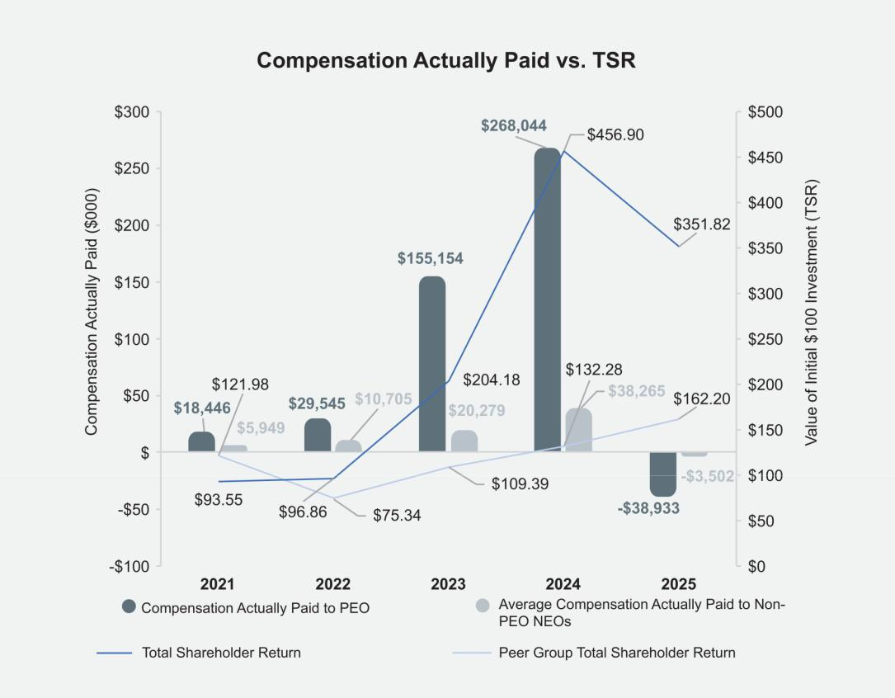

Fair Isaac Corporation l 2026 Proxy Statement 82

Table of Contents

Proxy | Board of | Corporate | Executive |  | Audit Committee | Charter | Stock | Other
Summary | Directors | Governance | Compensation |  | Matters | Amendments | Ownership | Matters

Relationship Between Compensation Actually Paid to PEO and Non-PEO NEOs (Average) and Net Income

The graph below illustrates the relationship between “Compensation Actually Paid” to our PEO and on average to our Non-PEO NEOs compared to net income over the five covered fiscal years.
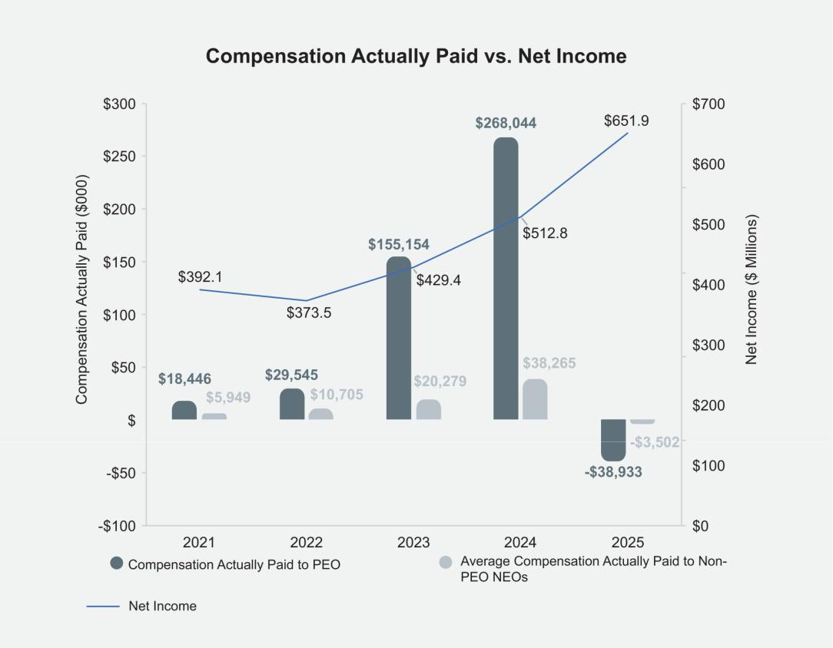

Fair Isaac Corporation l 2026 Proxy Statement 83

Table of Contents

Proxy | Board of | Corporate | Executive |  | Audit Committee | Charter | Stock | Other
Summary | Directors | Governance | Compensation |  | Matters | Amendments | Ownership | Matters

Relationship Between Compensation Actually Paid to PEO and Non-PEO NEOs (Average) and Relative One-Year TSR

The graph below illustrates the relationship between “Compensation Actually Paid” to our PEO and on average to our Non-PEO NEOs compared to our relative one-year TSR over the five covered fiscal years.
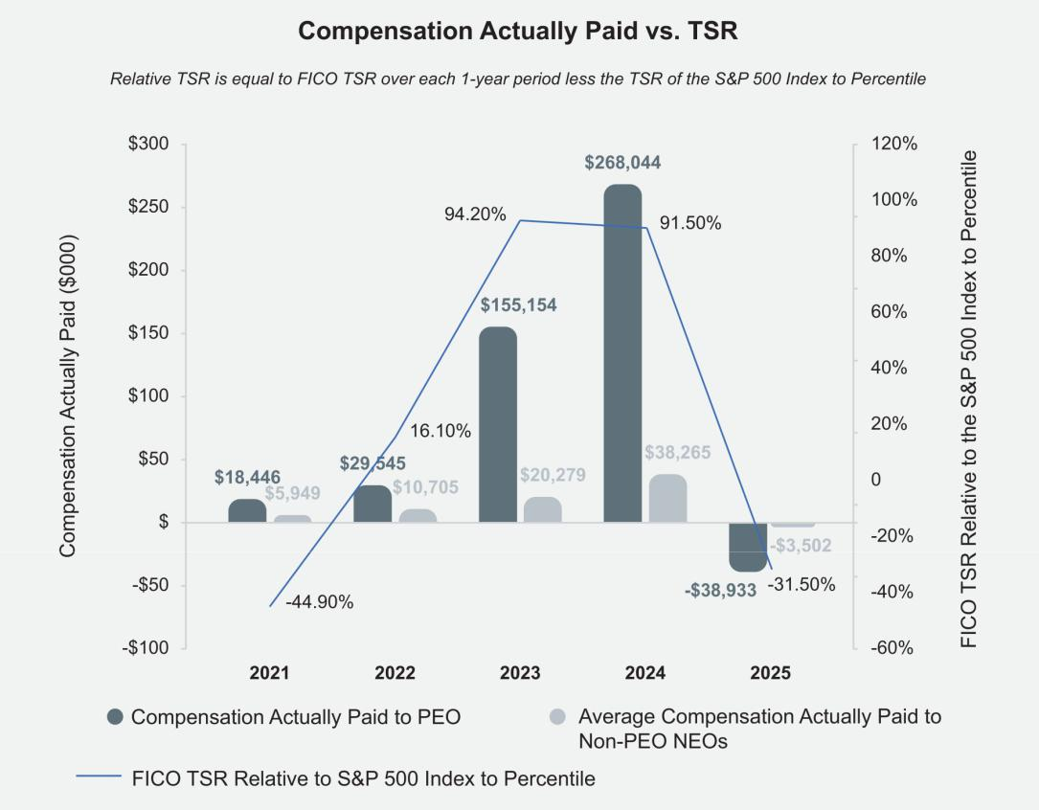

Tabular List of Most Important Performance Measures

The following table presents the financial performance measures that the Company considers to have been the most important in linking Compensation Actually Paid to our PEO and our Non-PEO NEOs for the fiscal year ended September 30, 2025 to Company performance. The measures in this table are not ranked.

- One-year TSR relative to 55th Percentile of S&P 500 Index

- Adjusted Revenue

- Adjusted EBITDA

Fair Isaac Corporation l 2026 Proxy Statement 84

Table of Contents

Proxy | Board of | Corporate | Executive | Audit Committee |  |  | Charter | Stock | Other
Summary | Directors | Governance | Compensation | Matters |  |  | Amendments | Ownership | Matters

PROPOSAL 3: Ratification of Independent Registered Public Accounting Firm

The Board recommends a vote FOR this proposal

It is the responsibility of the Audit Committee to select and retain independent auditors. Our Audit Committee has appointed Deloitte & Touche LLP (“Deloitte”) as our independent auditors for the Company’s fiscal year ending September 30, 2026. Although stockholder ratification of the Audit Committee’s selection of independent auditors is not required by our Bylaws or otherwise, we are submitting the selection of Deloitte for stockholder ratification so that our stockholders may participate in this important corporate decision. If not ratified, the Audit Committee will reconsider the selection, although the Audit Committee will not be required to select different independent auditors for the Company.

Representatives of Deloitte will be present at the Annual Meeting and will have an opportunity to make a statement and respond to questions from stockholders present at the meeting.

Audit and Non-Audit Fees

The following table presents fees for professional audit services rendered by the Company’s independent registered public accounting firm for the fiscal years ended September 30, 2025 and September 30, 2024, for the audit of our annual financial statements and fees for other services rendered by the firm during those respective periods.

 |  | 2025 |  |  | 2024
Audit Fees |  | $3,728,000 |  |  | $3,242,000
Audit-Related Fees |  | 337,000 |  |  | 383,000
Tax Fees |  | 128,000 |  |  | 103,000
All Other Fees |  |  | 2,000 |  | 2,000
Total |  | $4,195,000 |  |  | $3,730,000

Audit Fees. Audit fees consisted of fees for services rendered in connection with the annual audit of our consolidated financial statements, quarterly reviews of financial statements included in our quarterly reports on Form 10-Q, and the audit of internal control over financial reporting. Audit fees also consisted of services provided in connection with statutory audits, consultation on accounting matters and SEC registration statement services.

Audit-Related Fees. Audit-related fees consisted principally of fees for financial and non-financial attestation services (Service Organization Control), debt refinancing, customer compliance audits and audits of financial statements of employee benefit plans.

Tax Fees. Tax services consisted of fees for tax consultation and tax compliance services.

All Other Fees. All other fees consisted of fees for access to an online library of accounting and financial reporting literature.

Our Audit Committee considers whether the provision of services other than for audit fees is compatible with maintaining our independent auditor’s independence, and has determined that these services for fiscal 2025 and 2024 were compatible. The services described above were approved by the Audit Committee pursuant to Rule 2-01 of Regulation S-X under the Exchange Act.

Fair Isaac Corporation l 2026 Proxy Statement 85

Table of Contents

Proxy | Board of | Corporate | Executive | Audit Committee |  |  | Charter | Stock | Other
Summary | Directors | Governance | Compensation | Matters |  |  | Amendments | Ownership | Matters

Policy on Audit Committee Preapproval of Audit and Non-Audit Services of Independent Auditors

Our Audit Committee is responsible for appointing, setting compensation, and overseeing the work of the independent auditors. The Audit Committee has established a policy regarding preapproval of all audit and permitted non-audit services provided by the independent auditors. On an ongoing basis, management communicates specific projects and categories of service for which it requests the advance approval of the Audit Committee. The Audit Committee reviews these requests and advises management if the Audit Committee approves the engagement of the independent auditors. On a periodic basis, management reports to the Audit Committee regarding the actual spending for such projects and services compared to the approved amounts. The Audit Committee may also delegate the ability to preapprove audit and permitted non-audit services to a subcommittee consisting of one or more members, provided that any such preapprovals are reported on at the next Audit Committee meeting.

Fair Isaac Corporation l 2026 Proxy Statement 86

Table of Contents

Proxy | Board of | Corporate | Executive | Audit Committee |  |  | Charter | Stock | Other
Summary | Directors | Governance | Compensation | Matters |  |  | Amendments | Ownership | Matters

REPORT OF THE AUDIT COMMITTEE OF THE BOARD OF DIRECTORS

The Audit Committee selects and retains an independent registered public accounting firm as the Company’s independent auditor and assists the Board in overseeing (1) the integrity of the Company’s financial statements, (2) the independent auditor’s qualifications and independence, (3) the performance of the Company’s internal audit function and independent auditor, and (4) the compliance by the Company with legal and regulatory requirements related to financial affairs and reporting. The Board of Directors has adopted a written charter for the Audit Committee that addresses the responsibilities of the Audit Committee. This charter is available on the “Investors” page of our website at www.fico.com.

While the Audit Committee has the responsibilities and powers set forth in its charter, it is not the duty of the Audit Committee to plan or conduct audits or to determine that the Company’s financial statements and disclosures are complete and accurate and are in accordance with generally accepted accounting principles and applicable legal and other requirements. These are the responsibilities of management and the independent auditor. Additionally, in performing its oversight function, the Audit Committee necessarily relies on the work and assurances of, and information provided by, management and the independent auditor.

Deloitte & Touche LLP (“Deloitte”) served as the Company’s independent auditor for the fiscal year ended September 30, 2025. In fiscal 2025, the Audit Committee met and held discussions with management and Deloitte on numerous occasions. In fulfilling its oversight responsibilities, the Audit Committee reviewed and discussed with management and Deloitte the Company’s quarterly consolidated financial statements prior to the filing of each Quarterly Report on Form 10-Q and the audited consolidated financial statements included in the Annual Report on Form 10-K for the fiscal year ended September 30, 2025. The Audit Committee discussed with Deloitte matters required to be discussed by the applicable requirements of the Public Company Accounting Oversight Board and the SEC. Deloitte also provided to the Audit Committee the written disclosures and letter required by applicable requirements of the Public Company Accounting Oversight Board regarding the independent accountant’s communications with the Audit Committee concerning independence, and the Audit Committee discussed with Deloitte the firm’s independence and tenure.

Based upon the Audit Committee’s discussions with management and the independent auditor, and the Audit Committee’s review of the representations of management and the report of the independent auditor to the Audit Committee, the Audit Committee recommended to the Board of Directors that the audited consolidated financial statements be included in the Company’s Annual Report on Form 10-K for the fiscal year ended September 30, 2025, as filed with the SEC.

Submitted by the Audit Committee:

David A. Rey, Chair

Marc F. McMorris
H. Tayloe Stansbury

Fair Isaac Corporation l 2026 Proxy Statement 87

Table of Contents

Proxy | Board of | Corporate | Executive | Audit Committee |  |  | Charter | Stock | Other
Summary | Directors | Governance | Compensation | Matters |  |  | Amendments | Ownership | Matters

Certain Relationships and Related Persons Transactions

We maintain a written policy for the approval of any related person transactions. A “Related Person,” for purposes of our policy, means:

- Any person who is, or at any time since the beginning of our last fiscal year was, a director or executive officer or a nominee for director;

- Any person known to be the beneficial owner of more than 5% of our common stock; or

- Any immediate family member of the foregoing persons.

“Immediate family members” include children, stepchildren, parents, stepparents, spouses, siblings, mothers- and fathers-in-law, sons- and daughters-in-law, brothers- and sisters-in-law and any other person (other than a tenant or employee) sharing the household of one of these individuals.

Under the Related Persons Transaction Policy, any transaction, arrangement or relationship in which the Company (including any of its subsidiaries) is or will be a participant and in which a Related Person has a direct or indirect interest (a “Related Persons Transaction”) must be reviewed by the Audit Committee, except that the following transactions, arrangements or relationships are exempt under the policy:

- Payment of compensation by the Company to a director or executive officer of the Company for such person’s service to the Company in that capacity;

- Transactions available to all employees or all stockholders of the Company on the same terms; and

- Transactions that, when aggregated with the amount of all other transactions between the Company and the Related Person or any entity in which the Related Person has an interest, involve less than $120,000 in a fiscal year.

In determining whether to approve a Related Persons Transaction, the Audit Committee will consider the following:

- Whether the terms are fair to the Company;

- Whether the transaction is material to the Company;

- The importance of the Related Persons Transaction to the Related Person;

- The role the Related Person has played in arranging the Related Persons Transaction;

- The structure of the Related Persons Transaction; and

- The interests of all Related Persons in the Related Persons Transaction.

We will only enter into a Related Persons Transaction if the Audit Committee determines that the Related Persons Transaction is not inconsistent with the interests of the Company and its stockholders, the Related Persons Transaction is beneficial to the Company, and the terms of the Related Persons Transaction are fair to the Company. No Related Persons Transactions occurred during fiscal 2025.

Fair Isaac Corporation l 2026 Proxy Statement 88

Table of Contents

Proxy | Board of | Corporate | Executive | Audit Committee | Charter |  |  | Stock | Other
Summary | Directors | Governance | Compensation | Matters | Amendments |  |  | Ownership | Matters


PROPOSAL 4: Approval of an Amendment to the Company’s Restated Certificate of Incorporation to Allow for Exculpation of Officers as Permitted by Delaware Law

The Board recommends a vote FOR this proposal

In August 2022, the State of Delaware, which is the Company’s state of incorporation, enacted legislation that enables Delaware corporations to limit the personal liability of certain of their officers for monetary damages for breach of the duty of care in certain circumstances, as permitted under Section 102(b)(7) of the Delaware General Corporation Law (the “DGCL”). Previously, exculpation was only available for directors under the DGCL. In light of this legislation and the adoption of this provision by many other Delaware corporations, the Board has adopted, and recommends that stockholders approve, an amendment (the “Exculpation Amendment”) to our Restated Certificate of Incorporation to allow for the exculpation of officers as permitted by Delaware law.

In accordance with the DGCL, the officers who would be covered by the Exculpation Amendment include any officer who, during the course of conduct alleged to be wrongful, (i) is or was the Company’s president, chief executive officer, chief operating officer, chief financial officer, chief legal officer, controller, treasurer or chief accounting officer; (ii) is or was identified in the Company’s public filings with the SEC as an NEO of the Company; or (iii) has, by written agreement with the Company, consented to being identified as an officer for purposes of accepting service of process.

The Exculpation Amendment is aligned with the narrow class and type of claims for which certain officers’ liability can be exculpated under Section 102(b)(7) of the DGCL. Accordingly, the Exculpation Amendment would only permit exculpation for direct claims (as opposed to derivative claims made by stockholders on behalf of the Company) and would not apply to: (i) breaches of the duty of loyalty to the Company or its stockholders; (ii) acts or omissions not in good faith or which involve intentional misconduct or a knowing violation of law; or (iii) any transaction in which the officer derived an improper personal benefit.

In considering whether to propose the Exculpation Amendment, the Board considered that the role of an officer (like the role of a director) often requires them to make time-sensitive decisions on critical matters that can create substantial risk of investigations, claims, actions, lawsuits or proceedings seeking to impose liability on the basis of hindsight, especially in the current litigious environment and regardless of merit. The Board believes the proposed Exculpation Amendment better aligns the protections available to our officers with those currently available to our directors and would lower the risk of plaintiffs’ lawyers adding officers to direct claims relating to breaches of the duty of care, which can lead to increased litigation and insurance costs.

In addition, the Board believes that the Exculpation Amendment would better position the Company to continue to attract and retain top executive talent by providing protection against the potential exposure to liabilities and costs of defense tied to such claims. For these reasons, and taking into account the narrow class of officers and the limits on the types of claims for which those officers’ liability would be exculpated, the Board determined that approval of the Exculpation Amendment to allow for exculpation of certain of the Company’s officers is advisable and in the best interests of the Company and its stockholders.

The full text of the Exculpation Amendment, which would add a new Article 8 to our Restated Certificate of Incorporation, is provided below:

“8. (a) An officer of the corporation shall not be liable to the corporation or its stockholders for monetary damages for breach of fiduciary duty as an officer, except for liability (i) for any breach of the officer’s duty of loyalty to the corporation or its stockholders,
- for acts or omissions not in good faith or which involve intentional misconduct or a knowing violation of law, (iii) for any transaction from which the officer derived an improper personal benefit, or (iv) in any action by or in the right of the corporation.”

The Board has approved and declared advisable the Exculpation Amendment in accordance with the DGCL. If stockholders approve the Exculpation Amendment, it will become effective upon the filing of a Certificate of Amendment with the Delaware Secretary of State, which we anticipate doing as soon as reasonably practicable after receiving stockholder approval. Other than the addition of Article 8, the remainder of our Restated Certificate of Incorporation will remain unchanged after effectiveness of the Certificate of Amendment, with the exception of the removal of Article 6(d) as set forth in Proposal 5, if approved by stockholders. The Board retains the discretion to abandon, and not implement, the Exculpation Amendment at any time before it becomes effective, even if it is approved by stockholders.

Fair Isaac Corporation l 2026 Proxy Statement 89

Table of Contents

Proxy | Board of | Corporate | Executive | Audit Committee | Charter |  |  | Stock | Other
Summary | Directors | Governance | Compensation | Matters | Amendments |  |  | Ownership | Matters

PROPOSAL 5: Approval of an Amendment to the Company’s Restated Certificate of Incorporation to Eliminate the Supermajority Voting Requirement

The Board recommends a vote FOR this proposal

Article 6(d) of the Company’s Restated Certificate of Incorporation currently requires that the affirmative vote of the holders of at least 66-2/3% of the voting power of all of the then-outstanding shares of the stock of the Company entitled to vote generally in the election of directors, voting together as a single class, shall be required to amend or repeal Article 6 of the Company’s Restated Certificate of Incorporation.

The Board seeks approval from the Company’s stockholders to amend the Restated Certificate of Incorporation to eliminate this supermajority voting requirement for stockholders to amend Article 6 of the Company’s Restated Certificate of Incorporation (the “Supermajority Elimination Amendment”), so that stockholders could amend Article 6 of the Company’s Restated Certificate of Incorporation by the affirmative vote of the holders of a majority of the outstanding shares entitled to vote. If the Supermajority Elimination Amendment is approved by the Company’s stockholders, Article 6(d) of the Certificate of Incorporation would be removed in its entirety, which reads:

“(d) In addition to any vote of the holders of any class or series of the stock of this corporation required by law or by this Certificate of Incorporation, the affirmative vote of the holders of at least 66-2/3% of the voting power of all of the then-outstanding shares of the stock of the corporation entitled to vote generally in the election of directors, voting together as a single class, shall be required to amend or repeal this Article.”

The Board has approved and declared advisable the Supermajority Elimination Amendment in accordance with the DGCL. If stockholders approve the Supermajority Elimination Amendment, it will become effective upon the filing of a Certificate of Amendment with the Delaware Secretary of State, which we anticipate doing as soon as reasonably practicable after receiving stockholder approval. Following such approval and filing, we will not have any supermajority voting standards remaining in our governing documents. Other than the removal of Article 6(d), the remainder of our Restated Certificate of Incorporation will remain unchanged after effectiveness of the Certificate of Amendment, with the exception of the addition of Article 8 as set forth in Proposal 4 regarding the Exculpation Amendment, if approved by stockholders.

Fair Isaac Corporation l 2026 Proxy Statement 90

Table of Contents

Proxy | Board of | Corporate | Executive | Audit Committee | Charter | Stock |  |  | Other
Summary | Directors | Governance | Compensation | Matters | Amendments | Ownership |  |  | Matters

SECURITY OWNERSHIP OF CERTAIN BENEFICIAL OWNERS AND MANAGEMENT

Except as otherwise indicated, the following table and accompanying footnotes show information regarding the beneficial ownership of our common stock as of November 28, 2025 by:

- each person who is known by us to own beneficially more than 5% of our common stock;

- each current director and nominee for director;

- each named executive officer; and

- all directors and executive officers as a group.

As of the dates indicated in footnotes (3) and (4) below, publicly available information indicated that certain stockholders were beneficial owners of more than 5% of the outstanding shares of our common stock. The information in the table below is as reported in their filings with the U.S. Securities and Exchange Commission (“SEC”). The percentages noted in the table are as provided by such beneficial owners as of the date of their filing and not as of November 28, 2025. Based on a review of such SEC filings, we are not aware of any other beneficial owner of more than five percent of our common stock.

Shares of common stock underlying options that are currently exercisable or exercisable within 60 days are considered outstanding and beneficially owned by the person holding the options for the purposes of computing the percentage ownership of that person, but are not treated as outstanding for the purpose of computing the percentage ownership of any other person. Similarly, shares of common stock underlying RSUs, PSUs or MSUs that vest within 60 days are considered outstanding and beneficially owned by the person holding the RSUs, PSUs or MSUs for the purposes of computing the percentage ownership of that person, but are not treated as outstanding for the purpose of computing the percentage ownership of any other person. As of November 28, 2025, 23,690,661 shares of common stock were outstanding.

Directors, Director Nominees, Named Executive Officers, |  | Beneficial Ownership⁽¹⁾
Executive Officers and 5% Stockholders |  | Number | Percent⁽²⁾
Vanguard Group, Inc.⁽³⁾ |  | 3,069,749 | 12.78%
 | 100 Vanguard Blvd., Malvern, PA 19355
BlackRock, Inc.⁽⁴⁾ |  | 2,101,659 | 8.60%
 | 50 Hudson Yards, New York, NY 10001
William Lansing⁽⁵⁾ |  | 420,431 | 1.77%
Mark Scadina⁽⁶⁾ |  | 120,128 | *
Richard Deal⁽⁷⁾ |  | 64,476 | *
James Wehmann |  | 51,911 | *
Joanna Rees⁽⁸⁾ |  | 19,504 | *
Nikhil Behl⁽⁹⁾ |  | 18,744 | *
Braden R. Kelly⁽¹⁰⁾ |  | 15,888 | *
Eva Manolis⁽¹¹⁾ |  | 7,547 | *
David A. Rey⁽¹²⁾ |  | 7,192 | *
Steven Weber⁽¹³⁾ |  | 6,757 | *
Fabiola R. Arredondo⁽¹⁴⁾ |  | 6,131 | *
Marc F. McMorris⁽¹⁵⁾ |  | 2,600 | *
H. Tayloe Stansbury⁽¹⁶⁾ |  | 540 | *
All current directors, nominees and executive officers as a group (14 persons)⁽¹⁷⁾ |  | 719,282 | 3.02%
* | Represents holdings of less than 1%.

Fair Isaac Corporation l 2026 Proxy Statement 91

Table of Contents

Proxy | Board of | Corporate | Executive | Audit Committee | Charter | Stock |  |  | Other
Summary | Directors | Governance | Compensation | Matters | Amendments | Ownership |  |  | Matters

- To the Company’s knowledge, the persons named in the table have sole voting and sole dispositive power with respect to all shares shown as beneficially owned by them, subject to community property laws where applicable and the information contained in the footnotes to this table.

- If the named person holds stock options exercisable on or prior to January 27, 2026, or RSUs, PSUs or MSUs that will vest on or prior to January 27, 2026, the shares underlying those options, RSUs, PSUs and MSUs are included in the number for such person. Shares deemed issued to a holder of stock options, RSUs, PSUs or MSUs pursuant to the preceding sentence are not deemed issued and outstanding for purposes of the percentage calculation with respect to any other stockholder.
- Information as to this person (including affiliated entities) is based on the Schedule 13G/A filed by this person on October 30,
2025. The Vanguard Group has shared voting power as to 143,199 shares, sole dispositive power as to 2,840,425 shares and shared dispositive power as to 229,324 shares.

- Information as to this person is based on the Schedule 13G/A filed by this person on April 17, 2025. BlackRock, Inc. has sole voting power as to 1,925,321 shares and sole dispositive power as to 2,101,659 shares.

- Includes options to purchase 9,782 shares, RSUs representing 9,500 shares, PSUs representing 16,270 shares and MSUs representing 13,490 shares. The Lansing Revocable Trust holds 300,018 shares. The Lansing 2025 DRAT holds 18,300 shares, and the Lansing Foundation holds 10,933 shares.

- Includes RSUs representing 2,143 shares, PSUs representing 3,202 shares and MSUs representing 2,682 shares. The Scadina Revocable Trust holds 85,081 shares.

- Includes RSUs representing 2,143 shares, PSUs representing 3,202 shares and MSUs representing 2,682 shares. The Richard S. Deal Revocable Trust holds 56,449 shares.

- Includes options to purchase 8,300 shares. The Joanna Rees Revocable Trust holds 11,204 shares.

- Includes RSUs representing 1,315 shares, PSUs representing 1,240 shares and MSUs representing 714 shares. The Trust of Nikhil and Malvika holds 15,424 shares, and 5,000 of such shares are used to secure a margin loan account for non-FICO share purchases.

- Includes options to purchase 6,101 shares.

- Includes options to purchase 7,203 shares.

- Includes options to purchase 5,417 shares.

- Includes RSUs representing 2,335 shares, PSUs representing 1,540 shares and MSUs representing 1,020 shares.

- Includes options to purchase 4,203 shares.

- Includes options to purchase 2,358 shares.

- Includes options to purchase 357 shares.

- Reflects all options, RSUs, PSUs, MSUs and shares held directly and indirectly by individuals or entities listed in the table, referenced in footnotes 5 through 16 above, plus additional options to purchase 7,664 shares, RSUs representing 2,202 shares, PSUs representing 2,148 shares and MSUs representing 1,857 shares held by executive officers who are not individually listed in this table. Mr. Wehmann’s ownership is excluded from this amount as he is no longer an executive officer.

Fair Isaac Corporation l 2026 Proxy Statement 92

Table of Contents

Proxy | Board of | Corporate | Executive | Audit Committee | Charter | Stock | Other
Summary | Directors | Governance | Compensation | Matters | Amendments | Ownership | Matters

QUESTIONS AND ANSWERS ABOUT THE ANNUAL MEETING

Why did I receive this proxy statement?

The Board of Directors is soliciting your proxy to vote at the Annual Meeting to be held on March 4, 2026, because you were a stockholder of Fair Isaac Corporation at the close of business on January 5, 2026, the record date, and are entitled to vote at the meeting.

This proxy statement, the proxy card and the Annual Report (collectively, the “Proxy Material”) are being mailed to stockholders beginning on or about January 27, 2026. The proxy statement summarizes the information you need to know to vote at the Annual Meeting. You do not need to attend the Annual Meeting to vote your shares.

What is the difference between holding shares as a stockholder of record and as a beneficial owner?

If your shares are registered directly in your name with our transfer agent, Computershare, you are considered the “stockholder of record” with respect to those shares. We sent the Proxy Material directly to you. You have the right to vote these shares directly.

If your shares are held in a stock brokerage account or by a bank or other nominee, you are considered the “beneficial owner” of shares held in street name. In this case, the Proxy Material has been forwarded to you by your broker, bank or nominee who is considered the stockholder of record with respect to those shares. As the beneficial owner, you have the right to direct your broker, bank or nominee how to vote your shares by using the voting instruction card included in the mailing or by following their instructions for voting by telephone or the internet.

What am I voting on and how does the Board recommend that I vote?

- Election of eight directors: Braden R. Kelly, Fabiola R. Arredondo, William J. Lansing, Eva Manolis, Marc F. McMorris, Joanna Rees, David A. Rey, and H. Tayloe Stansbury;

- Approval of the advisory (non-binding) resolution relating to the named executive officer compensation as disclosed in this proxy statement;

- Ratification of the appointment of Deloitte & Touche LLP as our independent registered public accounting firm for the fiscal year ending September 30, 2026;

- Approval of an amendment to our Restated Certificate of Incorporation to allow for exculpation of officers as permitted by Delaware law;

- Approval of an amendment to our Restated Certificate of Incorporation to eliminate the supermajority voting requirement; and

- Any other such business as may properly come before the meeting or any adjournment thereof.

The Board recommends a vote FOR each of the nominees to the Board of Directors, FOR the approval of the advisory (non-binding) resolution relating to the named executive officer compensation as disclosed in this proxy statement, FOR the ratification of Deloitte’s appointment as independent registered public accounting firm for the fiscal year ending September 30, 2026, FOR the approval of the amendment to our Restated Certificate of Incorporation to allow for exculpation of officers as permitted by Delaware law, and FOR the approval of the amendment to our Restated Certificate of Incorporation to eliminate the supermajority voting requirement.

For all proposals, all votes will be tabulated by the inspector of election appointed for the Annual Meeting, who will tabulate affirmative votes, negative votes, abstentions and broker non-votes.

What is the voting requirement to elect the directors (Proposal 1)?

To be elected, the number of votes cast “FOR” a director nominee must exceed the number of votes cast “AGAINST” that nominee. The Company requires that all nominees submit an irrevocable letter of resignation as a condition to being named as a nominee, which resignation will be effective if (i) the nominee fails to receive a sufficient number of votes to be elected and (ii) the Board accepts such resignation. Cumulative voting for the election of directors is not permitted. Abstentions will not be counted “FOR” or “AGAINST” a nominee. Your broker or other nominee does not have discretionary authority to vote your shares on the election of directors, so any shares you hold

Fair Isaac Corporation l 2026 Proxy Statement 93

Table of Contents

Proxy | Board of | Corporate | Executive | Audit Committee | Charter | Stock | Other
Summary | Directors | Governance | Compensation | Matters | Amendments | Ownership | Matters

in street name will not be cast if your broker, bank, trust or other nominee does not receive voting instructions from you. Therefore, broker non-votes will be counted toward the presence of a quorum but will not be counted “FOR” or “AGAINST” a nominee.

What is the voting requirement for advisory approval of the named executive officer compensation as disclosed in this proxy statement (Proposal 2)?

The affirmative vote of a majority of the shares present or represented by proxy and entitled to vote on this proposal at the Annual Meeting is necessary for advisory approval of the named executive officer compensation as disclosed in this proxy statement. Because your vote on executive compensation is advisory, it will not be binding upon the Company or the Board of Directors. However, the LDCC will take into account the outcome of the vote when considering future executive officer compensation programs. Abstentions will be counted toward a quorum and have the effect of negative votes with respect to this proposal. Your broker or other nominee does not have discretionary authority to vote your shares on compensation-related proposals, so any shares you hold in street name will not be cast if your broker, bank, trust or other nominee does not receive voting instructions from you. Therefore, broker non-votes will be counted toward the presence of a quorum but will not be counted “FOR,” “AGAINST” or “ABSTAIN” on Proposal 2.

What is the voting requirement to ratify the appointment of Deloitte (Proposal 3)?

The affirmative vote of a majority of the shares present or represented by proxy and entitled to vote on this proposal at the Annual Meeting is necessary to ratify the appointment of Deloitte as our independent auditors for the fiscal year ending September 30, 2026. Abstentions will be counted toward a quorum and have the effect of negative votes with respect to this proposal. Your broker or other nominee does have discretionary authority to vote your shares on Proposal 3, even if the broker or other nominee does not receive voting instructions from you. Therefore, we do not expect any broker non-votes with respect to Proposal 3.

What is the voting requirement to approve the amendment to the Company’s Restated Certificate of Incorporation to allow for exculpation of officers as permitted by Delaware law (Proposal 4)?

The affirmative vote of a majority of the outstanding shares entitled to vote on this proposal at the Annual Meeting is necessary to approve the amendment to the Company’s Restated Certificate of Incorporation to allow for exculpation of officers as permitted by Delaware law. Abstentions will be counted toward a quorum and have the effect of negative votes with respect to this proposal. Your broker or other nominee does not have discretionary authority to vote your shares on Proposal 4, so any shares you hold in street name will not be cast if your broker, bank, trust or other nominee does not receive voting instructions from you. Therefore, broker non-votes will be counted toward the presence of a quorum and will have the same effect as votes cast “AGAINST” Proposal 4.

What is the voting requirement to approve the amendment to the Company’s Restated Certificate of Incorporation to eliminate the supermajority voting requirement (Proposal 5)?

The affirmative vote of the holders of at least 66-2/3% of the outstanding shares entitled to vote on this proposal at the Annual Meeting is necessary to approve the amendment to the Company’s Restated Certificate of Incorporation to eliminate the supermajority voting requirement in Article 6(d). Abstentions will be counted toward a quorum and have the effect of negative votes with respect to this proposal. Your broker or other nominee does not have discretionary authority to vote your shares on Proposal 5, so any shares you hold in street name will not be cast if your broker, bank, trust or other nominee does not receive voting instructions from you. Therefore, broker non-votes will be counted toward the presence of a quorum and will have the same effect as votes cast “AGAINST” Proposal 5.

What if other business is properly brought before the Annual Meeting for stockholder action?

The Board knows of no other matters to be presented for stockholder action at the Annual Meeting. However, if other matters are properly brought before the Annual Meeting, the persons named as proxies in the accompanying proxy card will have discretion with respect to how to vote the shares represented by them.

How many votes do I have?

You are entitled to one vote for each share of common stock that you hold for each nominee for director and for each other matter presented for a vote at the Annual Meeting. There is no cumulative voting.

Fair Isaac Corporation l 2026 Proxy Statement 94

Table of Contents

Proxy | Board of | Corporate | Executive | Audit Committee | Charter | Stock | Other
Summary | Directors | Governance | Compensation | Matters | Amendments | Ownership | Matters

How do I vote my shares?

If you are a stockholder of record, you may vote by proxy prior to the Annual Meeting by marking, signing, dating and returning the proxy card, or by following the internet or telephone voting instructions on the proxy card. You many also attend the Annual Meeting and vote in person.

If you are a beneficial owner of shares held in street name, you may vote by proxy prior to the Annual Meeting by following the instructions you receive from the broker, bank or nominee that is considered the stockholder of record with respect to those shares. If you would like to vote at the Annual Meeting, you must obtain a legal proxy from your broker, bank or nominee and present it to the inspector of election with your ballot when you vote at the meeting.

What can I do if I change my mind after I vote my shares?

If you are a stockholder of record, you may revoke your proxy at any time before it is voted at the Annual Meeting by:

- Sending written notice of revocation to the Corporate Secretary of FICO, 181 Metro Drive, Suite 700, San Jose, California 95110;

- Submitting a new proxy by telephone, internet or paper ballot after the date of the revoked proxy; or

- Attending the Annual Meeting and voting in person.

If you are a beneficial owner of shares, you may submit new voting instructions by contacting your broker, bank or nominee. You may also vote in person at the Annual Meeting if you obtain a legal proxy as described in the answer to the previous question.

Who will count the vote?

Representatives of Broadridge Financial Solutions, Inc. will tabulate the votes and act as the inspector of election.

Is my vote confidential?

Any proxy, ballot or other voting material that identifies the particular vote of a stockholder and contains the stockholder’s request for confidential treatment will be kept confidential, except in the event of a contested proxy solicitation or as may be required by law. We may be informed whether or not a particular stockholder has voted and will have access to any comment written on a proxy, ballot or other material and to the identity of the commenting stockholder. The inspector of election will be an independent third party not under our control.

What constitutes a quorum?

As of the record date, 23,765,456 shares of FICO common stock were issued and outstanding. A majority of the outstanding shares, present or represented by proxy, constitutes a quorum for the purpose of adopting proposals at the Annual Meeting. If you submit a properly executed proxy, then you will be considered part of the quorum. Abstentions and broker non-votes will be counted in determining if there is a quorum.

Who can attend the Annual Meeting?

All stockholders as of the record date may attend the Annual Meeting but must have an admission ticket. If you are a stockholder of record, the ticket attached to the proxy card will admit you. If you are a beneficial owner, you may request a ticket by writing to the Corporate Secretary, 181 Metro Drive, Suite 700, San Jose, California 95110. You must provide evidence of your ownership of shares with your ticket request, which you can obtain from your broker, bank or nominee. Stockholders who arrive at the Annual Meeting without an admission ticket will be required to present identification matching the corresponding stockholder account name at the registration table located outside the meeting room. If you are a stockholder whose shares are held by a bank, broker or other nominee, you will be asked to certify to such ownership at the registration table prior to the Annual Meeting.

What are FICO’s costs associated with this proxy solicitation?

We have hired Innisfree M&A Incorporated to assist in the solicitation of proxies for a fee not to exceed $25,000, plus reasonable out-of-pocket expenses. FICO employees, officers and directors may also solicit proxies. We will bear the expense of preparing, printing and mailing the Proxy Material, and reimburse brokerage houses and other

Fair Isaac Corporation l 2026 Proxy Statement 95

Table of Contents

Proxy | Board of | Corporate | Executive | Audit Committee | Charter | Stock | Other
Summary | Directors | Governance | Compensation | Matters | Amendments | Ownership | Matters

custodians, nominees and fiduciaries for their reasonable out-of-pocket expenses for forwarding proxy and solicitation materials to the owners of common stock.

How can I obtain the Company’s corporate governance information?

The following FICO corporate governance documents are available on the “Investors” page of our website at www.fico.com and are also available in print and free of charge to any stockholder who requests them:

- Corporate Governance Guidelines;

- Board Committee Charters — Audit Committee; Governance, Nominating and Executive Committee; and Leadership Development and Compensation Committee;

- Code of Business Conduct and Ethics;

- Code of Ethics for Senior Financial Management; and

- Director Independence Criteria.

IMPORTANT NOTICE REGARDING THE AVAILABILITY OF PROXY MATERIALS FOR THE STOCKHOLDER MEETING TO BE HELD ON WEDNESDAY, MARCH 4, 2026: The Proxy Material is located on the “Investors” page of our website at www.fico.com, and at the following cookies-free website that can be accessed anonymously: https://fico.gcs-web.com/corporate-information.

Fair Isaac Corporation l 2026 Proxy Statement 96

Table of Contents

Proxy | Board of | Corporate | Executive | Audit Committee | Charter | Stock | Other
Summary | Directors | Governance | Compensation | Matters | Amendments | Ownership | Matters

OTHER INFORMATION

Stockholder Communications with Directors

Stockholders and other interested parties may communicate with non-employee directors by sending written communications to the Board of Directors or specified individual directors by addressing their communications to the Corporate Secretary, Fair Isaac Corporation, 181 Metro Drive, Suite 700, San Jose, California 95110. The communications will be collected by the Corporate Secretary and delivered, in the form received, to the presiding director, or, if so addressed, to a specified director.

Stockholder Proposals and Nominations of Directors

Under the SEC rules, if a stockholder wants us to include a proposal in our proxy statement and proxy card for our 2027 annual meeting of stockholders, the proposal must be received by our Corporate Secretary, 5 West Mendenhall, Suite 105, Bozeman, Montana 59715, no later than 5:00 P.M. local time on September 29, 2026, to be considered for inclusion in the proxy statement and proxy card for that meeting. Stockholder communications to the Board, including any such communications relating to director nominees, may also be addressed to our Corporate Secretary at that address.

In order for business, other than a stockholder proposal included in our proxy statement and proxy card, to be properly brought by a stockholder before the 2027 annual meeting, the stockholder must give timely written notice thereof to the Corporate Secretary and must otherwise comply with our Bylaws. Our Bylaws provide that, to be timely, a stockholder’s notice must be received by our Corporate Secretary at our principal executive offices no fewer than 90 days nor more than 120 days prior to the first anniversary of the date of the preceding year’s annual meeting. In the case of an annual meeting which is held more than 25 days before or after such anniversary date, in order for notice by the stockholder to be considered timely, it must be received no later than the close of business on the 10th day following the date of the first public announcement of the date of the annual meeting.

In addition to satisfying the foregoing requirements, in order to comply with the universal proxy rules, a stockholder who intends to solicit proxies in support of director nominees for election at the 2027 annual meeting, other than the Company’s nominees, must provide notice that sets forth the information required by Rule 14a-19 under the Exchange Act no later than January 4, 2027.

Householding

We may deliver just one proxy statement to two or more stockholders who share an address, unless we have received contrary instructions from one or more of the stockholders. Each stockholder will receive a separate proxy card. This practice, which is commonly referred to as “householding,” is permitted by Rule 14a-3(e)(1) under the Exchange Act. It helps to reduce costs, clutter and paper waste for us and our stockholders.

However, we will promptly deliver a separate copy if requested by any stockholder at a shared address subject to householding.

Requests for additional copies of this proxy statement should be directed in writing to Broadridge Financial Solutions, Inc., Attn.
Householding Department, 51 Mercedes Way, Edgewood, New York 11717 or by phone at 1-866-540-7095.

In addition, stockholders who share a single address, but receive multiple copies of the proxy statement, may request that in the future they receive a single copy of any future proxy materials by contacting the Corporate Secretary at 181 Metro Drive, Suite 700, San Jose, California 95110 (if your shares are registered in your own name) or your bank, broker or other nominee (if your shares are registered in their name).

Internet Access to Proxy Materials

The proxy materials are located on the “Investors” page of our website at www.fico.com, and at the following cookies-free website that can be accessed anonymously: https://fico.gcs-web.com/corporate-information.

Fair Isaac Corporation l 2026 Proxy Statement 97

Table of Contents

Proxy | Board of | Corporate | Executive | Audit Committee | Charter | Stock | Other
Summary | Directors | Governance | Compensation | Matters | Amendments | Ownership | Matters

Requesting a Copy of the Company’s Annual Report on Form 10-K

We will mail without charge, upon written request, a copy of our Annual Report on Form 10-K for the fiscal year ended September 30, 2025, including the consolidated financial statements, schedules and list of exhibits and any particular exhibit specifically requested. Requests should be sent to: Fair Isaac Corporation, 181 Metro Drive, Suite 700, San Jose, California 95110, Attn: Investor Relations. The Annual Report on Form 10-K is also available on the “Investors” page of our website at www.fico.com.

Fair Isaac Corporation l 2026 Proxy Statement 98

Table of Contents

APPENDIX A

RECONCILIATION OF NON-GAAP FINANCIAL MEASURES

Adjusted EBITDA is referenced in the proxy statement to which this Appendix A is attached, and means GAAP net income, adjusted for certain items, as set forth in the reconciliation below. Adjusted EBITDA is a non-GAAP financial measure and is not intended to be considered in isolation or as a substitute for, or superior to, the financial information prepared and presented in accordance with GAAP. The Company’s definition of this measure is not necessarily comparable to other similarly titled captions of other companies due to different methods of calculation.

The following table contains a reconciliation of net income to Adjusted EBITDA for the fiscal years ended September 30, 2025

and 2024:

 | Year Ended |  |  | Year Ended
 | September 30, |  |  | September 30,
(in thousands) |  | 2025 |  | 2024
GAAP net income | $ | 651,946 |  | $ 512,811
Adjustments:
Interest expense, net |  | 133,647 |  | 105,638
Income tax provision |  | 150,649 |  | 129,214
Other expense (income), net⁽¹⁾ |  | (4,677) |  | (3,310)
Amortization of intangible assets |  | - |  | 917
Depreciation |  | 10,657 |  | 9,397
Share-based compensation expense |  | 156,667 |  | 149,439
Restructuring charges |  | 10,922 |  | -
Adjusted EBITDA | $ | 1,109,811 |  | $904,106

- Excludes gains and losses from securities held under a supplemental retirement and savings plan for certain officers and senior management employees, as the offsetting entries are included (as compensation expenses) in operating expenses, resulting in a net zero impact to the company’s net income.

Free cash flow is referenced in the proxy statement to which this Appendix A is attached, and means GAAP net cash provided by operating activities, less capital expenditures, as set forth in the reconciliation below. Free cash flow is a non-GAAP financial measure and is not intended to be considered in isolation or as a substitute for, or superior to, the financial information prepared and presented in accordance with GAAP. The Company’s definition of this measure is not necessarily comparable to other similarly titled captions of other companies due to different methods of calculation.

The following table contains a reconciliation of net cash provided by operating activities to free cash flow for the fiscal years ended September 30, 2025 and 2024:

 | Year Ended |  | Year Ended
 | September 30, |  | September 30,
(in thousands) | 2025 |  | 2024
GAAP net cash provided by operating activities | $778,807 |  | $632,964
Reduced by cash flow items:
Capital expenditures | 39,407 |  | 25,551
Free Cash Flow | $739,400 |  | $607,413

Table of Contents
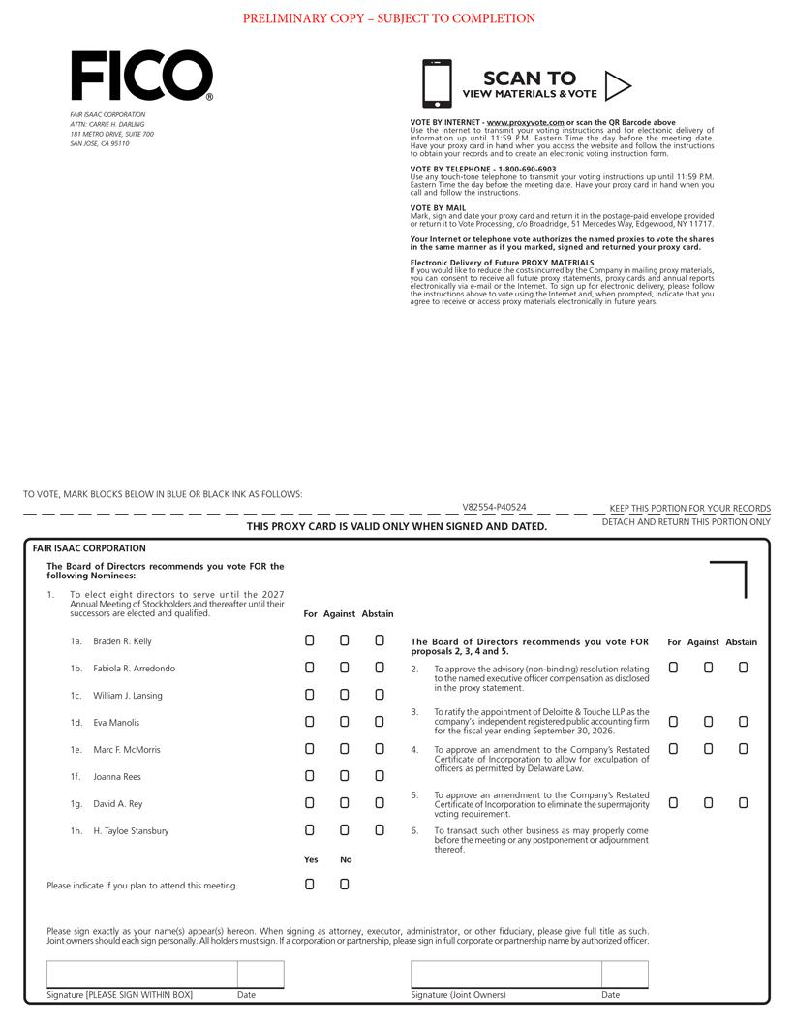

Table of Contents


